EXT203
Weight indicator manual
EXT203-9xxx1

directory
1. Basic Information 1
1.1. Features and Specifications 1
1.2. Overall diagram 3
1.3. Connection Port 4
1.3.1 Sensor wiring method 7
1.3.2 Wiring method of switching quantity 7
1.3.3 Serial port wiring method 8
1.4. Mounting Dimension 9
2. Working parameter setting 10
2.1. Parameter setting instructions 10
2.2. Work parameter setting items 10
3. Weight Calibration 18
3.1. Calibration instructions 18
3.2. Calibration with weights 18
3.2.1 Entry calibration 18
3.2.2 Setting of dec-point 19
3.2.3 Setting of min-div 20
3.2.4 Max-range 20
3.2.5 Sensor test 21
3.2.6 Gain calibration 23
3.2.7 Serial port calibration switch 25
3.2.8 Calibration password change 26
3.3. Calibration Without Weights 26
3.3.1 Entry without weight calibration 26
3.3.2 Sensor sensitivity input 27
3.3.3 Sensor range input 27
4. I/O 28
5. Preset 31
6. PLC model 35
7. custom 39
8. Parameters of the reset 45
9. Warring 46

Basic Information

Features and Specifications
EXT203-N is a small weight display for industrial weighing design. The weighing display has the characteristics of compact size, stable performance and rich interface. It can be widely used in: Concrete mixing and asphalt mixture equipment、metallurgical blast furnace, converter and chemical industry, feed weight control and other occasions.
EXT203-N has the following basic features：
●Working voltage：DC24V
●Weighing channel: single channel
●Sensor：DC5V/6 wire resistance strain bridge weighing sensor.
●Switch quantity：5 input /7 output
●Serial port 1: Standard RS485 port. Support Modbus, RE protocol, etc.
●Serial port 2: Standard, adjustable serial port with RS485 and RS232 interfaces. All support Modbus and RE protocols.
●Installation method： DIN35 Buckle type installation

The detailed technical specifications are as follows：
Transducer Excitation | DC5V±10%/120mA Drive current/can receive eight Ω 350 specifications of the sensor
Adaptive Sensor Sensitivity | 2mV/V or 3mV/V
Input Signal Range | 0～15mV
Minimum Input Sensitivity | 0.5uV/d
Nonlinearity | 0.02%FS（3mV/V hour）
Zero Drift | ＜0.5μV/℃
Gain Drifting | ＜10PPM/℃
AD Rate | The highest is 960 Times/Seconds
Maximum Accuracy of Display | 1/100000
Product Accuracy Grade | 
Working Voltage | DC24V（18V～30V compatibility）
Product Power Consumption | ＜5W
Operating Temperature Range | -10℃~45℃
Storage Temperature | -20℃~60℃
Humidity | Within 90%RH（No Condensation）

Overall diagram
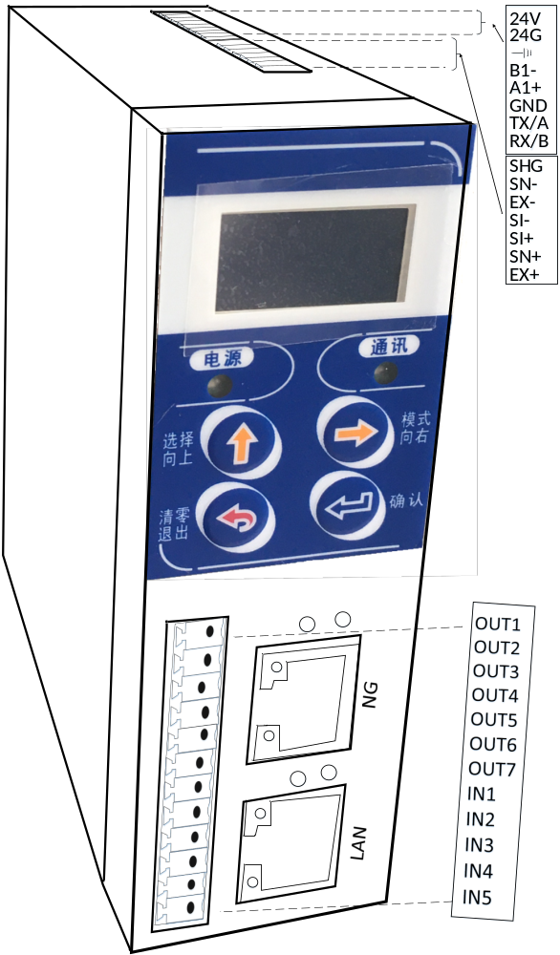
The front panel of the instrument is composed of liquid crystal display, 2 indicator lights and 4 keys.
The explanation is as follows:
indicator lights
communication | When the serial port receives the instruction and responds to the indicator light once
power supply | Power-on constant light
buttons
clear/exit | Under the weight display, press this button to clear a zero operation. Long press this key to mark the current weight to zero. On other screens, press this button to exit the previous menu.  In the parameter input interface, long press this key to clear the parameter to zero.
select/Up | Use to select a parameter in the parameter setting screen, or to enter a parameter value to increase the number by 1
pattern/right | It is used to enter parameter setting and calibration in the weighing interface, and also to select the cursor when entering parameter value
confirm | Use to save the current Settings while a parameter is being set

Connection Port
Wiring ports are shown in the figure below:
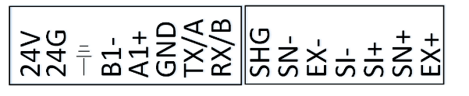
The wiring ports are described as follows:
type | Interface | Instructions
power supply | 24V | DC24V+
power supply | 24G | DC24V-
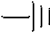 | EARTH | grounding
standard serial port (RS485) | B1- | RS485 B-
standard serial port (RS485) | A1+ | RS485 A+
Adjustable serial port is standard | GND | GND pin of RS232 for adjustable serial port 2
Adjustable serial port is standard | TX/A | Adjustable serial port 2, RS232 is TX when the switch is flipped, and RS485 is A+ when the switch is flipped
Adjustable serial port is standard | RX/B | Adjustable serial port 2, RS232 is RX when the switch is flipped, RS485 is B- when the switch is flipped
sensor  interface | EX+ | Load Cell Excitation+
sensor  interface | SN+ | Load Cell Sense+
sensor  interface | SI+ | Load Cell Signal+
sensor  interface | SI- | Load Cell Signal-
sensor  interface | EX- | Load Cell Excitation-
sensor  interface | SN- | Load Cell Sense-
sensor  interface | SHG | Load Cell Shielded Wire
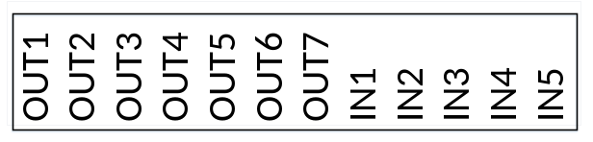
output | OUT1 | output 1 | UserDef 1
output | OUT2 | output 2 | UserDef 2
output | OUT3 | output 3 | UserDef 3
output | OUT4 | output 4 | UserDef 4
output | OUT5 | output 5 | UserDef 5
output | OUT6 | output 6 | UserDef 6
output | OUT7 | output 7 | UserDef 7
input | IN1 | input 1 | Zeroing
input | IN2 | input 2 | OFF
input | IN3 | input 3 | OFF
input | IN4 | input 4 | OFF
input | IN5 | input 5 | OFF
network interface | net interface | If the ext203-N meter is used, the TCP interface is used. If the ext203-P meter is used, the PROFINET interface is used
network interface | PN interface | PROFINET interface, only ext203-P meter is valid

Sensor wiring method
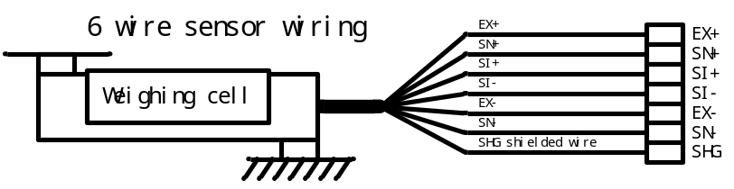
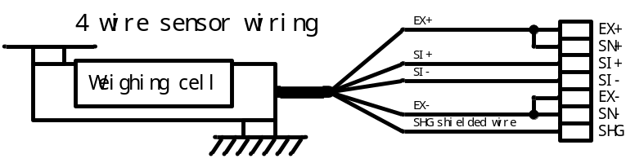

Wiring method of switching quantity
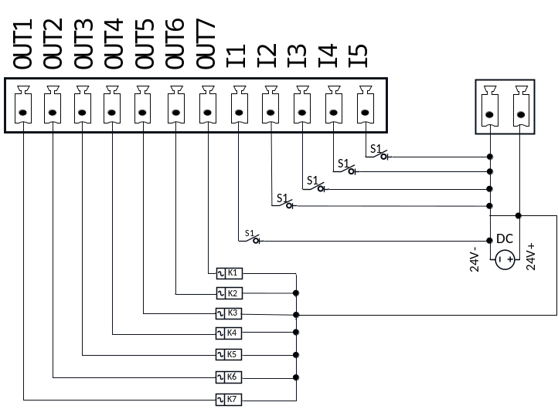
External circuit driven by input and output switching quantities should meet two main points:
1. The external circuit shall be co-located with instrument；
2. Low level indicates that the output is valid, otherwise it is invalid.
3. When the external circuit inputs low power, it means that the input is valid; otherwise, it means that the input is invalid.

Serial port wiring method
RS485 Wiring schematic：
instrument 1
1
A+
B-
GND
A+
B-
GND
A+
B-
GND
computer/PLC
A+
B-
GND
instrument 2
1
instrument N
1
RS232 Wiring schematic：
instrument

RXD
TXD
GND
Computer
/PLC
RXD
TXD
GND

Mounting Dimension
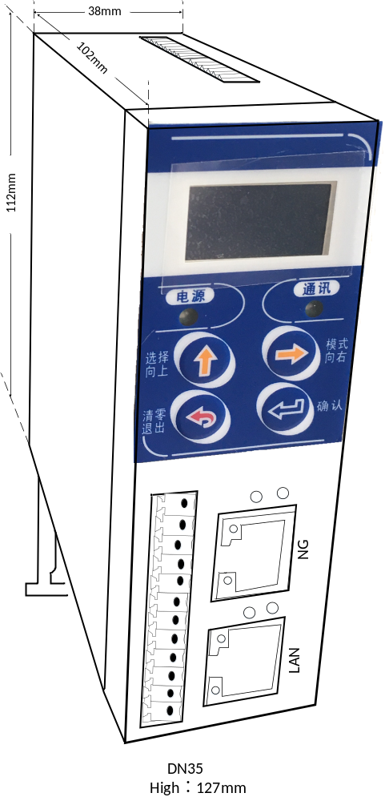

Working parameter setting

Parameter setting instructions
In the weighing state, press the key ，after the setting page is displayed, the cursor stops at 1 Working Parameter. Press if the parameter password is enabled, enter the parameter password input state. If the password is disabled, enter the work parameter setting item directly, be careful when entering the parameter password. You must enter all six digits, even if they are all six zeros.
The default password before delivery is 000000, and the password switch is turned off by default.

Basic Wt
The following is the list of parameters. Please refer to Chapter 2 for details on how to modify a parameter.
num | parameter | instructions | initial
1.1 | Basic Wt | The first item of parameters (weight related)
1.1.1 | Power zero | Power on automatic reset switch. If the parameter is ON，then after power ON, if the zero clearing condition is satisfied, the meter will perform zero clearing once. | OFF
1.1.2 | Zero range | 0~9d.If there is a small weight on the scale that lasts less than the zero track range for a period of 2 seconds, a zero clearance is performed. | 0
1.1.3 | Stable range | 1~9d。 | 3
1.1.4 | Stable time | 0.1~9.9s,The stability range and time are used together. When the weight changes less than the stability range within the stability time, it is considered to be stable. | 0.5
1.1.5 | Zero range | 00%~99%,If the current weight > maximum range × zero clearing range, the meter prompts“ Beyond the zero range” to alarm. | 50
1.1.6 | Number filter | 0~9,  0：The weakest filtering；  9：The strongest filtering | 3
1.1.7 | state filter | The steady state filtering：0：The weakest filtering；9：The strongest filtering，（0~9 optional） | 0
1.1.8 | AD rate | AD Sampling speed:  15PS：15 times per second  30PS：30 times per second  60PS：60 times per second  120PS：120 times per second  240PS：240 times per second  480PS：480 times per second | 120PS
1.1.9 | zero value | When the PLC mode is unloading and IO is defined as unloading function, if the weight is lower than the zero zone range, then wait for the unloading delay time, and then consider the unloading completed, and return to step 1, start the next PLC process; | 10
1.2 | Comm para | Second largest parameter (communication related)
1.2.1 | serial port | Serial correlation
1.2.1.1 | ID | Standard RS485 meter number (01-99 Optional) | 1
1.2. 1.2 | Baudrate | Standard RS485 baud rate, 1200240 0480 0960 0192 00384 00576 00115 200 is optional 1200,2400,4800,9600,19200,38400,57600,115200 is optional | 9600
1.2. 1.3 | protocol | Standard RS485 communication protocol,  Rtu-h: modbus-RTU, with the high byte first  Rtu-l: modbus-RTU, with the lower byte first  ASCII: Modbus - ASCII  RECont: indicates that the packets are sent continuously in RE format  RERead: The RE format is a command  YHcont: for internal use | rtu-H
1.2. 1.4 | DataFormat | Standard RS485 character format  7-E-1:7 data bits, parity, and 1 stop bit  7-O-1:7 data bits, odd check, 1 stop bit  8-N-1:8 data bits, no parity bit, 1 stop bit  8-E-1:8 data bits, parity, 1 stop bit  8-O-1:8 data bits, odd check, 1 stop bit | 8-N-1
1.2. 1.5 | Send speed | When P2.3 is RE and continuous transmission, this parameter is the continuous transmission speed of RS485  Auto: indicates the maximum speed  100 PS: 100 times per second  50 PS: 50 beats per second  25 PS: 25 times per second  20 PS: 20 times per second  10 PS: 10 times per second  1 PS: 1 time per second | Auto
1.2.1.6 | ID | 01-99 (refer to 1.2.1.1) | 1
1.2. 1.7 | Baudrate | Baud rate of Serial port 2 (see 1.2.1.2) | 9600
1.2. 1.8 | protocol | Serial Port 2 Communication protocol (refer to 1.2.1.3) | rtu-H
1.2. 1.9 | DataFormat | Serial port 2-character format (for details, see 1.2.1.4) | 8-N-1
1.2. 1.10 | Send speed | Serial port 2 Continuous transmission speed (for details, see 1.2.1.5) | Auto
1.2.2 | Web Param | Network Port Correlation
1.2.2.1 | IP | Meter IP Address | 196.168.0.1
1.2.2.2 | MAC | This parameter can be set to any value. During networking, note that the offset MAC addresses of multiple meters must be different | 0
1.2.2.3 | Port | Instrument Port number Server Port | 502
1.2.2.4 | protocol | Rtu-h: modbus-RTU, with the high byte first  Rtu-l: modbus-RTU, with the lower byte first | rtu-H
1.3 | memory | THREE item of parameter (user memory)
1.3.1 ~  1.3.9 | memory 1 ~9 | User memory 1 to 9 (each memory unit can write for 50,000 times) | NO
1.4 | password | The FOURTH item of parameter
1.4.1 | switch | Parameter setting password switch | OFF
1.4.2 | modify | Parameter password, enter the same password twice, press OK to save as a new password | 0

1）Continuous mode in RE communication format:
When P1.2.1.3 or P1.2.1.8 is RECONT in the working parameter setting is RECONT. The data format is as follows:
Meter response:
state | , | GS | , | symbol | DDDDDDD | unit | CR | LF
among：
state —— two，OL：（4FH 4CH） overflow
ST：（53H 54H） stable
US：（55H 53H） unstable
， —— 2C（HEX）
symbol —— +（2BH）； -（2DH）
unit ——20H 67H( g)，6BH 67H(kg)，20H 74H( t),6CH 62H(lb).
CR ——（0DH） enter
LF ——（0AH） newline
When weighing the display automatically sends the following frame of data:
53 54 2C 47 53 2C 2B 30 31 31 2E 31 32 30 6B 67 0D 0A
The current status is stable, the data value is positive, and the displayed value is 11.120kg
2）Command mode in RE communication format:
When P1.2.1.3 or P1.2.1.8 is REREAD in the working parameter setting is RECONT. The data format is as follows:
R | E | A | D | CR | LF
among：
R ——（52H）
E ——（45H）
A ——（41H）
D ——（44H）
CR ——（0DH） enter
LF ——（0AH） newline
The data frame returned by the instrument in response is the same as the data frame returned by the RE protocol in continuous mode. For details, see the Description of Data Frame Returned in Continuous Mode.
3）rtu-H/ rtu-L/ ASCII
Modbus address table is required for the three protocols. If necessary, please contact our salesman.
4）YHCont continuously send：
The data is output by ASCII code, and each frame consists of 8 groups of data (including the decimal point). Each frame of data is separated by a group of "=". For example, if the weight is 70.15, the string "51.0700 =" will be sent consecutively.

Calib

Calibration instructions
Any changes in the structure of the meter or scale for the first time, or if you change the sensor, a weight calibration operation should be performed.

Calibration with weights

Entry calibration
In the weighing state, press the key twice, the cursor stays in the "2 calib" item. Press to enter the calibration password input state.
Password
0—————
When the password is entered, the password input interface is displayed as shown on the right:
There are two points to pay attention to when you enter your password. One is that you must enter a 6-digit password. Even if the password is all zeros, you have to enter six zeros. Second, the password is entered for three times at most, after three attempts, the password is still not correct, the meter will be locked, the main display displays Password mistake after the meter is locked, it can only be unlocked by re-energizing the meter.
The factory default password is "000000".
After entering the correct password, the calibration setting interface is entered
The menu is as follows:
number | parameter
2 | Calib
2.1 | Point
2.2 | Units
2.3 | min-div
2.4 | Max range
2.5 | Loadcell vol
2.6 | Zero calib
2.7 | Calib1
2.8 | Calib2
2.9 | Calib3
2.10 | Calib4
2.11 | Calib5
2.12 | Calib6
2.13 | Calib7
2.14 | Calib8
2.15 | Calib9
2.16 | Calib10
2.17 | Comm.Clb
2.18 | Clb PSW set

Point
After entering the decimal point Settings, the current decimal point Settings are displayed.
Press the key  to select the desired decimal position, press to hold Settings and switch to the next item, press  do Not Save Settings and return to the calibration setting interface. The menu is as follows
number | value | instrument shows
① | 0 | “0”
② | 1 | “0.0”
③ | 2 | “0.00”
④ | 3 | “0.000”
⑤ | 4 | “0.0000”

Min-div
After entering the minimum indexing setting, the current minimum indexing setting is displayed to select the required minimum indexing, press to keep the Settings and return to the calibration Settings screen，Press not to save the setting and return to the calibration setting interface. The minimum indexing menu is as follows.
number | value | instrument shows
① | 1 | “Id= 01”
② | 2 | “Id= 02”
③ | 5 | “Id= 05”
④ | 10 | “Id= 10”
⑤ | 20 | “Id= 20”
⑥ | 50 | “Id= 50”

Max-range
Current weight value > (maximum range + 10 degrees ),the meter indicates OFL.
After entering the maximum range, the meter displays the maximum range set last time, and the leftmost digit flashes, at this point you can use and modify the maximum range Settings, press keep the Settings and return to the calibration Settings screen，Press not to save the setting and return to the calibration setting interface.

Sensor test
Under the sensor test interface, the meter displays the current millivolt, Under this interface, it can test whether the sensor signal is normal or not, and whether the scale body has four Angle error, etc.
When the sensor signal is too small, the instrument displays “-ADOFL”；When the sensor signal is too large, the meter displays “ADOFL”.
To check for four-angle errors on the scale, place the same standard weight on each of the four corners of the platform and record the millivolt response each time. If the four angles have different millivolts, then there is a four-angle error, then adjust the structure so that the four angles have the same millivolts.
Press and return to the calibration setting screen zero calibration.
The function of zero calibration is as follows:
0.011
0.000
Meter display:
Meter display:
After zero calibration
Figure: The role of zero calibration
Empty weighing platform
When the instrument is installed for the first time or the replacement of the sensor, the need for zero calibration, zero calibration is actually to let the instrument to empty scale when the sensor voltage is recorded as zero.
There are two methods for zero calibration. The first is to empty the platform, and then the actual number of millivolts as zero, this method is called with weight calibration zero, the second method is to input the historical millivolt and set it to zero. This method is called the input millivolt calibration zero. The following describes the two operation methods of zero calibration:

Zero Clb

Zero clb
After entering the zero point calibration interface, the instrument displays the current millivolt, for example, the meter display indicates that the current millivolt is 2.203 millivolts, empty the scale, wait for the stability indicator to light, then press ,mark 2.203 mV as zero, and then automatically return to the calibration setting interface.

Zero Clb with weights
Input Mv
000.000 mV
SV：2.203mV
After entering the zero point calibration interface, the instrument displays the current millivolt, For example, the instrument display indicates that the current mV is 2.203 mV. If instead of using the currently displayed millivolt as the zero, instead of using the input millivolt as the zero, Then press the key the main display will change to the millivolt input interface as shown on the right:
SV is the current millivolt number, at this time input zero millivolt number, and then press save and complete the zero calibration without weight, and return to the calibration setting interface

Gain calibration
The function of gain calibration is shown as follows:
500g
500g
523g
500g
The instrument shows：
The instrument shows：
After gain calibration
Figure: The role of gain calibration
Gain calibration actually allows the meter to remember the relationship between weight and millivolt. Gain calibration should be performed the first time a meter is used or when a sensor is changed. There are also two ways to calibrate the gain. The first is the gain calibration with weights. As the name implies, the actual weight calibration gain is placed on the scale platform. The use of the gain with weights must first go through the zero calibration with weights; The second is the input millivolt gain calibration, which inputs the historical weight and millivolt into the meter for gain calibration. The following is the operation process of the two calibration:

Weight gain calibration
EXT203 supports up to ten gain calibration points, and the method for each gain calibration point is the same. After entering the gain calibration interface, the meter displays the current gain millivolt (gain millivolt = current millivolt - zero millivolt)，For example, the meter indicates that the current gain is 0.225 mV（Generally speaking, if the zero-crossing calibration with weights is carried out, the gain millivolt is generally 0 when the gain calibration with weights is entered.)
Place the standard weight on the weighing table and wait for the gain millivolt to stabilize. When the stability indicator is on, press the key, at this point, the meter switches to the gain weight input interface. After entering the weight of the weight of the weight, press the key to save the gain calibration and return to the calibration Settings screen.

Input millivolt gain calibration
After entering the gain calibration interface, the meter displays the current gain millivolt (gain millivolt = current millivolt - zero millivolt), for example, the meter show the current gain is 0.225 mV (Generally speaking, if the zero-crossing calibration is carried out with the weight, the gain millivolt is generally 0 when entering the gain calibration with the weight.)
If you want to manually enter the millivolt calibration gain, you can press. Switch the meter to the gain millivolt input interface, As shown in the picture below:
Input mv:
000.000mV
SV: 0.225mV
SV is the current millivolt, after the gain millivolt input is completed press the instrument switches to the gain weight input interface, after the input gain weight is completed press save and complete the gain calibration without weight, and return to the calibration setting interface.

Serial port calibration switch
Enter the serial port calibration switch setting, Instrument display ① off, ② on, when the selection of open to allow the serial port to modify the calibration parameters, otherwise the serial port can not calibrate and modify the calibration parameters.

Calibration password change
2.18 Clb PSW set
0—————
Enter the calibration password change, the instrument display as shown on the right: Note that when entering a password, you must enter a 6-digit password. Even if the password is all zeros, you must enter 6 zeros. The two input passwords must be consistent. If inconsistent, the first input will be returned and re-input. After successful input, save the password to enter the calibration setting password interface and return to the calibration setting interface

No Calib

Entry without weight calibration
In the weighing state, press the key three times, The main display cursor stops at "3 no calib". press to enter the no-weight calibration password input state.
The password input screen is displayed when the password is entered :0—————,there are two points to pay attention to when you enter your password. One is that you must enter a 6-digit password, Even if the password is all zeros, you have to enter six zeros; The second is to enter the password for three times at most, after three attempts, the password is still not correct, the meter will lock. The main display shows password mistake after the meter is locked, it can only be unlocked by re-energizing the meter.
The factory default password is "000000".
After entering the correct password, enter the decimal point Settings.
The following calibration (point/unit/min-div/range/loadcell vol) with the weight calibration, this is not to repeat. After zero calibration, press "OK" button to complete zero calibration when "OX.XXX" is displayed, then switch to the next item of "Sensor Sensitivity Input", which will start from the sensor sensitivity input steps:

Loadcell mv/v input
After entering the sensor sensitivity input interface, the meter displays the current sensor sensitivity. For example, instrument display的7/5000 .The sensor sensitivity is 2.0000MV/V。Find the sensitivity provided on the sensor certificate and enter the value into the meter. When completed, press the key to save the parameters and automatically switch to the sensor range input.

loadcell range input
After entering the sensor range input, the meter first displays the sensor range last set, and the leftmost digit blinks. At this point, you can use and to modify sensor range Settings. Press hold setting and return to the calibration Settings screen.
The serial port calibration switch setting and the subsequent password setting shall be set in the follow-up setting with the serial port calibration switch with the weight calibration, which will not be repeated here.

I/O
The meter has five inputs and seven outputs. Both input and output can be defined. Under the weight display interface, press the key four times, Until the main display cursor stops at "4 switch quantity", press the key to enter the input and output definition, if the password is open, you need to enter the correct password to access the next level menu.
When leaving the factory, the password is "000000", the password switch is off.
The menu is as follows:
I/O
num | para | instructions | default value
4.1 | I/O custom
4.1.1 | IN1 | Select the definition of switch quantity input, optional:  Off: disables and does not perform any operation  zeroing: indicates that the system is cleared once  Run: Start the PLC | zeroing
4.1.2 | IN2 |  | OFF
4.1.3 | IN3 |  | OFF
4.1.3 | IN4 |  | OFF
4.1.3 | IN5 |  | OFF
4.1.4 | OUT 1 | Select the definition of the switch quantity output, optionally:  "①OFF",  "②stab ",  "③zero ",  "④overflow ",  "⑤zero value",  "⑥Preset 1",  "⑦Preset 2",  "⑧Preset 3",  "⑨Preset 4",  "⑩Preset 5",  "⑨Preset 4",  "⑩Preset 5",  "⑪Preset 6",  "⑫Preset 7",  "⑬PLC Fast",  "⑭PLC Med",  "⑮PLC fine",  "⑯PLC fix",  "⑰PLC disc",  "⑱UserDef 1",  "⑲UserDef 2",  "⑳UserDef 3",  "21 UserDef 4",  "22 UserDef 5",  "23 UserDef 6",  "24 UserDef 7", | UserDef 1
4.1.5 | OUT 2 |  | UserDef 2
4.1.6 | OUT 3 |  | UserDef 3
4.1.7 | iOUT 4 |  | UserDef 4
4.1.8 | OUT 5 |  | UserDef 5
4.1.9 | OUT 6 |  | UserDef 6
4.1.10 | OUT 7 |  | UserDef 7
4.2 | I/O test
Please see the picture below for detailed description
4.3 | password
4.3.1 | switch | Parameter Setting Password switch | OFF
4.3.2 | modify | To change the password, enter the same password twice and press OK to save the new password | 000000
Note: An illustration of the output type is shown below:
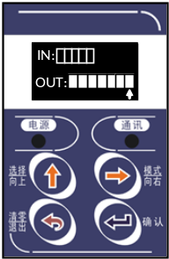
As shown IN the figure above: IN: IN is the input test port. The 5 squares from left to right are IN1,IN2,IN3,IN4,IN5
OUT：OUT is the output test port. The 7 squares from left to right are OUT1, OUT2, OUT3，OUT4，OUT5，OUT6，OUT7 in turn， is moving the cursor， is a valid and invalid state switch
□：effective ■：invalid

Preset point
Under the weight display interface, press the key five times, Until the main display cursor stops at "5 preset point", press the key to enter the preset point related parameter setting, if the password is open, you need to enter the correct password to access the next level menu.
When leaving the factory, the password is "000000", the password switch is off.
The menu is as follows：
Preset point
number | parameter | instructions | default
5.1 | Stable switch | For weight comparison, determine stability, off/on optional:  Off: Not judged  Open: stability | OFF
5.2 | output time | Output holding time: When the conditions are met, the output holding time of the switch quantity is set from 0.0 to 99.9 (unit: s). | 0
5.3 | Preset Number | The number of preset points and preset points together determine the preset point range | 6
5.4 | Preset 1 | Setting range: maximum range ~99999  Number of preset s =1: Preset s 1234 have no comparison  Number of preset s =2: Preset 1 < preset 2  Number of preset s =3: preset 1 < Preset 2 < preset 3  Number of preset s =4: preset 1 < preset 2 < preset 3 < preset 4  Number of preset s =5: preset 1 < preset 2 < preset 3 < preset 4 < preset 5  Number of preset s =6: preset 1 < preset 2 < preset 3 < preset 4< Preset 5 < preset6 | 0
5.5 | Preset 2 |  | 0
5.6 | Preset 3 |  | 0
5.7 | Preset 4 |  | 0
5.8 | Preset 5 |  | 0
5.9 | Preset 6 |  | 0
5.10 | password
5.10.1 | switch | Parameter Setting Password switch | OFF
5.10.2 | modify | To change the password, enter the same password twice and press OK to save the new password
Note: When the preset output function is used, the corresponding output switch quantity needs to be defined. For details, see Switch quantity Input and Output.
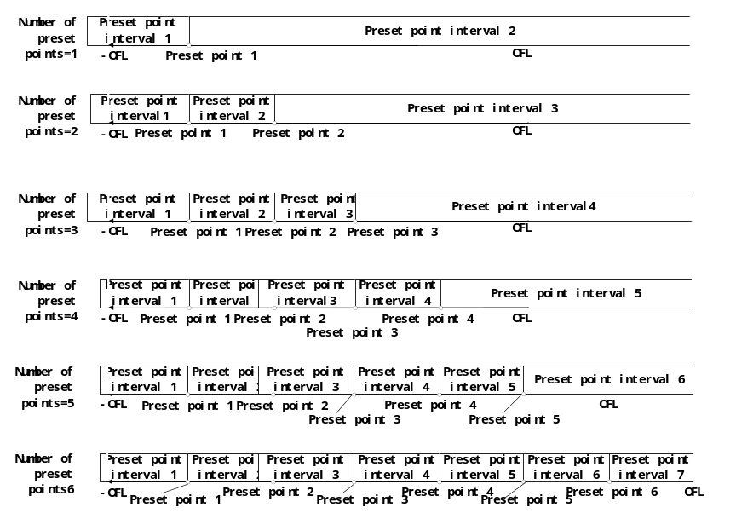
Figure 6-0
Preset 1: valid when the weight is less than preset 1
(-OFL < weight < preset 1)

Preset 2: valid when the weight is equal to preset 1 and less than preset 2. Note that if preset 1 = preset 2, preset 2 is invalid
(preset 1 = weight < preset 2)
Preset 3: valid when the weight is equal to preset 2 and less than preset 3. Note that if preset 2 = preset 3, preset 3 is invalid
(preset 2 = weight < preset 3)
Preset 4: valid when the weight is equal to preset 3 and less than preset 4. Note that if preset 3 = preset 4, preset 4 is invalid
(preset 3 = weight < preset 4)
Preset 5: If the weight is greater than or equal to preset 4, it is valid. Note that if preset 4 = preset 5, preset 5 is invalid
(preset 4 = weight < preset 5)
Preset 6: If the weight is greater than or equal to preset 5, it is valid. Note that if preset 5 = preset 6, preset 6 is invalid
(preset 5 = weight < preset 6)

Preset 7: when the weight is greater than or equal to the preset 6 is effective
(preset 6 = weight < OFL)

Note: There is a size relationship between presets 1~6. When an error is reported when setting the preset value, please set the larger value of the preset first.

PLC
Under the weight display interface, press the key six times until the display cursor stops at 6 PLC mode, press the key to enter PLC mode, if the password is opened, you need to enter the correct password to enter the next level menu.
When leaving the factory, the password is "000000", the password switch is off.
Packaging parameter Setting
number | parameter | instructions | value
6.1 | Target | Target value setting, 0 ~the maximum range | 0
6.2 | Fast Feed | Fast feed setting, 0~ target value; When the weight value≥target - Fast feed，Shut down fast and activate med  (Note: fast >med>slow, when set to 0, close the fast) | 0
6.3 | Med Feed | med feed setting, 0~ target value; When the weight value≥target - med feed，Shut down med and activate slow  (Note: fast >med>slow, when set to 0, close the fast) | 0
6.4 | Fine Feed | slow feed setting, 0~ target value; When the weight value≥target - slow feed，Shut down slow.  (Note: fast >med>slow, when set to 0, close the slow) . | 0
6.5 | Out mode | Packing mode: ① combined output /② independent output is optional. Please see the introduction of combined output and independent output below for details | ①
6.6 | output time | Output hold time: When the conditions are met, the output hold time ranges from 0.0 to 99.9 (unit: s). | 0.5
6.7 | Fix time | Fixed holding time: when the PLC ends small casting, fixed output holding time, setting range: 0.0~99.9 (unit: s) | 0.5
6.8 | Disc time | Unloading delay time: when the PLC is finished setting the value, the instrument will start unloading output until the weight is less than zero zone, and the unloading output will keep the unloading delay time. When the time is over, the unloading will be closed. Setting range: 0.0~99.9 (unit: s) | 0.5
6.9 | password
6.9.1 | switch | Parameter Setting Password switch | OFF
6.9.2 | modify | To change the password, enter the same password twice and press OK to save the new password
Note: When using the simple packaging function, it is necessary to define the input-output switch quantity. For details, see the Input-output switch quantity.
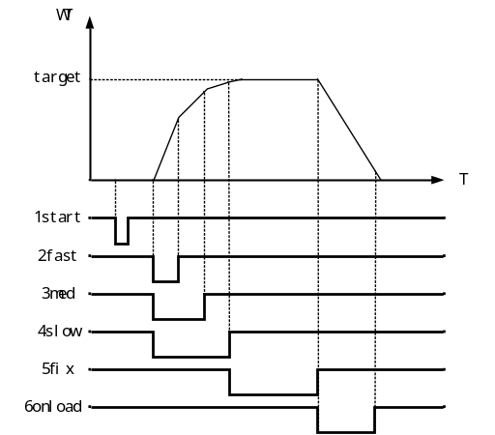
PLC simple packaging process description:
      - Start and run;
      - Determine the running status based on the current weight.
If the weight value≤ target value – fast feed, output fast and start slow output time. During the minimum output time, the weight is not judged.
If the target value – fast feed ≤ when the weight value ≤ target value – med feed, output the med and start the slow output time, and do not make weight judgment during the minimum output time.
If target value-med feed≤weight value≤target value-slow feed，Output slow and start the minimum output time, do not make weight judgment in the minimum output time;
If the target value - small weight advance≤current weight, skip 3 and go directly to 4；
If the target value – slow feed ≤ current weight, skip 3 and go directly to 4;
      - After the minimum output time is over, check the weight
When weight value≥target value -fast feed，close fast and enter med.
When weight value≥target value -med feed，close med and enter slow.
When weight value≥target value - slow drop value， close the slow, end the feeding process,
      - Start PLC fixed value output and [6.7 Fixed value Holding time]. After the fixed value holding time is over, close PLC fixed value and output PLC unloading signal;
      - When the weight is less than zero zone, start the unloading delay time. When the delay time reaches, stop unloading. Complete a simple packaging process.
Influence of combined output mode and independent output mode on switching quantity defined as PLC:
Combined output mode
fast：PLC fast，PLC med，PLC slow
med：PLC med，PLC slow
fine：PLC slow
Independent output mode
fast：PLC fast
med：PLC med
fine：PLC slow

UserDef
On the weight display interface, press the key seven times until the main display cursor stops at "7 Custom", and press the key to enter the parameter setting of UserDef. If the password is opened, you need to enter the correct password to enter the next-level menu.
Factory time, the password is "000000", password switch is off state.
The menu list is as follows:
UserDef
num | parameter | instructions | value
7.1 | UserDef 1
7.1.1 | out type | 4 types of output：（For the description of output types, see the interval diagram outside the table.) Note: When output type ④P1 to P2⑤ is less than P1 or greater than P2, P2 must be greater than P1, or the custom will have no output  ① Shut down: shut down the output;  ②-OFL to P1: the output is effective when the weight is between the set value of P1 and minus infinity;  ③P2 to OFL: the output is effective when the weight is between P2 set value and positive infinity;  ④P1 to P2: the weight output is effective when the P1 set value is to P2 set value;  ⑤ Less than P1 or greater than P2: the output is valid when the weight is less than P1 or greater than P2 | P2~OFL
7.1.2 | P1 set | P1 set value，0~99999  (When the output type is ④⑤, need P1<P2) | 0
7.1.3 | P2 set | P2 set value，0~99999  (When the output type is ④⑤, need P1<P2) | 100
7.1.4 | Out if stable | For weight comparison, determine stability, off/on optional:  Off: Not judged  Open: stability | OFF
7.1.5 | output time | Output holding time: When the conditions are met, the output holding time of the switch quantity is set from 0.0 to 99.9 (unit: s). | 0
7.2 | UserDef 2
7.2.1 | out type | The same as Custom 1 output port Settings | -OFL~P1
7.2.2 | P1 set | The same as Custom 1 output port Settings | 10
7.2.3 | P2 set | The same as Custom 1 output port Settings | 0
7.2.4 | Out if stable | The same as Custom 1 output port Settings | OFF
7.2.5 | output time | The same as Custom 1 output port Settings | 0
7.3 | UserDef 3
7.3.1 | out type | The same as Custom 1 output port Settings | 关
7.3.2 | P1 set | The same as Custom 1 output port Settings | 0
7.3.3 | P2 set | The same as Custom 1 output port Settings | 0
7.3.4 | Out if stable | The same as Custom 1 output port Settings | OFF
7.3.5 | output time | The same as Custom 1 output port Settings | 0
7.4 | UserDef 4
7.4.1 | out type | The same as Custom 1 output port Settings | OFF
7.4.2 | P1 set | The same as Custom 1 output port Settings | 0
7.4.3 | P2 set | The same as Custom 1 output port Settings | 0
7.4.4 | Out if stable | The same as Custom 1 output port Settings | OFF
7.4.5 | output time | The same as Custom 1 output port Settings | 0
7.5 | UserDef 5
7.5.1 | out type | The same as Custom 1 output port Settings | OFF
7.5.2 | P1 set | The same as Custom 1 output port Settings | 0
7.5.3 | P2 set | The same as Custom 1 output port Settings | 0
7.5.4 | Out if stable | The same as Custom 1 output port Settings | OFF
7.5.5 | output time | The same as Custom 1 output port Settings | 0
7.6 | UserDef 6
7.6.1 | out type | The same as Custom 1 output port Settings | OFF
7.6.2 | P1 set | The same as Custom 1 output port Settings | 0
7.6.3 | P2 set | The same as Custom 1 output port Settings | 0
7.6.4 | Out if stable | The same as Custom 1 output port Settings | OFF
7.6.5 | output time | The same as Custom 1 output port Settings | 0
7.7 | UserDef 7
7.7.1 | out type | The same as Custom 1 output port Settings | OFF
7.7.2 | P1 set | The same as Custom 1 output port Settings | 0
7.7.3 | P2 set | The same as Custom 1 output port Settings | 0
7.7.4 | Out if stable | The same as Custom 1 output port Settings | OFF
7.7.5 | output time | The same as Custom 1 output port Settings | 0
7.8 | password
7.8.1 | switch | Parameter Setting Password switch | OFF
7.8.2 | modify | To change your password, enter the same password twice and press OK to save it as a new password | 000000
Note: When you use the UserDef output function, you need to define the corresponding output switch. For details, see Switch Input and Output.
Note: An illustration of the output type is shown below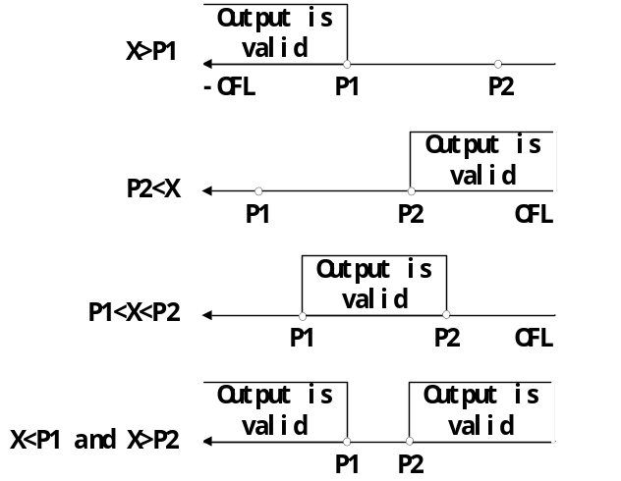

System
Reset is used to reset a function to its factory default state. Here's how he does it:
8.1 | Reset
8.1.1 | Basic Wt | Restore the working parameter item to its initial value
8.1.2 | Calib | Restore the working parameter item to its initial value
8.1.3 | I/O | Restore the working parameter item to initial value (including PLC mode, preset, custom reset)
8.1.4 | PLC | Restore the working parameter item to its initial value
8.1.5 | All para | Restore everything to its original value (retain password Settings)
8.2 | Display | Refresh time:0.0~999.9s
8.3 | Language | ①简体中文  ②English
8.4 | Show | ①On: Display company logo at startup  ②Off: Do not display company logo at startup  ③Custom: display custom logo at startup
8.5 | Screen save
8.5.1 | save type | ①Display weight: During the screen saver time. If no key operation is performed, only weight will be displayed, and the weight display position will change with time.  ② lock screen .
8.5.2 | save time | 0~600s  If no key operation is performed during this time, the screen saver interface will be entered.  Set to 0 to turn off the screen saver.
8.6 | password
8.6.1 | switch | Parameter Setting Password switch
8.6.2 | modify | To change your password, enter the same password twice and press OK to save it as a new password

Warring
The following is the alarm information that may appear on this meter, and how to deal with it.
warring | instructions | solution
Zero must stable | Reset unstable alarm, when the unstable press the reset key | Make sure it is stable and then reset to zero, or modify the stabilizing time and stabilizing range to appropriate values
Over zero rng | Clearing zero out of range | Make sure the zeros are within the range, or change the zeros to an appropriate value
-OFL | Negative spillover | Check whether the sensor signal is too small or whether the weight value exceeds the negative maximum scale range
OFL | positive spillover | Check whether the sensor is overloaded or whether the weighing value exceeds the maximum range
-ADOFL | The sensor signal is too low | Check the sensor and force transfer mechanism
ADOFL | The sensor signal is too high | Check the sensor and force transfer mechanism
Not same | The password is different with the second password | The first input of the password is different from the second input
Parameter out of range | Parameter Settings are out of the range | Enter a value according to the delivered range on the meter Settings page. If the value is millivolts, enter a value less than 15MA.
It is unstable when the gain is scaled | The calibration gain is unstable | Please make sure the scale is stable before calibrating the gain
Incorrect password input | Incorrect password input | Please check the password
Preset setting error, the preset function stopped | The preset Settings do not comply with the rule | Check the requirements of "5 Preset" and modify the preset Settings as required
Custom setting error, the custom function stopped | Custom Settings do not comply with rules | View the requirements of "7 Custom" and modify the custom Settings as required
PLC setting error, PLC function stopped | PLC Settings do not comply with the rules | Check the requirements of "6 PLC" and modify PLC Settings as required
Preset error! Please re-enter | The input parameter does not comply with the rule | View the requirements of "Five preset points" and re-enter parameters as required
UserDef error! Please re-enter | The input parameter does not comply with the rule | View the requirements in "7 Custom" and re-enter parameters as required
PLC setting error! Please re-enter | The input parameter does not comply with the rule | View the requirements of "6 PLC" and re-enter parameters as required

