AMC401-6K
Multi-channel Small Package Controller Instruction Manual

©2018 Shenzhen Accurate Measurement and processing Technology Co ltd, copyright ownership.
Without permission from Shenzhen Accurate Measurement and processing Technology Co ltd, No unit or individual shall reproduce, disseminate, transcribe or translate into another language in any form or by any means.
As our products have been continuously improved and updated, we reserve the right to revise this manual without further notice. To do this, visit the company's website frequently to get timely information.
Company web site：http://www.szamp.com.cn/

This product carries out the standard:
GB/T 7724-2008 National standard of <electronic weighing instrument>
JJF1624-2017 Type evaluation outline of <digital weighing indicator (weighing indicator) >
JJG649-2016 Verification regulation of digital weighing indicator (weighing indicator)

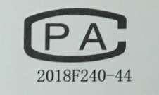
Catalog
I. Basic information 1
1.1. Features and Specifications 1
1.2. Front panel 3
1.3. Wiring port 4
1.3.1. Loadcell wiring method 7
1.3.2. IO wiring method 7
1.3.3. Comm wiring method 8
1.1. installation size 9
II. Function Menu 10
2.1. Weight calibration 11
2.1.1. Weight calibration process 12
2.1.2. Quickly calibrate the empty scale 13
2.1.3. Calibration Precautions 14
2.2. Basic weighing parameters 14
2.2.1. Zero function 14
2.2.2. Stable & Tracking 15
2.2.3. Digital filtering 16
2.3. Process control parameters 17
2.3.1. Pattern-related 17
2.3.2. Feeding process 20
2.3.3. Fixed value process 21
2.3.4. Disc process 23
2.3.5. Clear the material 36
2.3.6. Material level setting 36
2.3.7. Run monitor 40
2.3.8. Bag clamping and coding 43
2.4. Step motor Settings 44
2.4.1. Motor parameter group number 44
2.4.2. Disc motor of Channel 1# 45
2.4.3. Disc motor for channels 2# to 6# 48
2.5. Formula setting 48
2.5.1. Formula number 48
2.5.2. Feed speed selection 48
2.5.3. Product specification 49
2.5.4. Feed analog 50
2.5.5. Time parameter 50
2.5.6. Step motor group 52
2.6. AI packaging 52
2.6.1. Function Settings 53
2.6.2. Speed control 53
2.6.3. AI choose 55
2.6.4. Initial value 55
2.7. IO 56
2.7.1. IN Setting 56
2.7.2. OUT Setting 67
2.7.3. HO Setting 78
2.7.4. M Setting 81
2.7.5. IO Test 82
2.8. Analog quantity 85
2.8.1. Analog range 85
2.8.2. Analog calib 85
2.8.3. Analog Testing 86
2.9. ACC data 87
2.10. Comm Setting 89
2.10.1. Serial Port 1 Settings 89
2.10.2. Serial Port2 Settings 90
2.11. Password 90
2.12. Logic programming 92
2.12.1. Logic output timing diagram 95
2.12.2. illustrate 96
2.13 System 97
2.14 Self-check 98
III. Packaging process 99
3.1. Equipment structure diagram 99
3.2. Main process sequence diagram 99
3.3. Process description 101
IV. Alarm information 102
V. Troubleshooting Common Faults 105

Basic information

Features and Specifications
The AMC401-6K is a multi-channel small package controller designed specifically for industrial weighing. The controller features a compact size, stable performance and rich interfaces. It can be widely applied to small packaging linear scales and other equipment in industrial sites.
The AMC401-6K has the following basic characteristics:
- Working voltage: DC24V
- Weighing channels: up to 6 channels
- Sensor: DC5V/ 4-wire resistance strain bridge load cell
- Switch quantity: 9-channel input
18-channel output
6-channel input/output multiplexing port
9-channel high-speed pulse output ports
- Standard communication interface: 2 serial port RS485 channels.
- Communication protocol: Modbus-RTU
- Analog output: Each channel corresponds to 2 analog output channels of 0~5V (a total of 12 analog output channels), which can control the feeding of the vibrating disc.
- Installation method: Rail snap-on installation

Detailed technique, and the specifications are as follows:
Sensor incentive | DC5V ± 10% / 120 mA drive current / 8350 Ω size sensors
Adaptive sensor sensitivity | 2 mV / V or 3 mV / V
Enter the signal range | 0～15mV
input sensitivity | 0.5uV/d
Nonlinear | 0.02%FS (at 3 mV / V)
zero drift | ＜0.5μ V/℃
gain drift | ＜10PPM/℃
AD slew rate | And 960 beats / second
Highest display resolution | 1/100000
Product accuracy level | 
working voltage | DC24V (18V ~30V compatible)
Product power consumption | ＜5W
working temperature | -10℃~45℃
storage temperature | -20℃~60℃
humidity | Within 90% RH (no condensation)

Front panel
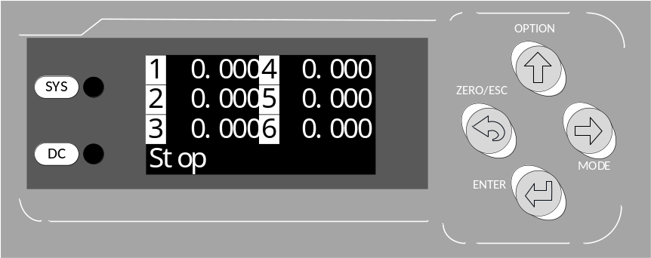
The front panel of the instrument is composed of a liquid crystal display screen, two indicator lights and four buttons.
The explanation is as follows:
Indicator light
DC | It remains bright when powered on.
System | Internal system power-on indicator light
Key press
ZERO/ESC | - Press a key on the menu interface to exit the upper-level menu at one time.  - The single-channel display interface keys perform the zeroing operation once.  - Long press the single-channel display interface to perform the zero calibration operation.  - In the numerical input interface, long press to clear the input data.  - The alarm can be cleared when there is an alarm message.
OPTION | - The main interface can be used to switch the single-channel display interface from 1# to 6#.  - For the menu and selection interface, move the cursor upwards.  - In the numerical input interface, increase the flashing number by 1.
Mode | - On the main interface, enter the menu interface.  - In the menu and selection interface, move the cursor down.  - In the numerical input interface, move the cursor to the right to flash.
ENTER | - Menu and selection interface, confirm entry to the current option.  - In the numerical input and option interface, confirm to save the current data.
Display screen

Wiring port
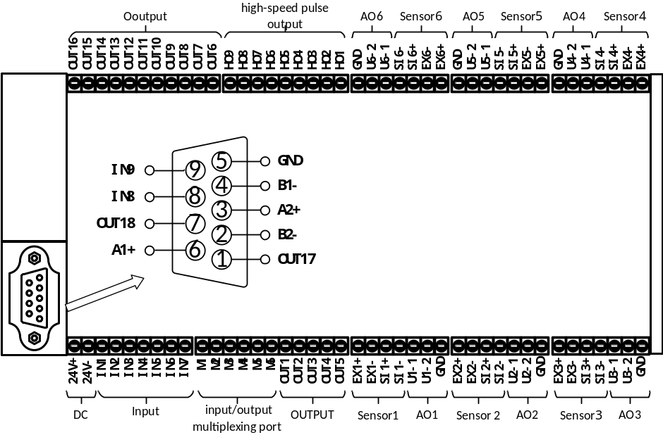 The wiring port description is as follows:
class | joggle | explain
DC | 24V | DC24V Positive power supply
DC | 24G | The DC24V power supply is negative
sensor 1 | EX1+ | Sensor excitation negative
sensor 1 | EX1- | Sensor signal positive
sensor 1 | SI1+ | Sensor signal positive
sensor 1 | SI1- | Sensor signal negative
sensor 2 ~6 | Reference Sensor 1 Interface Description。
AO 1 | Analog output is used to control two vibrating feeders for feeding.
AO 1 | GND | Common negative for analog output GND
AO 1 | U1-1 | U1-1 Positive terminal of the output
AO 1 | U1-2 | U1-2 Positive terminal of the output
AO 2~6 | Reference analog quantity 1 Interface Description
Comm 1  (RS485) | A1+ | RS485 A+
Comm 1  (RS485) | B1- | RS485 B-
Comm 2  (RS485) | A2+ | RS485 A+
Comm 2  (RS485) | B2- | RS485 B-
Output | OUT1 | Q1.Running
Output | OUT2 | Q8.clamp
Output | OUT3 | Q1_10.1#Disc.On
Output | OUT4 | Q2_10.2#Disc.On
Output | OUT5 | Q3_10.3#Disc.On
Output | OUT6 | Q4_10.4#Disc.On
Output | OUT7 | Q5_10.5#Disc.On
Output | OUT8 | Q6_10.6#Disc.On
Output | OUT9 | Q1_17.1#Disc.Direction
Output | OUT10 | Q2_17.2#Disc.Direction
Output | OUT11 | Q3_17.3#Disc.Direction
Output | OUT12 | Q4_17.4#Disc.Direction
Output | OUT13 | Q5_17.5#Disc.Direction
Output | OUT14 | Q6_17.6#Disc.Direction
Output | OUT15 | Q1_15.1#Feed Complete
Output | OUT16 | Q2_15.2#Feed Complete
Output | OUT17 | Q3_15.3#Feed Complete
Output | OUT18 | Q4_15.4#Feed Complete
high-speed pulse output port | The high-speed pulse output port can be configured as "High-Speed Pulse" or "General Output" through parameter settings. For details, refer to Section 2.7.3.
high-speed pulse output port | HO1 | High speed pulse | P1.1#Disc Pulse
high-speed pulse output port | HO2 | High speed pulse | P2.2#Disc Pulse
high-speed pulse output port | HO3 | High speed pulse | P3.3#Disc Pulse
high-speed pulse output port | HO4 | High speed pulse | P4.4#Disc Pulse
high-speed pulse output port | HO5 | High speed pulse | P5.5#Disc Pulse
high-speed pulse output port | HO6 | High speed pulse | P6.6#Disc Pulse
high-speed pulse output port | HO7 | Normal | Q5_15.5#Feed complete
high-speed pulse output port | HO8 | Normal | Q6_15.6#Feed complete
high-speed pulse output port | HO9 | High speed pulse | P0.NONE
Input | IN1 | I1.Running
Input | IN2 | I2.Stop
Input | IN3 | I14.Clamp/Disc.En
Input | IN4 | I1_10.1#Disc.Close OK
Input | IN5 | I2_10.2#Disc.Close OK
Input | IN6 | I3_10.3#Disc.Close OK
Input | IN7 | I4_10.4#Disc.Close OK
Input | IN8 | I5_10.5#Disc.Close OK
Input | IN9 | I6_10.6#Disc.Close OK
input/output multiplexing port | The input/output multiplexed port can be configured via parameter settings as a digital "input" or "output" function. For details, please refer to Section 2.7.4.
input/output multiplexing port | M1 | Input | I1_9.1#Manual Disc.
input/output multiplexing port | M2 | Input | I2_9.2#Manual Disc.
input/output multiplexing port | M3 | Input | I3_9.3#Manual Disc.
input/output multiplexing port | M4 | Input | I4_9.4#Manual Disc.
input/output multiplexing port | M5 | Input | I5_9.5#Manual Disc.
input/output multiplexing port | M6 | Input | I6_9.6#Manual Disc.

Loadcell wiring method
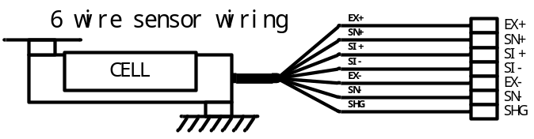
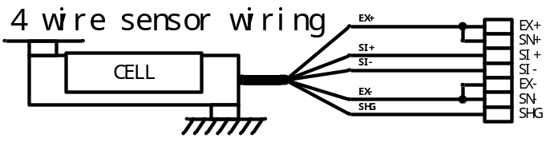

IO wiring method
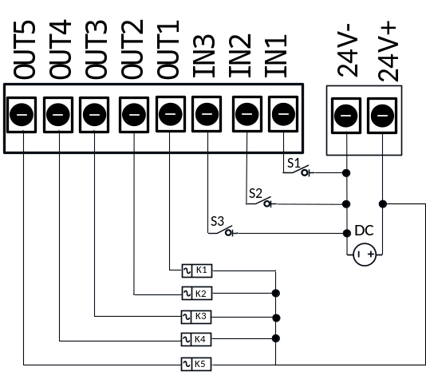
The external circuit driven by the following two points:
- The external circuit should share with the controller;
- When the external circuit is input at a low level, the input is valid, otherwise, the input is invalid.

The external circuit driven by the output switching quantity should meet the following two main points:
- The external circuit should share with the controller;
- The switching output is low.
Note: The maximum driving capacity of each switching output port is 500 mA. Please pay attention to the power of the load when connecting the load. Over the driving capacity of the output port may cause damage to the switching output port.

Comm wiring method
RS 485 Wiring signal:
Instrument 1
A+
B-
GND
Instrument 2
A+
B-
GND
appearance N
A+
B-
GND
computer /PLC
A+
B-
GND

installation size
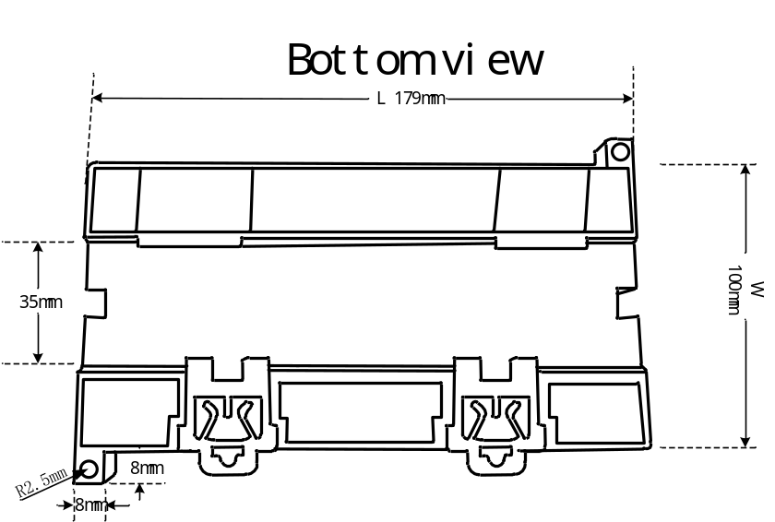
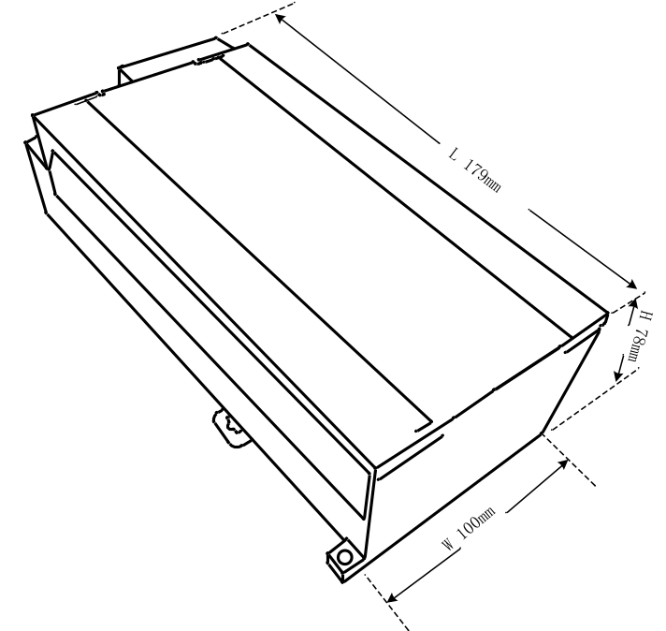

Function Menu
Under the standby interface, pressingthe keys can lead you to the function menu selection interface, where you can set and view the various function configurations of the controller. The function menu is shown in the following table
number | Project | Explanation
1 | Calibration | Operations related to weight calibration.
2 | weighing para | Basic parameters for weight collection and processing.
3 | Ctrl para | Parameters related to functional process control.
4 | Step motor Set | Functional parameters related to stepper motor control.
5 | Recipe setting | 20 sets of product formula parameters.
6 | AI packaging | AI machine learning intelligent packaging function Settings.
7 | IO | Definition of switch functions and port testing.
8 | Analog | Analog output range and calibration.
9 | Acc data | Cumulative data and preset batch viewing and setting.
10 | Comm setting | Parameter Settings related to the communication serial port.
11 | Password | Set the entry password for each project.
12 | Logic | Parameters related to logic programming.
13 | System | Parameter reset and system language Settings, etc.
14 | SelfTest | Test whether the operation of each mechanical structure of the equipment is normal.
Each project has a password function, allowing you to set whether to open the entry password for that project.
All passwords are factory-default "000000".

Weight calibration
For the relevant operations of weight calibration in this project, if it is the first time to install and use this product or there are any changes to the scale structure, such as replacing the sensor or weighing platform, a weight calibration operation should be carried out to ensure the accuracy of the weight display.
number | Parameter | Explanation |  | Init value
1.1 | unit | ①g/②kg/③t/④lb; Select the unit for the system weight display. |  | ②kg
1.2 | point | ①0/②0.0/③0.00/④0.000/⑤0.0000  Select the decimal number for the system weight. |  | ④0.000
1.3 | Min-Div | ①1d = 1/②1d = 2/③1d = 5/④1d = 10/⑤1d = 20/⑥1d = 50  Select the minimum separation value displayed by the system weight. |  | ①1d =0.001
1.4 | Max range | Set the maximum weighing range.  If the weight exceeds the set maximum range, the weight overflows "OFL" |  | 100.000
1.5 | 1#Calib
1.5.1 | Loadcell Vol | Displays the voltage signal size of the current sensor input.  Abs：The absolute voltage magnitude of the current sensor signal。  Gain：The voltage magnitude of the current sensor signal relative to the calibrated zero point。
1.5.2 | Zero clb | Clear the scale platform ,Empty the scale table zero according to confirmation.。   Manual input of no-load voltage for calibration is allowed。
1.5.3 | Gain clb | Place objects with known weight on the weighing platform for gain calibration.  Enter the exact weight of the put object after confirmation.  Manually input gain voltage and corresponding weight for calibration.
1.6 | 2#Calib |  | Reference 1# Calibration Instructions
1.7 | 3#Calib
1.8 | 4#Calib
1.9 | 5#Calib
1.10 | 6#Calib

Weight calibration process
The following takes the calibration of No. 1 as an example to illustrate the process of weight calibration.
- Set the parameters such as the weight decimal point, unit, minimum division, and maximum range used by the system properly.
- Calibration of empty scale.
Enter the [1.5.2 Empty Scale Calibration] interface as shown in the following figure:
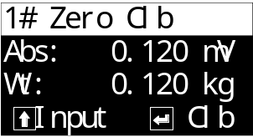
The main display shows the absolute voltage magnitude of the current sensor and the current weight value.
At this point, empty the scale platform to keep the sensor voltage value stable. Afterpressing the confirmation key, the controller starts to collect signals for empty scale calibration. After calibration is completed, the current weight is displayed as 0, as shown in the following figure
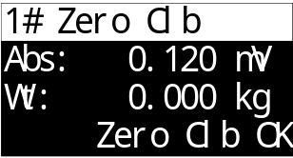
- Calibration of weights.
Enter the [1.5.3 Weight Calibration] interface as shown in the following figure:
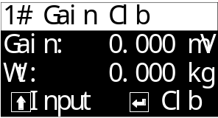
The main display shows the voltage magnitude of the current sensor relative to the empty scale and the current weight value.
At this point, place the weights on the scale platform. The relative voltage value of the sensor will increase. Wait for the displayed voltage value to stabilize, thenpress the confirmation key. The weight input will be displayed on the bottom line
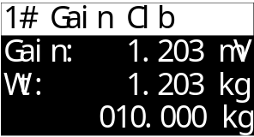
After inputting the weight of the weights,press the confirmation key to complete the calibration of the weights. The voltage relative to the zero point and the input weight will be automatically calibrated.

Quickly calibrate the empty scale
In the stop state, pressthe button to switch to the single-channel display interface where the empty scale calibration is required. Hold down thecontroller key for about 2 seconds. After hearing a long beep from the buzzer, release it. This can quickly calibrate the current state to zero.
Note: The weight needs to be stable when quickly calibrating the empty scale.

Calibration Precautions
- When calibrating an empty scale and weights, the normal sensor voltage range is greater than 0mV and less than 10mV (15mV for a sensor with a sensitivity of 3). If the sensor voltage shows 0mV or exceeds 10mV, it indicates that the current sensor signal is abnormal. It is necessary to check whether the sensor's circuit connection and installation are normal and whether the sensor is damaged.
- When calibrating the empty scale and weights, the calibration operation can only be carried out if the displayed sensor voltage is stable and does not fluctuate. If abnormal and continuous fluctuations of the sensor voltage are found, it is necessary to check whether the sensor circuit connection and installation are normal and whether the sensor is damaged.
- The calibration of empty scales and weights supports manual input of sensor voltage values for calibration. Just press the keys according to the prompts onthe calibration interface.

Basic weighing parameters
Set the parameters for the functions related to weight signal acquisition and processing in this project.

Zero function
Function Settings related to weight reset.
number | Parameter | Explanation | Init value
2.1 | Zero function
2.1.1 | Zero range | 0.0% to 100.0% When performing the zeroing operation, the weight must be less than or equal to "【1.4 Maximum Range 】×【2.1.1 Zeroing Range 】" to allow zeroing. | 20.0%
2.1.2 | Zero range startup | 0.0% to 100.0% When the controller is powered on and detects that the current weight is less than or equal to "【1.4 Maximum Range 】×【2.1.2 Zero range startup】", it will automatically perform a zeroing once.  Note: When set to 0.0%, the automatic reset function upon power-on will be turned off. | 0.0%
2.1.3 | Zero Save | ①off: After the weight is reset to zero, power off and restart will restore the weight value before it was reset to zero.  ②On: After the weight is reset to zero, if the power is cut off and the device is restarted, the weight still shows 0. | ① off

Stable & Tracking
The condition Settings for determining whether the weight is stable and the parameter Settings for the zeroing-tracking function.
number | Parameter | Explanation |  | Init value
2.2 | Stable & Tracking
2.2.1 | Stable range | 0~99d | d represents the minimum graduation value.  These two parameters work together to determine whether the weight is stable.  Take all the weight values within the "stabilization time". If the difference between the maximum and minimum values is less than or equal to the "stabilization range", it is considered that the weight value is stable at this time.  Note: When the stability range is set to 0, the controller will consider the weight to remain stable all the time. | 2d
2.2.2 | Stable time | 0.1 ~ 9.9 s |  | 0.8 s
2.2.3 | Zero tracking range | 0~99d | d represents the minimum graduation value.  When the weight value is within 0± [zeroing range], and the weight remains stable and continuously exceeds the set [zeroing time], the weight reset will be automatically executed.  Note: The zeroing function is turned off when the zeroing range is set to 0. | 1d
2.2.4 | Zero tracking time | 0.1 ~ 9.9 s |  | 2.0 s
2.2.5 | Zero tracking work time | ① Only stop: The zeroing-chasing function only works in the stop state.  ② Run and stop: The zeroing-chasing function works both when the controller is in running and stopped states. |  | ①Only stop

Digital filtering
Set the software digital filtering levels for each state.
number | Parameter | Explanation | Init value
2.3 | Weighting filter
2.3.1 | Weighting filter Stop | 0~9; The intensity level of software digital filtering should be set according to the actual debugging effect of the equipment, with appropriate filtering level parameter values.  0: Weakest filtering, fast weight response, and poor anti-vibration effect;  9: Strongest filtering, slow weight response, and excellent anti-vibration effect. | 7
2.3.2 | Weighting filter Feed |  | 5
2.3.3 | Weighting filter Hold |  | 5
2.3.4 | Weighting filter Disc. |  | 3

Process control parameters
All parameters related to the equipment process control function are set in this project.

Pattern-related
Set the operation mode of the controller and other functions.
number | Parameter | Explanation | Init value
3.1 | Work Mode
3.1.1 | Work mode | ① Lock mode: Each channel's Disc is interlocked, and only one channel is unloaded at a time.  ② single mode: Each channel operates independently without interfering with each other.  ③ Group mode: All channels are divided into two groups. The Disc of each channel in each group is interlocked, and only one channel in each group is unloaded at a time.  For a detailed description of the working mode, please refer to the2.3.1.1section. | ①Lock mode
3.1.2 | Inter Disc. interval time | 0~60000ms;【3.1.1 Working Mode 】 It works when set to "①Lock mode ".  The minimum interval time from the completion of Disc of the previous package to the start of Disc of the next package.  When the "3.4.2Disc. Start Condition" is set to "③clamp Bag" and the "5.3.9 scale comb Times" is set to be greater than 1, it is used as the minimum interval time between two Disc operations. | 500ms
3.1.3 | Auto zero interval | 0~999; After each packaging process, perform a zeroing before the feeding begins.  Note: When set to 0, the automatic zeroing function is turned off. | 0
3.1.4 | Zero Additional Delay | 0~60,000ms; The automatic zeroing interval function has been enabled. When zeroing is required before this feeding, after the [3.2.4 Delay before feed] time expires, an additional delay for zeroing will be initiated. Once this delay time is up, a stable zeroing will be performed.  This function is designed to increase the waiting time before zeroing, facilitating the stability of weight during the zeroing process. | 500ms
3.1.5 | Zero First Threshold | 0.0% to 100.0% Before the first feeding after startup, if the current weight is ≤ [target value] × [first startup zeroing threshold], then zeroing should be done before starting to add materials.  Note: When set to 0.0%, it will not be reset to zero at the first startup. | 0.0%
3.1.6 | Single-run mode | ①OFF  ②ON  After this function is enabled, each channel will automatically switch to a stop state after running once upon startup. | ①OFF
3.1.7 | Tare Deduction | ①OFF  ② ON  After this function is enabled, the current weight will be used as the tare weight to remove the tare before adding materials each time. After Disc is completed, the tare weight will be cleared. | ①OFF

Detailed description of the working mode
- Lock mode
Structural schematic diagram
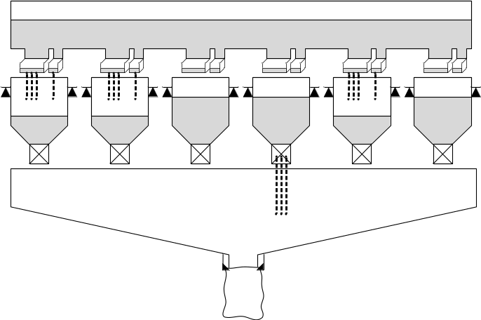
【3.4.2 Disc. Start Conditions 】 When set to "① Disc. Enable or "③clamp bag", the switch input uses the total function "I14 clamp/Disc. En" signal.
- Independent mode
Structural schematic diagram
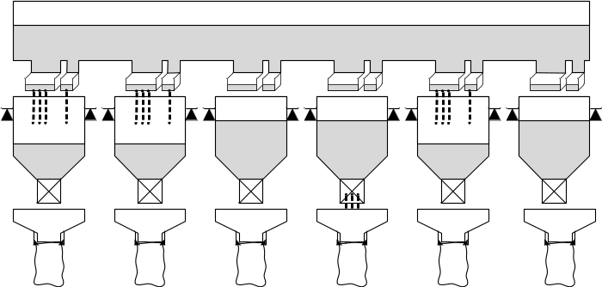
【3.4.2 Disc. Start Conditions】 When set to "① Disc. Enable or "③clamp bag ", the switch input uses the "I(1~6)14 clamp/Disc. En" signal of each channel's sub-function.
- Grouping mode
Structural schematic diagram
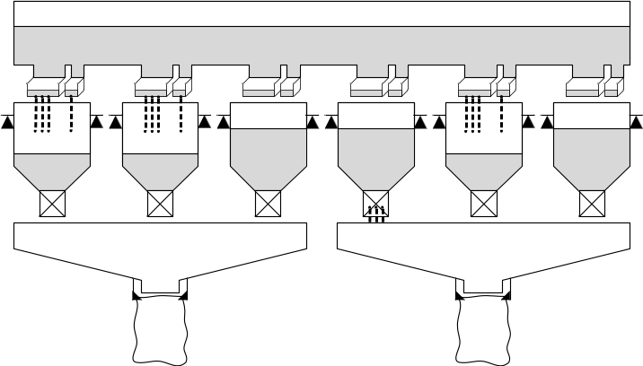
【3.4.2 Disc. Start Conditions】 When set to "① Disc. Enable or "③clamp bag ", the switch quantity input uses "I[1]_9" in the group function. Group [1] with Clamp/Disc.En "and" I[2]_9. Group [2]with Clamp/Disc.En ".
In the grouping mode, the default grouping situation of the controller is as follows:
Channel 6: Group [1] : 1#, 2#, 3#. Group [2] : 4#, 5#, 6#.
Since the AMC401-6K multi-channel small packaging controller can be equipped with different channel numbers when leaving the factory, the grouping situation when other channel numbers are selected is as follows:
Channel 5: Group [1] : 1#, 2#, 3#. Group [2] : 4#, 5#.
Channel 4: Group [1] : 1#, 2#. Group [2] : 3#, 4#.
Channel 3: Group [1] : 1#, 2#. Group [2] : 3#
Channel 2: Group [1] : 1#. Group [2] : 2#
Channel 1: Group [1] : 1#. Group [2] : None.

Feeding process
Set the relevant functional parameters for the feeding process.
number | Parameter | Explanation | Init value
3.2 | Feeding process
3.2.1 | Feed signal set | ① IO & analog; When adding materials, simultaneously output switch signals for fast, med and slow dosages as well as analog signals.  ②only IO; When adding materials, only output the switch signals for fast, med and slow dosages. | ①IO & analog
3.2.2 | IO feed mode | ① Combination  Quick feeding: Effective for fast, med and slow feeders  Med feeding: Effective for med and slow dosages  Slow feeding: A slow amount is effective  ② Independence  fast feeding: Fast input is effective  Med feeding: Mid-range feeding is effective  Slow feeding: A slow amount is effective | ① Combination
3.2.3 | Acc, moment | ① After Disc,  ② After hold | ①After Disc
3.2.4 | Delay before feed | 0~60,000ms; The delay time before the feeding starts after the operation is initiated. | 500ms

Fixed value process
Set the relevant functions during the value setting process after the feeding is completed.
number | Parameter | Explanation | Init value
3.3 | Hold Process
3.3.1 | Hold mode | ① Time mode: After the feeding is completed, start the [5.5.7 result hold Time]. Once the time ends, the setting is finished and the feeding result is recorded.  ② Stable mode: After the feeding is completed, wait for the current weight to stabilize, then set the value and record the feeding result.  ③ Time & stable: After the feeding is completed, start the [5.5.7 result hold time]. When the time ends and wait for the current weight to stabilize, the setting is completed and the feeding result is recorded.  ④ Fast mode: After startup, the first 6 scales will learn by judging stable values. Later, a time value setting method will be adopted. Based on the learning situation of the previous scales, calculations will be made to predict the result of this feeding. In this mode, the "5.5.7 result hold time" can be set very short (it is recommended to be 200 to 500ms), achieving the goal of quickly setting the value and obtaining relatively accurate feeding results. | ①Time mode
3.3.2 | Stop after Hold | ① OFF  ②ON: Returns to the stop state after the setting is completed. | ①OFF
3.3.3 | Result hold | ①OFF  ② On: After the setting is completed, the controller will continuously display the feeding result recorded in the setting until the Disc is finished, at which point the real-time weight will be shown. | ①OFF
3.3.4 | Over/under Func | ①OFF: No Over/under detection is conducted.  ② ON: After each feeding is completed, the feeding results will be checked for excess or deficiency.  Over or under is a collective term for over/under Func. During the packaging process, if the packaging result is higher than the target value by a certain range, it is considered over-tolerance, while if it is lower than a certain range, it is considered under-tolerance. This range is set according to production requirements. | ① OFF
3.3.5 | Over/under alarm time | 0~60,000ms; The alarm time when an over-limit or under-limit error occurs. | 1000ms
3.3.6 | Over/under Pause | ① OFF /② ON  When both the "Over-limit and Under-limit Detection" switch and the "Over-limit and Under-limit Pause" switch are turned on, if an over-limit or under-limit occurs, the controller will alarm and wait for the user to handle it. At this time, the "I5 Clear Alarm" input will resume operation, or the "I2 Stop" signal can be given to return to the stop state for processing. | ① OFF
3.3.7 | Under replenish | ① OFF  ②ON: When a deficiency occurs, the replenishment process will be initiated. | ① OFF
3.3.8 | Replenish Min time | 0~60,000ms; The minimum time for slow input output when replenishing materials. | 500ms
3.3.9 | Replenish Max time | 0~60,000ms; The maximum time for slow input output when replenishing materials. If the material replenishment is not completed after this time, the current material replenishment process will be forcibly stopped. | 5000ms

Disc process
Settings of relevant functions such as Disc control mode.
number | Parameter | Explanation | Init value
3.4 | Disc. process
3.4.1 | Disc. control mode | ①Air (No place)  ②Air (with place)  ③ motor one Dir  ④ motor two Dir  ⑤ Step motor one Dir  ⑥Step motor two Dir  ⑦Step motor one Dir(No place)  ⑧Step motor two Dir(No place)  For detailed introductions to the functions of each Disc mode, please refer2.3.4.1to the chapters. | ①Air (No place)
3.4.2 | Disc. start condition | ① Disc Enable: After the feeding is completed, wait for the external input signal "I14. Loosen the bag/Disc" to be valid before starting the Disc.  ② NONE: Disc can start directly after the feeding is completed.  ③clamp bag: After the feeding is completed, wait for the bag clamping to be finished before starting the Disc. | ③clamp bag
3.4.3 | Disc. End condition | ① Time: After the Disc begins, the Disc is considered complete and ends after the [5.5.8 Disc holding time].  ② Zero Area: After the Disc begins, if the weight is lower than the [3.4.4 Disc Zero Zone Value], and after the [5.5.8 Disc holding time], it is considered that the Disc is completed and the Disc is ended. | ①Zero Area
3.4.4 | Disc. Zero Area | When the current weight is within the range of "0± [Disc zero zone value]", it is considered to be in the zero zone.  【3.4.3 Disc. End condition 】 It takes effect when set to "②Zero Area ".  【3.4.5 Rerun condition 】 It takes effect when set to "②Zero Area ". | 0.050 kg
3.4.5 | Rerun condition | ①NONE: After the Disc is completed, when the [3.4.6 Restart delay] time is up, the next feeding process can be directly initiated.  ②Zero Area: After the Disc is completed, [3.4.6 Rerun delay] when the time is up, it is necessary to wait for the weight to fall within the range of "0± [3.4.4 Disc. Zero Area]" before starting the next feeding process. | ②Zero Area
3.4.6 | Rerun delay | 0~60,000ms; The delay time from the completion of Disc to the start of the next feeding process. | 500ms
3.4.7 | Disc. open time | 0~60,000ms; 【3.4.1 Disc. control mode】 It takes effect when set to "③motor one Dir " or "④motor two Dir ".Set the time it takes for the motor discharge door to open to the maximum. | 500ms
3.4.8 | Disc. close timeout | 0~60,000ms; If the "Disc Close OK" signal input is still not detected to be valid after this period of time when the Disc door is closed, it is considered that the Disc door has exceeded the closing time limit and an alarm prompt will be issued. | 5000ms
3.4.9 | Wait Disc. Close OK | ① OFF  ②ON: After the Disc is completed, it is necessary to wait for the signal of the Disc door closing in place to be valid before starting [3.4.6 Rerun delay], and then proceed to the next cycle process. For details, please refer to2.3.4.1the chapters. | ② ON
3.4.10 | Manual Disc. mode | ① Auto close: After manual Disc starts and the Disc is completed, the Disc door will automatically close.  ② Manual close: After manual Disc starts, the Disc door needs to be manually closed after Disc is completed. | ①Auto close
3.4.11 | Manual Disc. Acc Threshold | 0.0% ~100.0% If the weight of manual Disc≥ [target value] × [Manual Disc. Acc Threshold], the weight of manual Disc will be included in the cumulative value.  Note: When set to 0.0%, the weight of manual Disc is not included in the cumulative value. | 0.0%

Detailed description of the Disc mode
The following takes Channel 1 as an example to elaborate on the signal timing under different Disc modes.

Air (No place)/ Air (with place)
The pneumatic device controls the action of the Disc mechanism. The signal timing sequences of the two modes are the same. The difference is that when the Disc door of the " Air (with place)" mode is closed, there is a detection signal for the door closing position.
RelatedIO:"Q1_10.1#Disc On", "I1_10.1# Disc close OK".
Relevant parameters: [3.4.4Disc zero Area], [3.4.3 Disc end condition],[5.5.8Disc. hold Time].
When the [3.4.3 Disc end condition] is set to "① Time", the Disc. process is as follows:
At the beginning of Disc, the "Q1_10.1# Disc on" signal is output to control the opening of the Disc door. After a period of [5.5.8 Disc hold time], it is considered that the Disc is completed. Then, the "Q1_10.1# Disc on " signal is closed and the Disc door is closed.
The signal timing diagram is as follows:
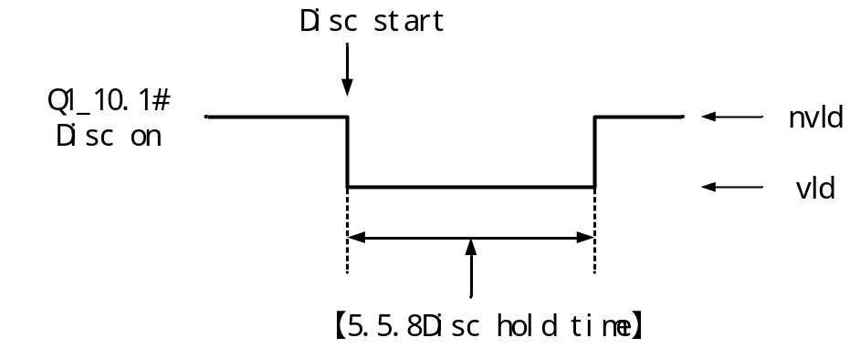
When the [3.4.3 Disc End Condition]is set to "② Zero Area", the Disc process is as follows:
At the beginning of Disc, the "Q1_10.1# Disc On" signal is output to control the opening of the Disc door. When the weight value is lower than the [3.4.4Disc Zero Area], after the [5.5.8 Disc hold time] period, it is considered that the Disc is completed, and the "Q1_10.1# Disc On" signal is closed to close the Disc door.
The signal timing diagram is as follows:
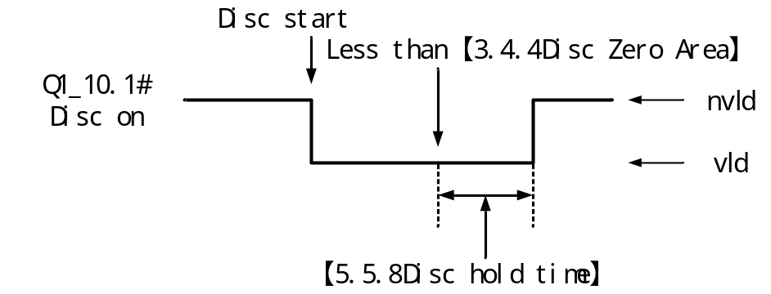

Motor One Dir
The common motor rotates one full circle to control the Disc mechanism to achieve the opening and closing of the Disc door.
RelatedIO:"Q1_10.1#Disc on", "I1_10.1#Disc close OK ".
Relevant parameters: [3.4.7Disc open Time], [3.4.8 Disc Close Timeout],[3.4.4Disc Zero Area],[3.4.3Disc End Condition],[5.5.8Disc hold Time].
When the [3.4.3 Disc end Condition] is set to "① Time", the Disc process is as follows:
At the beginning of Disc, the "Q1_10.1# Disc On" signal output is valid. After the [3.4.7 Disc open time], it is considered that the Disc door has been opened. At this time, the "Q1_10.1# Disc On" signal output is invalid. After the [5.5.8 Disc hold time] time is up, it is considered that the Disc is completed. Continue the"Q1_10.1# Disc On" signal output to effectively control the closing of the Disc door. Once the input signal "I1_10.1# Disc Close OK" is detected to be effective, it is considered that the Disc door has been closed OK, and the "Q1_10.1# Disc On" signal output becomes invalid, marking the end of the Disc process.
During the closing process of the discharge door, if the signal input of "I1_10.1# Disc Close OK" is still not detected to be valid after exceeding the [3.4.8 Disc Close Timeout] time, it is considered that the discharge door has exceeded the closing time and an alarm prompt will be issued.
Note: When the [5.5.8 Disch hold Time] is set to 0, the discharge motor can continuously rotate until the discharge door is closed without any pause in between.
The signal timing diagram is as follows:
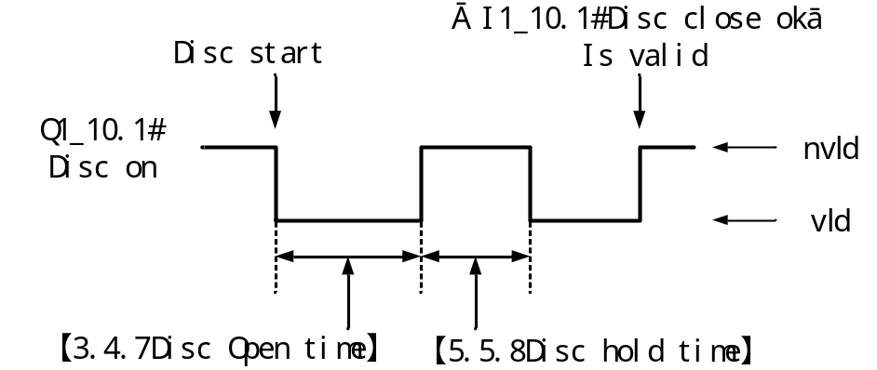
When the [3.4.3 Disc End Condition]is set to "② Zero Area", the Disc process is as follows:
At the beginning of Disc, the "Q34.1# Disc On" signal output is valid. After the[3.4.7 Disc open time], it is considered that the Disc door has been opened. At this time, the "Q1_10.1# Disc On" signal output is invalid. When the weight value is lower than the [3.4.4 Disc Zero Area], and after the [5.5.8 Disc hold time], it is considered that the Disc is completed. Continue the "Q1_10.1# Disc On" signal output to effectively control the closing of the Disc door. Once the input signal "I1_10.1# Disc Close OK " is detected to be effective, it is considered that the Disc door has been closed in place, and the "Q1_10.1# Disc On" signal output becomes invalid, marking the end of the Disc process.
During the closing process of the disc door, if the signal input of "I1_10.1# Disc Close OK" is still not detected as valid after exceeding the [3.4.8 Disc. close timeout] time, it is considered that the discharge door has exceeded the closing time and an alarm prompt will be given.
The signal timing diagram is as follows:
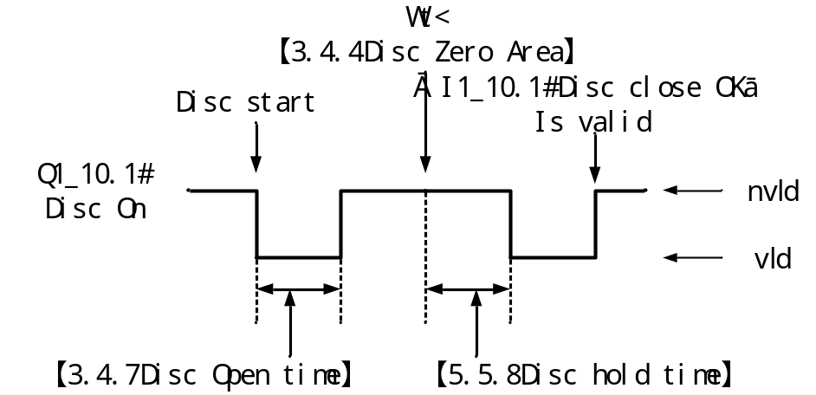

Motor two Dir
The forward and reverse rotation control of the discharge mechanism of the common motor realizes the opening and closing of the discharge door.
Related I/O:"Q1_10.1#Disc on", "Q1_11.1#Disc Off", "I1_10.1# Disc Close OK ".
Relevant parameters: [3.4.7 Disc open time], [3.4.8 Disc. close timeout],[3.4.4 Disc Zero Area],[3.4.3 Disc End Condition],[5.5.8Disc hold Time].

When the [3.4.3 Disc end Condition] is set to "① Time ", the Disc process is as follows:
At the beginning of Disc, the "Q1_10.1# Disc On" signal output is valid. After the[3.4.7 Disc open time], it is considered that the Disc door has been opened. At this time, the "Q1_10.1# Disc On" signal output is invalid. After the[5.5.8 Disc holding time] time is up, it is considered that the Disc is completed. The signal output of "Q1_11.1# Disc off " effectively controls the closing of the Disc door. Once the input signal "I1_10.1 # Disc close OK" is detected to be effective, it is considered that the Disc door has been fully closed. The signal output of "Q1_11.1# Disc off" becomes invalid, and the Disc process ends.
During the closing process of the discharge door, if the signal input of "I1_10.1# Disc Close OK " is still not detected as valid after exceeding the [3.4.8 Disc. close timeout] time, it is considered that the discharge door has exceeded the closing time and an alarm prompt will be given.
The signal timing diagram is as follows:
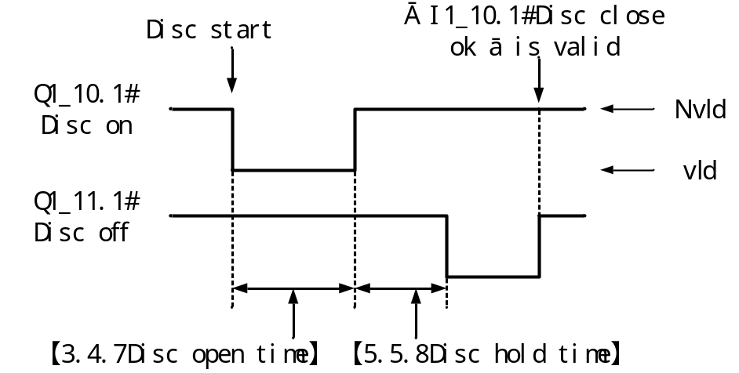
When the [3.4.3 Disc End Condition]is set to "② Zero Area", the Disc process is as follows:
At the beginning of Disc, the "Q1_10.1# Disc On" signal output is valid. After the [3.4.7 Disc open time], it is considered that the Disc door has been opened. At this time, the "Q1_10.1# Disc On" signal output is invalid. When the weight value is lower than the [3.4.4Disc Zero Area], and after the [5.5.8 Disc hold time], it is considered that the Disc is completed. The signal output of "Q1_11.1# Disc off" effectively controls the closing of the Disc door. Once the input signal "I1_11.1 # Disc off "is detected to be effective, it is considered that the Disc door has been fully closed. The signal output of "Q1_11.1# Disc off" becomes invalid, and the Disc process ends.
During the closing process of the disc door, if the signal input of "I1_10.1# Disc Close OK " is still not detected as valid after exceeding the [3.4.8 Disc. close timeout] time, it is considered that the discharge door has exceeded the closing time and an alarm prompt will be given.
The signal timing diagram is as follows:
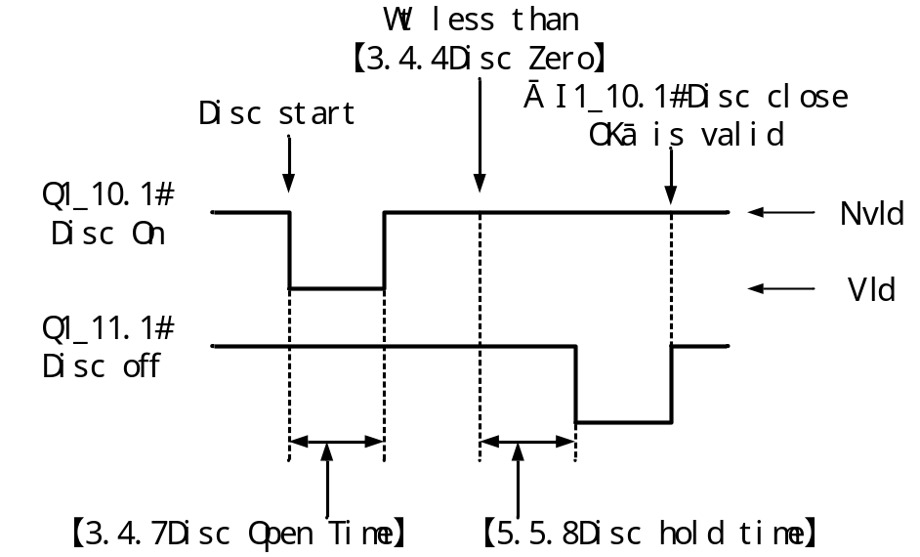

Step motor one Dir
The stepping motor rotates one full circle to control the Disc mechanism to achieve the opening and closing of the Disc door.
The operation of the stepper motor is controlled by pulse signals.
RelatedIO:"P1.1#Disc Pulse", "I1_10.1# Disc Close OK ".
Relevant parameters: [3.4.8 Disc. close timeout], [3.4.4 Disc Zero Area],[3.4.3Disc End Condition], [5.5.8Disc Holding Time], [4.2 1# Disc motor].
Note: The functions of relevant parameters such as the "Run frequ", "start frequ", and "deceleration frequ" of the Disc stepping motor are detailed in the section.2.4Here, it is assumed that the relevant parameters have been set.

When the [3.4.3 Disc end Condition] is set to "① Time", the Disc process is as follows:
At the beginning of Disc, the "P1.1# Disc pulse" signal starts to output pulses to control the opening of the Disc door. When the number of output pulses reaches the set [4.2.2 Open Pulse], the output pulse signal stops, indicating that the Disc door has opened. After waiting for the [5.5.8 Disc hold time], it is considered that the Disc is completed. The "P1.1# Disc Pulse" outputs the pulse again to control the closing of the discharge door. Once the input signal "I1_10.1# Disc Close OK" is detected to be valid, it is considered that the discharge door has been closed in place. Then, the "P1.1# Disc Pulse" stops outputting the pulse signal, and the discharge process is completed.
During the closing process of the discharge door, if the signal input of "I1_10.1# Disc Close OK" is still not detected to be valid after exceeding the [3.4.8 Disc. close timeout] time, it is considered that the discharge door has exceeded the closing time and an alarm prompt will be issued.
Note: When the [5.5.8 Disc hold Time] is set to 0, the discharge stepping motor can continuously rotate until the discharge door is closed without any pause in between.
The signal timing diagram is as follows:
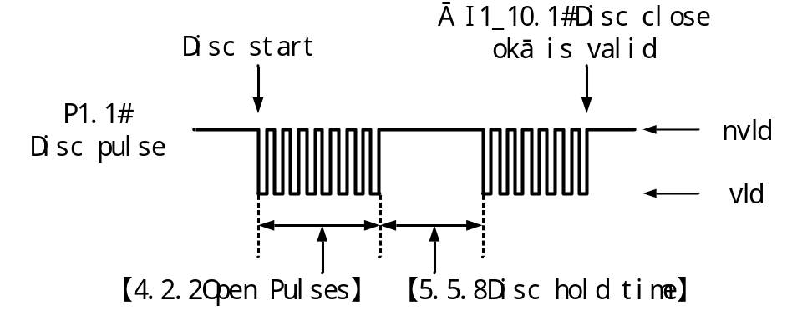
When the [3.4.3 Disc End Condition]is set to "② Zero Area", the Disc process is as follows:
At the beginning of Disc, the "P1.1# Disc pulse" signal starts to output pulses to control the opening of the Disc door. When the number of output pulses reaches the set [4.2.2 Door Open Pulse], the output pulse signal stops, indicating that the Disc door has opened. When the weight value is lower than the [3.4.4 Disc Zero Area], After an other period of [5.5.8 Disc hold time], it is considered that the Disc is completed. The "P1.1# Disc Pulse" outputs the pulse again to control the closing of the Disc door. When the input signal "I1_10.1# Disc Close OK "is detected to be valid, it is considered that the Disc door has been closed in place. The "P1.1# Disc pulse" stops outputting the pulse signal, and the Disc process is completed.
During the closing process of the discharge door, if the signal input of "I1_10.1# Disc Close OK " is still not detected as valid after exceeding the [3.4.8 Disc. close timeout] time, it is considered that the discharge door has exceeded the closing time and an alarm prompt will be given.
The signal timing diagram is as follows:
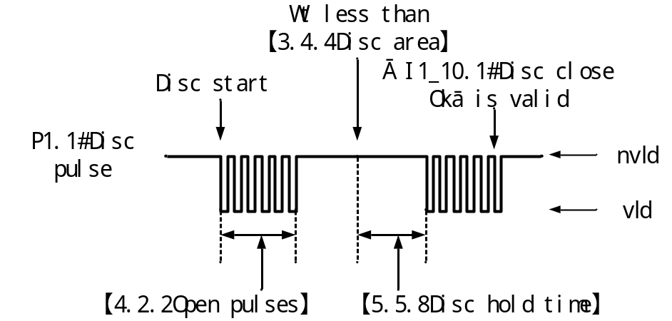

Step motor two Dir
The forward and reverse rotation of the stepping motor controls the discharge mechanism to achieve the opening and closing of the discharge door.
Related I/O:"P1.1#Disc pulse", "Q1_17.1# Disc Direction", "I1_10.1# Disc Close OK ".
Relevant parameters: [3.4.8 Disc. close timeout], [3.4.4 Disc Zero Area],[3.4.3 Disc end Condition], [5.5.8Disc Hold Time], [4.2 1# Disc motor].
Note: The functions of relevant parameters such as the "run frequ", "start frequ", and "stop frequ" of the Disc stepping motor are detailed in the section.2.4Here, it is assumed that the relevant parameters have been set.
When the [3.4.3 Disc end Condition] is set to "① Time", the Disc process is as follows:
At the beginning of Disc, the output of "Q1_17.1#Disc Direction" is invalid. The rotation direction of the control step motor is set to the door opening direction. The "P1.1# Disc pulse" signal starts to output pulses to control the opening of the Disc door. After the number of output pulses reaches the set [4.2.2 Open pulses], the output of the pulse signal stops, and itis considered that the Disc door has opened. After the time of [5.5.8 Disc holding Time] is up, it is considered that the Disc is complete. The output of"Q1_17.1# Disc Direction" is valid, and the rotation direction of the stepping motor is controlled to be the closing direction. "P1.1# Disc pulse" outputs the pulse again to control the closing of the Disc door. When the input signal "I1_10.1# Disc Close OK " is detected to be valid, it is considered that the Disc door has been closed in place, and the "P1.1# Disc pulse" stops to output the pulse signal, and the Disc process is completed.
During the closing process of the discharge door, if the signal input of "I1_10.1# Disc Close OK" is still not detected to be valid after exceeding the [3.4.8 Disc. close timeout] time, it is considered that the discharge door has exceeded the closing time and an alarm prompt will be issued.
The signal timing diagram is as follows:
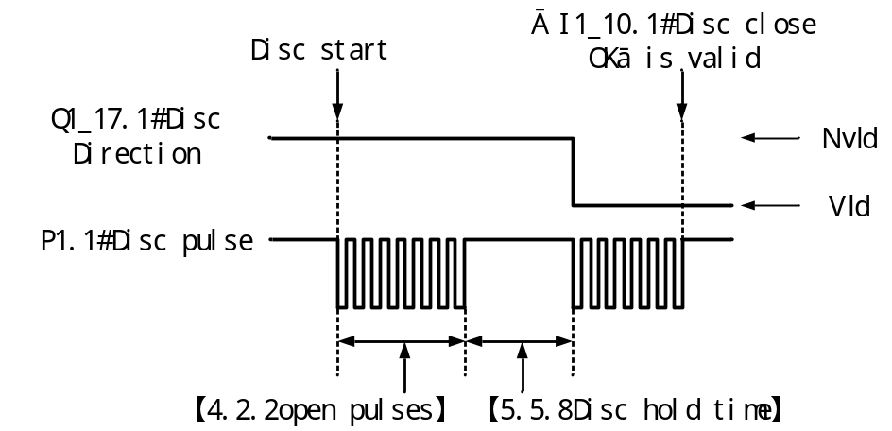
When the [3.4.3 Disc End Condition]is set to "② Zero Area", the Disc process is as follows:
At the beginning of Disc, the output of "Q1_17.1#Disc Direction" is invalid. The rotation direction of the control step motor is set to the door opening direction. The "P1.1# Disc pulse" signal starts to output pulses to control the opening of the Disc door. After the number of output pulses reaches the set [4.2.2Opening pulses], the output of the pulse signal stops, and it is considered that the Disc door has opened. When the weight value is lower than the [3.4.4 Disc Zero Area], after the [5.5.8 Disc hold time] period, it is considered that the Disc is completed. The output of "Q1_17.1# Disc Direction" is effective, controlling the rotation direction of the stepping motor to the closing direction. The "P1.1# Disc pulse" outputs the pulse again to control the closing of the Disc door. When the input signal "I1_10.1# Disc Close OK "is detected to be valid, it is considered that the Disc door has been closed in place, and the "P1.1# Disc pulse" stops to output the pulse signal, and the Disc process is completed.
During the closing process of the discharge door, if the signal input of "I1_10.1# Disc Close OK " is still not detected as valid after exceeding the [3.4.8 Disc. close timeout] time, it is considered that the discharge door has exceeded the closing time and an alarm prompt will be given.
The signal timing diagram is as follows:
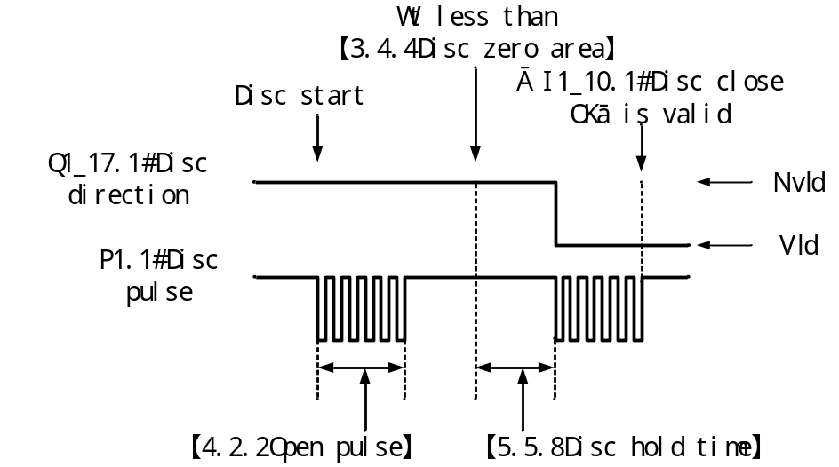

Step motor One Dir (No place)
Refer to the4Step motor one Dir function description in the reference chapter. The basic process is the same. The difference is that when the "infinite bit" mode closes the door and the number of output pulses reaches the [4.2.3 Closing Pulse Number] setting, the output pulse signal stops. At this point, it is considered that the Disc door has been fully closed, and there is no need to detect the closing signal.

Step motor Two Dir (No place)
Refer to the 5Step motor two Dir function description in the reference chapter. The basic process is the same. The difference is that when the "infinite bit" mode closes the door and the number of output pulses reaches the [4.2.3 Close Pulses] setting, the output pulse signal stops. At this point, it is considered that the Disc door has been fully closed, and there is no need to detect the closing signal.

Clear the material
Parameter Settings related to the material cleaning function.
When the material cleaning starts, the controller will output an analog quantity to control the vibrating disc to feed materials and open the discharge door to quickly clear the remaining materials in the hopper.
number | Parameter | Explanation | Init value
3.5 | Clear the material
3.5.1 | Clr Material U- 1 | 0.000~5.000V; The voltage value output by U-1 during material cleaning. | 3.500
3.5.2 | Clr Material U-2 | 0.000~ 5.000V; The voltage value output by U-2 during material cleaning. | 3.500
3.5.3 | Clr Material close Delay | 0~ 9999ms; When the material cleaning is closed, first turn off the analog output signal to stop feeding, and then delay for this time before closing the Disc. | 1000ms

Material level setting
Set the functional parameters related to the signal input of the material level gauge and the feeding control.
number | Parameter | Explanation | Init value
3.6 | Material level
3.6.1 | Material level Type | ① NONE  ②Only Lower  ③ upper& lower  ④ Only upper  Note: If the mode including the material discharge level is selected, the feeding will not be initiated when the material discharge level signal input is invalid. | ①NONE
3.6.2 | Supply trigger | ① Off: Turn off the feed output function  ② lower trigger: The feeding function is triggered when the "I12. Lower level" signal input is invalid.  ③upper trigger: The feeding function is triggered when the "I11. Upper level" signal input is invalid.  For a detailed introduction to the feeding function, please refer2.3.6.1to the section. | ①OFF
3.6.3 | Supply delay on time | 0~60,000ms; After the feeding function is triggered, delay for this period of time before output the "Q6. Supply fill". | 0ms
3.6.4 | Supply delay off time | 0~60,000ms; After the feeding is completed, delay for this period of time before turning off the "Q6. Supply fill ". | 3000ms
3.6.5 | Supply work time | ①run &stop: Supply materials both during operation and stoppage.  ② Only Run: Feeding only during operation. | ① Operation and stop
3.6.6 | Signal in debounce time | 0~60,000ms; The debunking time of the "I11.upper Level" and "I12. Lower level " signal inputs.  The signal is considered valid after it has been continuously and effectively maintained for this period of time.  The signal is considered invalid after continuous invalidity persists for this period of time.  Prevent interference caused by occasional instantaneous interruption or conduction of the signal. | 500ms

Detailed description of the feeding function
Material level mode: single Lower level; feed trigger: lower level trigger.
- The timing diagram is as follows:
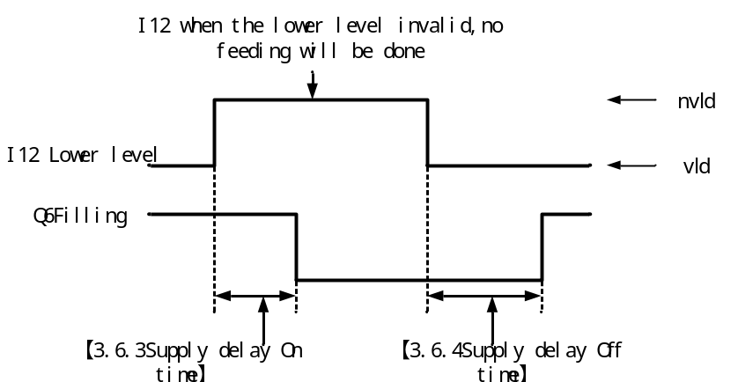
- Material level mode: upper and lower level; feeding trigger: lower level trigger.
The timing diagram is as follows:
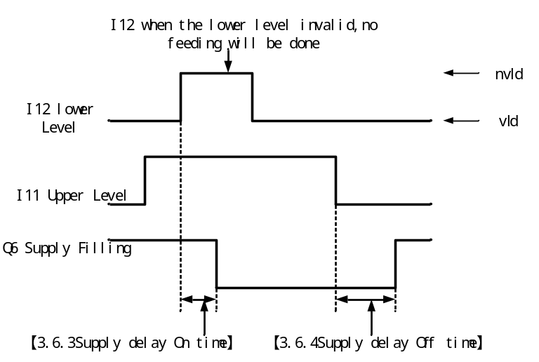
- Material level mode: upper and lower level; feed trigger: Upper level trigger.
The timing diagram is as follows:
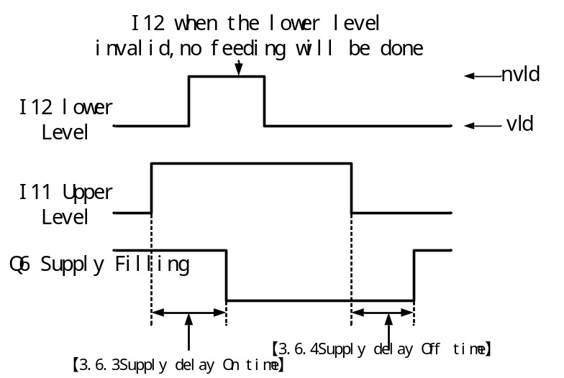
- Material level mode: single upper level; feeding trigger: upper level trigger.
The timing diagram is as follows:
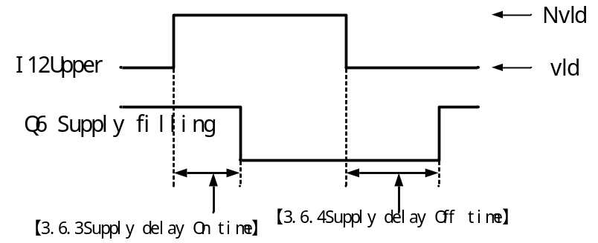

Run monitor
Time monitoring of each process during operation, alarm and handling after process timeout.
number | Parameter | Explanation | Init value
3.7 | Run monitor
3.7.1 | Feed timeout | 0.0~999.9 seconds; If the time taken to add materials during operation exceeds the set "feeding timeout time" and the feeding is not completed, it is considered that the feeding has exceeded the time limit.  When set to 0, the feeding timeout detection function is turned off. | 0.0 s
3.7.2 | Execute feed timeout | ①Warning: Only give an alarm prompt.  ② Wrn& stop: The alarm prompts and switches to the stop state.  ③ Wrn& stop feeding: The alarm will prompt and immediately stop feeding to continue the subsequent process. | ②Wrn& stop
3.7.3 | Feed timeout Alarm time | 0.0~999.9 seconds; The output time of the feeding timeout alarm will be displayed. The alarm will be automatically cleared when the time is up.  When set to 0, the feeding timeout alarm will keep outputting and can only be manually cleared. | 3.0 s
3.7.4 | Disc timeout | 0.0~999.9 seconds; If the time taken for Disc during operation exceeds the set "Disc timeout time" and the Disc is not completed, it is considered that the Disc has exceeded the timeout.  When set to 0, the Disc timeout detection function is turned off. | 0.0 s
3.7.5 | Execute Disc Timeout | ①Warning: Only give an alarm prompt.  ②Wrn& stop: The alarm prompts and switches to the stop state.  ③Wrn& stop Disc: Alarm prompts and immediately end Disc to continue the subsequent process. | ②Wrn& stop
3.7.6 | Disc timeout Alarm time | 0.0~999.9 seconds; The output time of the Disc timeout alarm will be displayed. The alarm will be automatically cleared when the time is up.  When set to 0, the Disc timeout alarm will continue to output and can only be manually cleared. | 3.0 s
3.7.7 | Auto zero Timeout | 0.0~ 999.9 seconds; The prerequisite for zeroing out is stable weight.  When the "3.1.3 Auto Zero Interval" is set and zeroing is required before feeding, if the waiting time for zeroing exceeds the set "Feeding Zeroing timeout Time" due to unstable weight and the zeroing has not been completed, it is considered that the feeding zeroing timeout has occurred.  When set to 0, the feeding reset timeout detection function is turned off. | 0.0 s
3.7.8 | Execute Auto Zero timeout | ①Warning: Only give an alarm prompt.  ②Wrn& stop: The alarm prompts and switches to the stop state.  ③Wrn& Force zero: An alarm will prompt and force the current weight to be reset to zero.  ④Wrn&Next: The alarm prompts and skips the zeroing process. Reset the next package before adding materials.  ⑤Wrn 3times stop: The alarm prompts and skips the zeroing process. If all three consecutive zeroing attempts exceed the time limit, it will switch to the stop state. | Wrn 3times stop
3.7.9 | Auto Zero Timeout Alarm Time | 0.0~999.9 seconds; The output time of the alarm for the feeding and zeroing timeout will be displayed. The alarm will be automatically cleared when the time is up.  When set to 0, the feeding reset timeout alarm will continue to output and can only be manually cleared. | 3.0 s
3.7.10 | Check Disc Close | ① Off  ②NO: Before feeding, check whether the "Disc close OK" signal is valid. If it is not, an alarm will sound that the discharge has not been closed in place. | ① Off
3.7.11 | Execute Disc Close Failed | ① warning: Only give an alarm prompt.  ②Wrn & stop: The alarm prompts and switches to the stop state. | ①warning
3.7.12 | Disc. Close failed alarm time | 0.0~999.9 seconds; The output time of the alarm for incomplete Disc will be displayed. The alarm will be automatically cleared when the time is up.  When set to 0, if the Disc is not fully closed, the alarm will continue to output and can only be manually cleared. | 0.0 s

Bag clamping and coding
Parameter Settings related to bag clamping and coding functions.
number | Parameter | Explanation | Init value
3.8 | clamp and Print coding
3.8.1 | Clamp delay time | 0~60,000ms; After the "Q8. Clamp" is output and passes through the " Clamp delay time ", it is considered that the bag clamping action is completed and the subsequent process can continue. | 500ms
3.8.2 | Unclamp delay time | 0~60,000ms; After the "Q8.Clamp" is turned off and the " Unclamp delay time " is passed, it is considered that the bag release action is completed and the subsequent process can continue. | 500ms
3.8.3 | Unclamp mode running | ① Auto unclamp: The bags are automatically loosened after Disc is completed.  ② Manual unclamp: After the Disc is completed, input the"I14.Clamp/Disc En" signal externally to perform manual bag loosening. | ①Auto unclamp
3.8.4 | Print code Func. | ① Off  ② On  The main switch for the coding function. When the function is enabled, after the bag is clamped,the"Q9.Print Code" signal is output to control the coding machine to print the code onto the bag.  For the sequence diagram of the blurring function, please refer to the section2.3.8.1 | ①Off
3.8.5 | Print code start delay | 0~60,000ms; After the "Q8.Clamp " signal is output, it passes through the" Print code start delay" and then outputs the "Q9. Print Code" . | 500ms
3.8.6 | Print code time | 0~60,000ms; The effective time of the "Q9. Print Code" signal output. | 1000ms
3.8.7 | Do not Disc. when Printing | ① Off  ②ON: When the "Q9.Print Code" signal output is valid, the Disc process will not be initiated and wait for "Q9. Print Code " signal output is turned off. | ① Off

Detailed description of the blurring function
The sequence diagram of the blurring function is as follows:
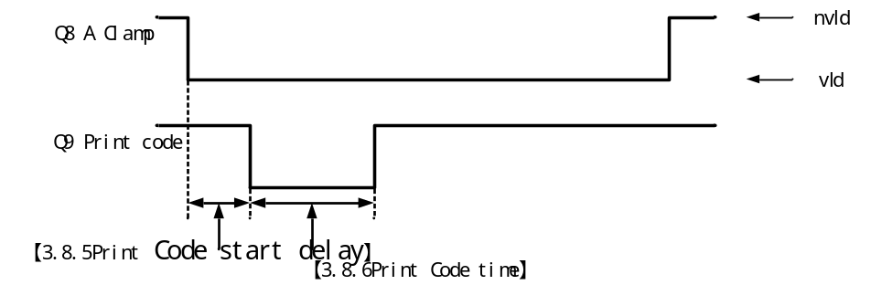

Step motor Settings
When the [3.4.1 Disc Ctrl Mode] is set to "⑤ Step motor One Dir" or "⑥ Step motor two Dir ", this parameter is used to set the relevant functional parameters for the operation of the unloading stepper motor.
The controller has a total of 5 groups of stepper motor parameters available for setting. Users can adopt different unloading stepper motor action controls according to different material packaging specifications. In the formula parameter [5.6 Step Motor Group ], select the corresponding unloading stepper motor parameter group used in the formula.

Motor parameter group number
Set the parameter group number of the currently selected stepper motor.
number | Parameter | Explanation | Init value
4.1 | group num | 1~5 | 1

Disc motor of Channel 1#
Set the relevant action parameters of the stepping motor for discharging Channel 1#.
number | Parameter | Explanation | Init value
4.2 | No. 1 unloading step
4.2.1 | Run frequ | 0.0-60.0KHz;Control the pulse frequency of the stepper motor's rotation. The higher the frequency, the faster the action. | 20.0KHz
4.2.2 | Open Pulses | 0-250,000 The number of pulses required for the discharge door to rotate from the closed position to the open position. | 10000
4.2.3 | Close Pulses | 0-250,000 The number of pulses required for the discharge door to rotate from the open position to the closed position.  This parameter can be set to 0. When closing the door, the stepping motor will keep rotating until the door is closed in place. | 0
4.2.4 | Start frequ | 0.0-60.0KHz;The frequency at which a stepper motor starts. | 2.0KHz
4.2.5 | Start pulses | 0-250,000 The number of pulses required for a stepping motor to accelerate from the "starting frequency" to the "pulse frequency". | 1000
4.2.6 | Stop frequ | 0.0-60.0KHz;The frequency at which the stepper motor has completed deceleration. | 2.0KHz
4.2.7 | Stop pulses | 0-250,000 The number of pulses required for a stepping motor to decelerate from the [operating frequency] to the [deceleration frequency]. | 1000
4.2.8 | direct sign | ①OFF-ON: "Q1_17.1# Disc direction" signal  The output is valid when the door is opened and invalid when it is closed.  ②ON-OFF -Door opening: "Q1_17.1# Disc direction " signal  The output is invalid when the door is opened and valid when the door is closed. | ② OFF-ON
4.2.9 | Enable sign | ① ON-Enable: "Q1_22. 1Disc enable" signal  When the stepper motor is enabled, the output is effective; when it is disabled, the output is ineffective.  ②OFF-Enable:: "Q1_17.1# Disc direction " signal  When the stepper motor is enabled, the output is invalid; when it is disabled, the output is valid. | ②OFF-Enable:

Detailed description of step motor action control
This controller adopts a control mode of "pulse" + "direction" signals for the rotational action control of the stepper motor. The "pulse" signal controls the rotation of the stepper motor, and the "direction" signal controls the rotation direction of the stepper motor. The following figure shows a common wiring reference for stepper motor drivers:
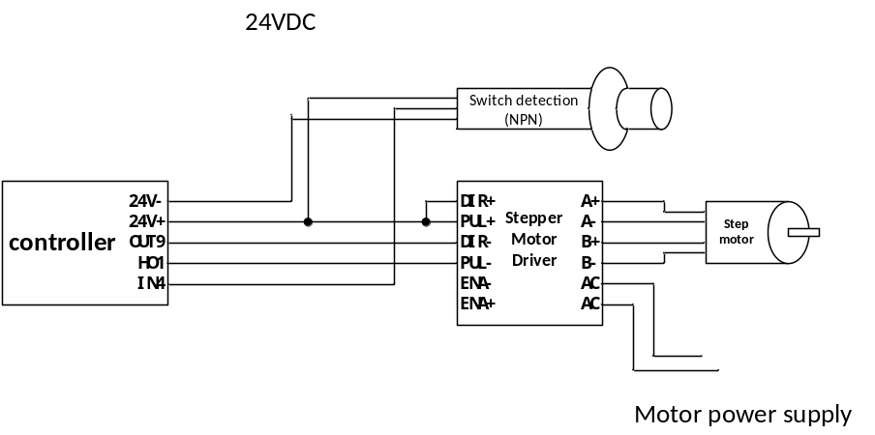
The switch quantities of the controller in the figure are defined as follows:
OUT9 | Q1_17.1 # Unloading step direction
HO1 | P1.1 # Disc pulse
IN4 | I1_10.1 # Disc close OK

The pulse signal frequency of the stepper motor controls the rotational speed of the stepper motor. This frequency parameter needs to be well coordinated with the subdivision parameters of the stepper motor driver. If the subdivision parameter of the stepper motor is set to 1000 pulses per revolution, then when controlled with 2.0KHz pulses, the rotational speed of the stepper motor is 2 revolutions per second.
When a stepper motor is in operation, to prevent problems such as step loss caused by excessive torque required during rotation due to heavy load, a process of gradually accelerating at start-up and gradually decelerating at stop is adopted to ensure smooth and stable operation and prevent issues like step loss. The following figure illustrates the actions of a stepping motor when it starts and stops:
【4.2.1 Run frequ 】 Set to 10.0KHz.
【4.2.2 Open Pulses 】 Set to 10,000.
【4.2.4 Start frequ 】 Set to 3.0KHz.
【4.2.5 Start pulses 】 Set to 2000.
【4.2.6 Stop frequ 】 Set to 5.0KHz.
【4.2.7 Stop pulses 】 Set to 2000.
Based on the above parameters, the relationship between the frequency and the number of pulses when the unloading stepping motor opens the door is shown in the following figure:
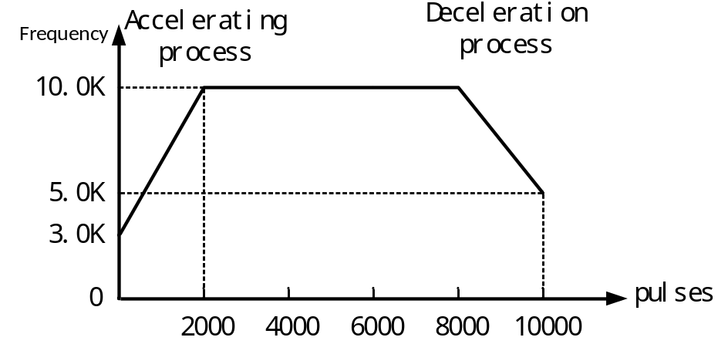

Disc motor for channels 2# to 6#
Refer to the relevant instructions for the unloading step of Channel 1#.

Formula setting
The controller has 20 sets of formula parameters available for setting. Users can set the commonly used formula parameters in advance and switch them to the corresponding formula numbers when in use.

Formula number
Set the currently selected recipe number.
number | Parameter | Explanation | Init value
5.1 | Recipe num | 1~20 | 1

Feed speed selection
Each channel of the controller has two analog quantities (U-1 and U-2) to control the feeding of the dual vibrating feeders. The analog output used for fast, med and slow feeders can be set respectively.
As shown in the following figure, this formula adopts two feeding speeds (med feeding and slow feeding). During med feeding, both analog quantities 1 and 2 are output simultaneously, while during slow feeding, only analog quantity 2 is output.
【5.2Feed speed 】 The parameter setting interface is as follows:

Product specification
Set the target value and other product specification-related parameters under the current formula.
number | Parameter | Explanation | Init value
5.3 | Product
5.3.1 | 1# Target value
5.3.1.1 | 1# Target | Set the target weight of the product to be packaged. | 0
5.3.1.2 | 1# Fast feed | When adding materials, if the weight value ≥the target value - Fast feed, close the fast feeding.  When set to 0, it indicates that the fast output process will not be initiated. | 0
5.3.1.3 | 1# Med feed | When adding materials, if the weight value ≥ the target value - Med feed, turn off the middle input.  When set to 0, it indicates that the mid-input output process will not be initiated. | 0
5.3.1.4 | 1# Slow feed | When adding materials, if the weight value ≥ the target value - Slow feed, close the slow input. | 0
5.3.7 | Over tolerance | When conducting over/under detection, if the weighing result ＞ the target value + Over tolerance, it will be judged as Over. | 0
5.3.8 | Under tolerance | When conducting o over/under detection, if the weighing value ＜ the target value - Under tolerance, it is judged as under. | 0
5.3.9 | Scale Cmb Times | 1~99 Set the number of times a packaging bag needs to be unloaded, that is, how many times it needs to be unloaded before loosening the bag once.  This function takes effect when the "3.4.2 Disc. Start Condition" is set to "③clamp bag. | 1

Feed analog
Set the voltage values of the analog quantities U-1 and U-2 output respectively during the fast, med and slow input processes.
number | Parameter | Explanation | Init
5.4 | Feed analog
5.4.1 | "U1 Settings"
5.4.1.1 | U1-1 fast feed volt | 0.000~5.000V; The voltage value output by U1-1 during the fast feed process. | 0
5.4.1.2 | U1-1 med feed volt | 0.000~5.000V; The voltage value output by U1-1 during the med feeding process. ； | 0
5.4.1.3 | U1-1 slow feed volt | 0.000~5.000V; The voltage value output by U1-1 during the slow feed process. | 0
5.4.1.4 | U1-2 fast feed volt | 0.000~.000V; The voltage value output by U1-2 during the fast feed process. | 0
5.4.1.5 | U1-2 med feed volt | 0.000~5.000V; The voltage value output by U1-2 during the med feed process. | 0
5.4.1.6 | U1-2 slow feed volt | 0.000~5.000V; The voltage value output by U1-2 during the slow feed process. | 0
5.4.2 | U2 Settings | Refer to the relevant instructions for U1 settings.
5.4.3 | U3 Settings
5.4.4 | U4 Settings
5.4.5 | U5 Settings
5.4.6 | U6 Settings
5.4.2 | U2 Settings

Time parameter
Settings of relevant time parameters during the feeding process.
number | Parameter | Explanation | Init
5.5 | Time parameter
5.5.1 | 1# Time comparison is prohibited
5.5.1.1 | 1#Fast No Cmp Time | 0~60,000ms; The vibration elimination time at the beginning of the fast throw. During this time, the fast throw signal remains valid and is not affected by weight. Only after this time ends is it determined whether the weight has reached the lead time for the fast throw, and thus the fast throw ends. | 500ms
5.5.1.2 | 1#Med No Cmp Time | 0~60,000ms; The vibration elimination time at the beginning of the med feed, during which the med feed signal remains valid and is not affected by weight. Only after this time ends is it determined whether the weight has reached the med feed, and thus the med output ends. | 500ms
5.5.1.3 | 1#Slow No Cmp Time | 0~60,000ms; The vibration elimination time at the beginning of the slow throw, during which the slow throw signal remains valid and is not affected by weight. Only after this time ends is it determined whether the weight has reached the slow throw drop value, and thus the slow throw ends. | 800ms
5.5.2 | 2# No Cmp Time | Refer to the relevant instructions on prohibiting comparison of time Settings in # 1
5.5.3 | 3# No Cmp Time
5.5.4 | 4# No Cmp Time
5.5.5 | 5# No Cmp Time
5.5.6 | 6# No Cmp Time
5.5.7 | Result Hold time | 0~60,000ms; After the feeding is completed, wait for this period of time before performing functions such as result accumulation and ove/und detection. | 1000ms
5.5.8 | Disc hold time | 0~60,000ms; The holding time after the disc door is opened during disc.  For a detailed introduction to the related functions of this parameter, please refer2.3.4.1to the section. | 1000ms
5.5.9 | Delay before auto unclamp | 0~60,000ms; The delay time from the completion of Disc during operation to the automatic unclamp. | 500ms

Step motor group
Set the parameter group number of the stepper motor used in the current formula.
number | Parameter | Explanation | Init value
5.6 | Step motor group | 1~5 | 1

AI packaging
The controller is equipped with an AI intelligent packaging algorithm independently developed by my company for the packaging process. It can collect the characteristic parameters of each feeding process, calculate the collected data through machine learning AI algorithms, and automatically adjust the parameters to make the operation of the packaging scale both fast and accurate.
When the intelligent packaging function is activated, the controller will automatically adjust the following parameters:
【Fast feed】
【Med feed】
【Slow feed】
【Med No Cmp Time】
【slow No Cmp Time 】
In addition, when the feed analog or Fast/med/slow Feed is all set to 0, the automatic learning process of the simulation quantity or the lead amount will be initiated first. For details, please refer to2.6.4the description in the section.

Function Settings
number | Parameter | Explanation | Init value
6.1 | Function Settings
6.1.1 | AI pack | ① OFF /② ON | ①OFF
6.1.2 | Material type | ① Granule /② powder  The AI intelligent packaging algorithm can be optimized for different types of materials to obtain relevant parameters that are more suitable for the characteristics of each material. | ① Particle
6.1.3 | 1# Sampled data | 0to 100; Display the number of packaging process data that have been sampled and saved by the intelligent packaging function.  Pressthe confirmation key to clear the sampling data. | 0
6.1.4 | 2# Sampled data |  | 0
6.1.5 | 3# Sampled data |  | 0
6.1.6 | 4# Sampled data |  | 0
6.1.7 | 5# Sampled data |  | 0
6.1.8 | 6# Sampled data |  | 0

Speed control
The parameters related to the packaging speed control of the AI intelligent packaging function can be set to be automatically calculated and controlled by the AI intelligent packaging algorithm, or the customer can manually set the packaging speed to be controlled, and the AI intelligent packaging algorithm will adjust the parameters to achieve the set speed.
Note: If the packaging speed set manually is too fast, exceeding the speed that the equipment can achieve, there may be a problem of inaccurate packaging accuracy.
number | Parameter | Explanation | Init value
6.2 | Speed control
6.2.1 | Speed control mode | ①Auto: The controller automatically controls the packaging speed  ② Manual: The packaging speed is determined by the set parameters [6.2.3 Slow Min Time] and [6.2.4 Minimum input Error Time]. | ① Auto
6.2.2 | Speed grade | 0~4; 【6.2.1 Speed Control Mode 】 It works when set to automatic, and the smaller the number, the faster the speed. | 1
6.2.3 | Slow Min Time | 0~60,000ms; 【6.2.1 Speed Control Mode 】 When set to manual, these two time parameters are used to determine the standard time for the slow throw.  The prohibited comparison time for slow investment + the shortest time for slow investment ≤ the standard time for slow investment ≤ the prohibited comparison time for slow investment + the shortest time for slow investment + the error time for slow investment.  The intelligent packaging function controls the slow drop time to always be within the standard time by adjusting the lead parameter. | 800ms
6.2.4 | Slow Error Time |  | 500ms
6.2.5 | Med Min Time | 0~60,000ms; These two time parameters determine the standard time for mid-investment.  The prohibited comparison time for mid-range investment + the shortest mid-range investment time ≤ the standard mid-range investment time ≤ the prohibited comparison time for mid-range investment + the shortest mid-range investment time + the mid-range investment error time.  The intelligent packaging function controls the input time to always be within the standard time by adjusting the lead parameter. | 500ms
6.2.6 | Med Error Time |  | 500ms
6.2.7 | Fast Buff | When decelerating, increase this buffer value on the basis of a fast lead investment.
6.2.8 | Med Buff | When decelerating, increase this buffer value on the basis of the mid-range lead.
6.2.9 | Start slow | ① OFF  ② ON: When starting up, increase the lead time for Fast feed and med feed to reduce the packaging speed. | ① OFF
6.2.10 | Lack Slow | ① OFF  ② ON: When there is a shortage of materials, increase the fast feed and med feed, and reduce the packaging speed. | ① OFF

AI choose
The correction switches for fast, med and slow investments can be controlled separately. Once turned off, the AI intelligent packaging algorithm will no longer adjust the corresponding lead time.
6.3 | Correction switch
6.3.1 | Fast AI Func | ① OFF: Do not correct the "Fast feed" parameter  ② ON | ② ON
6.3.2 | Med AI Func | ① OFF: Do not correct the "Med feed" parameter  ② ON | ② ON
6.3.3 | Slow AI Func | ① OFF: Do not correct the" Slow feed" parameter  ② ON | ② ON
6.3.4 | Med NoCmp AI | ① OFF: Do not correct the parameter "Med No Cmp time"  ② ON | ② ON
6.3.5 | Slow NoCmp AI | ① OFF: Do not correct the parameter "Slow No Cmp Time"  ② ON | ② ON

Initial value
The AI intelligent packaging algorithm control is divided into two stages: 1. The automatic learning stage, and 2. The automatic correction stage.
The automatic learning stage is further divided into self-learning of the feeding simulation quantity and self-learning of the lead quantity.
When all the feeding analog quantities are set to 0 for startup, the controller will enter the self-learning process of the feeding analog quantities. First, the learning process of the feeding voltage will be carried out, and then normal feeding will start. Based on the various values automatically learned, automatic correction will be made.
When the feeding simulation quantity is set but the lead time is all set to 0 for startup, the controller will enter the automatic learning process of the lead time. First, carry out the learning process of the advance quantity, and then the normal feeding will start. Based on the various values automatically learned, automatic correction will be made.
6.4 | Learn the initial value
6.4.1 | Fast Init | 1%~99% When the lead amounts for fast, med and slow feed are all set to 0, the controller starts to self-learn the initial values of the lead amounts for fast feed and med feed. | 80%
6.4.2 | Med Init |  | 40%
6.4.3 | Slow time | 0 ~60,000ms; The feeding time of the controller when learning the slow feed. | 2000
6.4.4 | U increase | 0-5.000V/s When all the feeding analog quantities are set to 0, the controller starts to automatically learn the feeding voltage value and the increase in voltage during the lead time. | 0.300 V/s

IO
The functions corresponding to the input and output ports of the switch quantity can be defined, and the switch quantity testing function can be used to test whether the external switch quantity circuit is normal.

IN Setting
Define the functions corresponding to the switch input ports IN1 to IN9. Select the switch port you want to set, and then choose the function you want to define in the option box list.
number | Parameter | Explanation |  | Init value
7.1 | Input Definition（IN）
7.1.1 | IN1 | Input Definition  Option list details 2.7.1.1。 | I1.Running
7.1.2 | IN2 | Input Definition  Option list details 2.7.1.1。 | I2.Stop
7.1.3 | IN3 | Input Definition  Option list details 2.7.1.1。 | I14.Clamp/Disc.En
7.1.4 | IN4 | Input Definition  Option list details 2.7.1.1。 | I1_10.1#Disc.Close OK
7.1.5 | IN5 | Input Definition  Option list details 2.7.1.1。 | I2_10.2#Disc.Close OK
7.1.6 | IN6 | Input Definition  Option list details 2.7.1.1。 | I3_10.3#Disc.Close OK
7.1.7 | IN7 | Input Definition  Option list details 2.7.1.1。 | I4_10.4#Disc.Close OK
7.1.8 | IN8 | Input Definition  Option list details 2.7.1.1。 | I5_10.5#Disc.Close OK
7.1.9 | IN9 | Input Definition  Option list details 2.7.1.1。 | I6_10.6#Disc.Close OK

List of switch input functions
Number | Function name | Description
I0 | NONE | No function definition.
Overall function
I1 | Running | All channels are started and running.
I2 | Stop | All channels have stopped operating.
I3 | Slow stop | All channels enter the slow-stop process, that is, they automatically stop running after the completion of this packaging process.
I4 | Zeroing | All channels undergo a zeroing operation once.
I5 | Clear alarm | Clear the alarm status of all channels.
I6 | Change Rec. | It is effective to automatically switch to the next formula with a non-zero target value once.
I7 | Clr total Acc | Clear the total cumulative data.
I8 | Clr Rec Acc | Clear the cumulative data of the current formula.
I9 | Running/Stop | All channels  Start running when effective.  Stop running when it is ineffective.
I10 | Running /Slow stop | All channels  Start running when effective.  When ineffective, enter the pause process.
I11 | Upper level | Input signal for material level detection.  When effective, it is considered that the material has reached the feeding level.
I12 | Lower level | Input signal for material discharge level detection.  When effective, it is considered that the material has reached the discharge level.  When ineffective, it is considered that the material has dropped below the discharge level and is in a state of material shortage.
I13 | Clr material | All channels  In the stopped state, the material cleaning process is effectively initiated once. When it is effective again, the material cleaning is turned off.
I14 | Clamp/Disc En | 【3.1.1 Working Mode 】 It works when set to "① Interlock Mode".  【3.4.2 Disc Start Condition 】 When set to "③clamp bag", it is used as the input function for the bag clamping and loosening signal.  【3.4.2 Disc Start Condition 】 When set to "① Disc enable", it is used as the input function for the unloading signal.
I15 | AI pack Disable | When this input is valid, the AI smart packaging function is disabled.
Function 1#
I1_1 | 1#running | Start running.
I1_2 | 1#Stop | Stop running.
I1_3 | 1# Slow stop | Enter the slow stop process, that is, automatically stop running after the completion of this packaging process.
I1_4 | 1# zeroing | Perform a reset operation.
I1_5 | 1#Clr Alarm | Clear the alarm status.
I1_6 | 1#running /Stop | Start running when effective.  Stop running when it is ineffective.
I1_7 | 1#running /Slow Stop | Start running when effective.  When ineffective, enter the pause process.
I1_8 | 1#clr material | In the stopped state, the material cleaning process is effectively initiated once. When it is effective again, the material cleaning is turned off.
I1_9 | 1#Manual Disc | Manual unloading input signal, input effectively to execute the unloading process.
I1_10 | 1# Disc close ok | Input signal of the detection switch for the discharge door to be fully closed. Valid indicates that the discharge door has been fully closed.
I1_11 | 1#Manual slow | In the stopped state, when it is effective, the slow throw is enabled; when it is effective again, the slow throw is disabled.
I1_12 | 1#Manual med | When in the stopped state, if it is effective, turn on the mid-range investment; if it is effective again, turn it off.
I1_13 | 1#Manual fast | In the stopped state, when it is effective, the fast throw is enabled; when it is effective again, the fast throw is disabled.
I1_14 | 1#Clamp/Disc En | 【3.1.1 Working Mode 】 It works when set to "② single Mode".  【3.4.2 Disc Start Condition 】 When set to "③clamp bag", it is used as the input function for the bag clamping and loosening signal.  【3.4.2 Disc Start Condition 】 When set to "① Disc En", it is used as the input function for the Disc signal.
Function 2#
I2_1 | 2# running | Start running.
I2_2 | 2# Stop | Stop running.
I2_3 | 2# Slow stop | Enter the slow-stop process, that is, automatically stop running after the completion of this packaging process.
I2_4 | 2# zeroing | Perform a reset operation.
I2_5 | 2#Clr Alarm | Clear the alarm status.
I2_6 | 2#running /Stop | Start running when effective.  Stop running when it is ineffective.
I2_7 | 2# running /Slow Stop | Start running when effective.  When ineffective, enter the pause process.
I2_8 | 2#clr material | In the stopped state, the material cleaning process is effectively initiated once. When it is effective again, the material cleaning is turned off.
I2_9 | 2#Manual Disc | Manual unloading input signal, input effectively to execute the unloading process.
I2_10 | 2# Disc close ok | Input signal of the detection switch for the discharge door to be fully closed. Valid indicates that the discharge door has been fully closed.
I2_11 | 2#Manual slow | In the stopped state, when it is effective, the slow throw is enabled; when it is effective again, the slow throw is disabled.
I2_12 | 2#Manual med | When in the stopped state, if it is effective, turn on the mid-range investment; if it is effective again, turn it off.
I2_13 | 2#Manual fast | In the stopped state, when it is effective, the fast throw is enabled; when it is effective again, the fast throw is disabled.
I2_14 | 2#Clamp/Disc En | 【3.1.1 Working Mode 】 It works when set to "② Single Mode".  【3.4.2 Disc Start Condition 】 When set to "③clamp bag", it is used as the input function for the bag clamping and loosening signal.  【3.4.2 Disc Start Condition 】 When set to "① Disc En", it is used as the input function for the Disc signal.
Function 3#
I3_1 | 3# running | Start running.
I3_2 | 3# Stop | Stop running.
I3_3 | 3# Slow stop | Enter the slow-stop process, that is, automatically stop running after the completion of this packaging process.
I3_4 | 3# zeroing | Perform a reset operation.
I3_5 | 3#Clr Alarm | Clear the alarm status.
I3_6 | 3#running /Stop | Start running when effective.  Stop running when it is ineffective.
I3_7 | 3# running /Slow Stop | Start running when effective.  When ineffective, enter the pause process.
I3_8 | 3#clr material | In the stopped state, the material cleaning process is effectively initiated once. When it is effective again, the material cleaning is turned off.
I3_9 | 3#Manual Disc | Manual unloading input signal, input effectively to execute the unloading process.
I3_10 | 3# Disc close ok | Input signal of the detection switch for the discharge door to be fully closed. Valid indicates that the discharge door has been fully closed.
I3_11 | 3#Manual slow | In the stopped state, when it is effective, the slow throw is enabled; when it is effective again, the slow throw is disabled.
I3_12 | 3#Manual med | When in the stopped state, if it is effective, turn on the mid-range investment; if it is effective again, turn it off.
I3_13 | 3#Manual fast | In the stopped state, when it is effective, the fast throw is enabled; when it is effective again, the fast throw is disabled.
I3_14 | 3#Clamp/Disc En | 【3.1.1 Working Mode 】 It works when set to "② Single Mode".  【3.4.2 Disc Start Condition 】 When set to "③clamp bag", it is used as the input function for the bag clamping and loosening signal.  【3.4.2 Disc Start Condition 】 When set to "① Disc En", it is used as the input function for the Disc signal.
Function 4#
I4_1 | 4#running | Start running.
I4_2 | 4# Stop | Stop running.
I4_3 | 4# Slow stop | Enter the slow-stop process, that is, automatically stop running after the completion of this packaging process.
I4_4 | 4# zeroing | Perform a reset operation.
I4_5 | 4#Clr Alarm | Clear the alarm status.
I4_6 | 4#running /Stop | Start running when effective.  Stop running when it is ineffective.
I4_7 | 4# running /Slow Stop | Start running when effective.  When ineffective, enter the pause process.
I4_8 | 4#clr material | In the stopped state, the material cleaning process is effectively initiated once. When it is effective again, the material cleaning is turned off.
I4_9 | 4#Manual Disc | Manual unloading input signal, input effectively to execute the unloading process.
I4_10 | 4# Disc close ok | Input signal of the detection switch for the discharge door to be fully closed. Valid indicates that the discharge door has been fully closed.
I4_11 | 4#Manual slow | In the stopped state, when it is effective, the slow throw is enabled; when it is effective again, the slow throw is disabled.
I4_12 | 4#Manual med | When in the stopped state, if it is effective, turn on the mid-range investment; if it is effective again, turn it off.
I4_13 | 4#Manual fast | In the stopped state, when it is effective, the fast throw is enabled; when it is effective again, the fast throw is disabled.
I4_14 | 4#Clamp/Disc En | 【3.1.1 Working Mode 】 It works when set to "② single Mode".  【3.4.2 Disc Start Condition 】 When set to "③clamp bag", it is used as the input function for the bag clamping and loosening signal.  【3.4.2 Disc Start Condition 】 When set to "① Disc En", it is used as the input function for the Disc signal.
Function 5#
I5_1 | 5#running | Start running.
I5_2 | 5# Stop | Stop running.
I5_3 | 5# Slow stop | Enter the slow-stop process, that is, automatically stop running after the completion of this packaging process.
I5_4 | 5# zeroing | Perform a reset operation.
I5_5 | 5#Clr Alarm | Clear the alarm status.
I5_6 | 5#running /Stop | Start running when effective.  Stop running when it is ineffective.
I5_7 | 5# running /Slow Stop | Start running when effective.  When ineffective, enter the pause process.
I5_8 | 5#clr material | In the stopped state, the material cleaning process is effectively initiated once. When it is effective again, the material cleaning is turned off.
I5_9 | 5#Manual Disc | Manual unloading input signal, input effectively to execute the unloading process.
I5_10 | 5# Disc close ok | Input signal of the detection switch for the discharge door to be fully closed. Valid indicates that the discharge door has been fully closed.
I5_11 | 5#Manual slow | In the stopped state, when it is effective, the slow throw is enabled; when it is effective again, the slow throw is disabled.
I5_12 | 5#Manual med | When in the stopped state, if it is effective, turn on the mid-range investment; if it is effective again, turn it off.
I5_13 | 5#Manual fast | In the stopped state, when it is effective, the fast throw is enabled; when it is effective again, the fast throw is disabled.
I5_14 | 5#Clamp/Disc En | 【3.1.1 Working Mode 】 It works when set to "② single Mode".  【3.4.2 Disc Start Condition 】 When set to "③clamp bag", it is used as the input function for the bag clamping and loosening signal.  【3.4.2 Disc Start Condition 】 When set to "① Disc En", it is used as the input function for the Disc signal.
Function 6#
I6_1 | 6#running | Start running.
I6_2 | 6# Stop | Stop running.
I6_3 | 6# Slow stop | Enter the slow-stop process, that is, automatically stop running after the completion of this packaging process.
I6_4 | 6# zeroing | Perform a reset operation.
I6_5 | 6#Clr Alarm | Clear the alarm status.
I6_6 | 6#running /Stop | Start running when effective.  Stop running when it is ineffective.
I6_7 | 6# running /Slow Stop | Start running when effective.  When ineffective, enter the pause process.
I6_8 | 6#clr material | In the stopped state, the material cleaning process is effectively initiated once. When it is effective again, the material cleaning is turned off.
I6_9 | 6#Manual Disc | Manual unloading input signal, input effectively to execute the unloading process.
I6_10 | 6# Disc close ok | Input signal of the detection switch for the discharge door to be fully closed. Valid indicates that the discharge door has been fully closed.
I6_11 | 6#Manual slow | In the stopped state, when it is effective, the slow throw is enabled; when it is effective again, the slow throw is disabled.
I6_12 | 6#Manual med | When in the stopped state, if it is effective, turn on the med-range investment; if it is effective again, turn it off.
I6_13 | 6#Manual fast | In the stopped state, when it is effective, the fast throw is enabled; when it is effective again, the fast throw is disabled.
I6_14 | 6#Clamp/Disc En | 【3.1.1 Working Mode 】 It works when set to "② single Mode".  【3.4.2 Disc Start Condition 】 When set to "③clamp bag", it is used as the input function for the bag clamping and loosening signal.  【3.4.2 Disc Start Condition 】 When set to "① Disc En", it is used as the input function for the Disc signal.
Group [1] Function
I[1]_1 | G[1]Running | Start running.
I[1]_2 | G[1]stop | Stop running.
I[1]_3 | G[1]Slow stop | Enter the slow-stop process, that is, automatically stop running after the completion of this packaging process.
I[1]_4 | G[1] zeroing | Perform a reset operation.
I[1]_5 | G[1]clear alarm | Clear the alarm status.
I[1]_6 | G[1]Running/stop | Start running when effective.  Stop running when it is ineffective.
I[1]_7 | G[1]Running/Slow stop | Start running when effective.  When ineffective, enter the pause process.
I[1]_8 | G[1]Clr material | In the stopped state, the material cleaning process is effectively initiated once. When it is effective again, the material cleaning is turned off.
I[1]_9 | G[1]Clamp/Disc.En | 【3.1.1 Working Mode 】 It works when set to "③ group Mode".  【3.4.2 Disc Start Condition 】 When set to "③ clamp bag", it is used as the input function for the clamp and unclamp signal.  【3.4.2 Disc Start Condition 】 When set to "① Disc Enable", it is used as the input function for the unloading signal.
Group [2] Function
I[2]_1 | G[2]Running | Start running.
I[2]_2 | G[2]stop | Stop running.
I[2]_3 | G[2]Slow stop | Enter the slow-stop process, that is, automatically stop running after the completion of this packaging process.
I[2]_4 | G[2] zeroing | Perform a reset operation.
I[2]_5 | G[2]clear alarm | Clear the alarm status.
I[2]_6 | G[2]Running/stop | Start running when effective.  Stop running when it is ineffective.
I[2]_7 | G[2]Running/Slow stop | Start running when effective.  When ineffective, enter the pause process.
I[2]_8 | G[2]Clr material | In the stopped state, the material cleaning process is effectively initiated once. When it is effective again, the material cleaning is turned off.
I[2]_9 | G[2]Clamp/Disc.En | 【3.1.1 Working Mode 】 It works when set to "③ group Mode".  【3.4.2 Disc Start Condition 】 When set to "③ clamp bag", it is used as the input function for the clamp and unclamp signal.  【3.4.2 Disc Start Condition 】 When set to "① Disc Enable", it is used as the input function for the unloading signal.

OUT Setting
Define the functions corresponding to the switch output ports OUT1 to OUT18. Select the switch port you want to set, and then choose the function you want to define in the option box list.
number | Parameter | Explanation | Init value
7.2 | Output definition（OUT）
7.2.1 | OUT1 | Output Definition  Option list details2.7.2.1。 | Q1.Running
7.2.2 | OUT2 | Output Definition  Option list details2.7.2.1。 | Q8.clamp
7.2.3 | OUT3 | Output Definition  Option list details2.7.2.1。 | Q1_10.1#Disc.On
7.2.4 | OUT4 | Output Definition  Option list details2.7.2.1。 | Q2_10.2#Disc.On
7.2.5 | OUT5 | Output Definition  Option list details2.7.2.1。 | Q3_10.3#Disc.On
7.2.6 | OUT6 | Output Definition  Option list details2.7.2.1。 | Q4_10.4#Disc.On
7.2.7 | OUT7 | Output Definition  Option list details2.7.2.1。 | Q5_10.5#Disc.On
7.2.8 | OUT8 | Output Definition  Option list details2.7.2.1。 | Q6_10.6#Disc.On
7.2.9 | OUT9 | Output Definition  Option list details2.7.2.1。 | Q1_17.1#Disc.Direction
7.2.10 | OUT10 | Output Definition  Option list details2.7.2.1。 | Q2_17.2#Disc.Direction
7.2.11 | OUT11 | Output Definition  Option list details2.7.2.1。 | Q3_17.3#Disc.Direction
7.2.12 | OUT12 | Output Definition  Option list details2.7.2.1。 | Q4_17.4#Disc.Direction
7.2.13 | OUT13 | Output Definition  Option list details2.7.2.1。 | Q5_17.5#Disc.Direction
7.2.14 | OUT14 | Output Definition  Option list details2.7.2.1。 | Q6_17.6#Disc.Direction
7.2.15 | OUT15 | Output Definition  Option list details2.7.2.1。 | Q1_15.1#Feed Complete
7.2.16 | OUT16 | Output Definition  Option list details2.7.2.1。 | Q2_15.2#Feed Complete
7.2.17 | OUT17 | Output Definition  Option list details2.7.2.1。 | Q3_15.3#Feed Complete
7.2.18 | OUT18 | Output Definition  Option list details2.7.2.1。 | Q4_15.4#Feed Complete

List of switch output functions
Number | Function name | Description
Q0 | NONE | No function definition.
Overall function
Q1 | Running | The output is valid when any channel is in operation.
Q2 | Stop | The output is valid when all channels are in a stopped state.
Q3 | Slow stop | The output is valid when any channel is in the pause process.
Q4 | Disc | The output is effective when any channel is in the unloading process.
Q5 | Batch complete | The output is valid after the set batch number is completed.
Q6 | Supply fill | Feed control output signal.  When the signal is valid, start the feeding device to supply materials to the storage hopper.
Q7 | starving | Output signal for material shortage status.  When the "I12. Discharge Level" signal input is invalid, it is in a state of material shortage.
Q8 | clamp | 【3.1.1 Working Mode 】 Set to "① Interlock Mode" 【3.4.2 Unloading Start Condition 】 Set to "③ Wait for bag clamping" to take effect.  The bag-clamping function outputs a signal to control the bag-clamping mechanism to clamp the bag.
Q9 | Print Code | The coding function outputs signals to control the coding machine to perform coding.
Q10 | warning | The output of the controller is valid when there is an alarm on any channel.
Q11 | Feed complete. | When the feeding signal of any channel is valid, the output of this signal is valid.
Q12 | Disc complete | When the unloading signal of any channel is valid, the signal output is valid.
Q13 | Logic 1 | Logic Programming 1 Function output signal.
Q14 | Logic 2 | Logic Programming 2 Function output signal.
Q15 | Logic 3 | Logic Programming 3 Function output signal.
Q16 | Logic 4 | Logic Programming 4 Function output signal.
Q17 | Logic 5 | Logic Programming 5 Function output signal.
Q18 | Logic 6 | Logic Programming 6 Function output signal.
Q19 | Logic 7 | Logic Programming 7 Function output signal.
Q20 | Logic 8 | Logic Programming 8 Function output signal.
Q21 | Logic 9 | Logic Programming 9 Function output signal.
Q22 | Logic 10 | Logic Programming 10 Function output signal.
Q23 | Logic 11 | Logic Programming 11 Function output signal.
Q24 | Logic 12 | Logic Programming 12 Function output signal.
Function 1#
Q1_1 | 1# Running | The output is valid when in operation.
Q1_2 | 1# Stop | The output is valid when in the stopped state.
Q1_3 | 1# slow stop | The output is valid during the pause process.
Q1_4 | 1# fast | Rapid feeding control signal.
Q1_5 | 1# med | Med feeding control signal.
Q1_6 | 1# slow | Slow feeding control signal.
Q1_7 | 1# hold | The output is valid when the feeding is completed. The duration can be set with the parameter [5.5.7 result hold time]. Record the result of this time after the time ends.
Q1_8 | 1# Ove/Und | The ove/Und function is ON. When an ove/Und alarm occurs in the feeding result, this output is valid.
Q1_9 | 1#warning | The output is effective when the controller has an alarm.
Q1_10 | 1#Disc ON | Control the operation of the Disc mechanism.
Q1_11 | 1#Disc OFF | Control the operation of the Disc mechanism.
Q1_12 | 1#Disc | The output is valid during the Disc process.
Q1_13 | 1#analog 1 En | When the analog quantity 1 outputs the feeding signal, this output is valid.
Q1_14 | 1#analog 2 En | When the analog quantity 2 outputs the feeding signal, this output is valid.
Q1_15 | 1#feed complete | After the setting process is completed, if the signal output is valid, it indicates that the feeding has been finished and unloading can be carried out.
Q1_16 | 1#Disc complete | After unloading is completed, output this signal for 1 second and then turn it off.
Q1_17 | 1# Disc direction | When the stepper motor controls the unloading, this signal serves as the direction signal of the stepper motor driver.
Q1_18 | 1#clamp | The Clamp output signal to control the clamp BAG mechanism to clamp the bag.
Q1_19 | 1#print code | The Print coding function outputs signals to control the coding machine to perform coding.
Q1_20 | 1# replenished | This signal output is effective during the feeding process.
Q1_21 | 1#feed/Disc Timeout | This output is valid when the alarm for feeding or discharging exceeds the time limit
Q1_22 | 1#Disc Enable | When a stepper motor controls Disc, this signal serves as the enable signal for the stepper motor driver.
Function 2#
Q2_1 | 2# Running | The output is valid when in operation.
Q2_2 | 2# Stop | The output is valid when in the stopped state.
Q2_3 | 2# slow stop | The output is valid during the pause process.
Q2_4 | 2# fast | Rapid feeding control signal.
Q2_5 | 2# med | Med feeding control signal.
Q2_6 | 2# slow | Slow feeding control signal.
Q2_7 | 2# hold | The output is valid when the feeding is completed. The duration can be set with the parameter [5.5.7 result hold time]. Record the result of this time after the time ends.
Q2_8 | 2# Ove/Und | The ove/Und function is ON. When an ove/Und alarm occurs in the feeding result, this output is valid.
Q2_9 | 2#warning | The output is effective when the controller has an alarm.
Q2_10 | 2#Disc ON | Control the operation of the Disc mechanism.
Q2_11 | 2#Disc OFF | Control the operation of the Disc mechanism.
Q2_12 | 2#Disc | The output is valid during the Disc process.
Q2_13 | 2#analog 1 En | When the analog quantity 1 outputs the feeding signal, this output is valid.
Q2_14 | 2#analog 2 En | When the analog quantity 2 outputs the feeding signal, this output is valid.
Q2_15 | 2#feed complete | After the setting process is completed, if the signal output is valid, it indicates that the feeding has been finished and unloading can be carried out.
Q2_16 | 2#Disc complete | After unloading is completed, output this signal for 1 second and then turn it off.
Q2_17 | 2# Disc direction | When the stepper motor controls the unloading, this signal serves as the direction signal of the stepper motor driver.
Q2_18 | 2#clamp | The Clamp output signal to control the clamp BAG mechanism to clamp the bag.
Q2_19 | 2#print code | The Print coding function outputs signals to control the coding machine to perform coding.
Q2_20 | 2# replenished | This signal output is effective during the feeding process.
Q2_21 | 2#feed/Disc Timeout | This output is valid when the alarm for feeding or discharging exceeds the time limit
Q2_22 | 2#Disc Enable | When a stepper motor controls Disc, this signal serves as the enable signal for the stepper motor driver.
Function 3#
Q3_1 | 3# Running | The output is valid when in operation.
Q3_2 | 3# Stop | The output is valid when in the stopped state.
Q3_3 | 3# slow stop | The output is valid during the pause process.
Q3_4 | 3# fast | Rapid feeding control signal.
Q3_5 | 3# med | Med feeding control signal.
Q3_6 | 3# slow | Slow feeding control signal.
Q3_7 | 3# hold | The output is valid when the feeding is completed. The duration can be set with the parameter [5.5.7 result hold time]. Record the result of this time after the time ends.
Q3_8 | 3# Ove/Und | The ove/Und function is ON. When an ove/Und alarm occurs in the feeding result, this output is valid.
Q3_9 | 3#warning | The output is effective when the controller has an alarm.
Q3_10 | 3#Disc ON | Control the operation of the Disc mechanism.
Q3_11 | 3#Disc OFF | Control the operation of the Disc mechanism.
Q3_12 | 3#Disc | The output is valid during the Disc process.
Q3_13 | 3#analog 1 En | When the analog quantity 1 outputs the feeding signal, this output is valid.
Q3_14 | 3#analog 2 En | When the analog quantity 2 outputs the feeding signal, this output is valid.
Q3_15 | 3#feed complete | After the setting process is completed, if the signal output is valid, it indicates that the feeding has been finished and unloading can be carried out.
Q3_16 | 3#Disc complete | After unloading is completed, output this signal for 1 second and then turn it off.
Q3_17 | 3# Disc direction | When the stepper motor controls the unloading, this signal serves as the direction signal of the stepper motor driver.
Q3_18 | 3#clamp | The Clamp output signal to control the clamp BAG mechanism to clamp the bag.
Q3_19 | 3#print code | The Print coding function outputs signals to control the coding machine to perform coding.
Q3_20 | 3# replenished | This signal output is effective during the feeding process.
Q3_21 | 3#feed/Disc Timeout | This output is valid when the alarm for feeding or discharging exceeds the time limit
Q3_22 | 3#Disc Enable | When a stepper motor controls Disc, this signal serves as the enable signal for the stepper motor driver.
Function 4#
Q4_1 | 4# Running | The output is valid when in operation.
Q4_2 | 4# Stop | The output is valid when in the stopped state.
Q4_3 | 4# slow stop | The output is valid during the pause process.
Q4_4 | 4# fast | Rapid feeding control signal.
Q4_5 | 4# med | Med feeding control signal.
Q4_6 | 4# slow | Slow feeding control signal.
Q4_7 | 4# hold | The output is valid when the feeding is completed. The duration can be set with the parameter [5.5.7 result hold time]. Record the result of this time after the time ends.
Q4_8 | 4# Ove/Und | The ove/Und function is ON. When an ove/Und alarm occurs in the feeding result, this output is valid.
Q4_9 | 4#warning | The output is effective when the controller has an alarm.
Q4_10 | 4#Disc ON | Control the operation of the Disc mechanism.
Q4_11 | 4#Disc OFF | Control the operation of the Disc mechanism.
Q4_12 | 4#Disc | The output is valid during the Disc process.
Q4_13 | 4#analog 1 En | When the analog quantity 1 outputs the feeding signal, this output is valid.
Q4_14 | 4#analog 2 En | When the analog quantity 2 outputs the feeding signal, this output is valid.
Q4_15 | 4#feed complete | After the setting process is completed, if the signal output is valid, it indicates that the feeding has been finished and unloading can be carried out.
Q4_16 | 4#Disc complete | After unloading is completed, output this signal for 1 second and then turn it off.
Q4_17 | 4# Disc direction | When the stepper motor controls the unloading, this signal serves as the direction signal of the stepper motor driver.
Q4_18 | 4#clamp | The Clamp output signal to control the clamp BAG mechanism to clamp the bag.
Q4_19 | 4#print code | The Print coding function outputs signals to control the coding machine to perform coding.
Q4_20 | 4# replenished | This signal output is effective during the feeding process.
Q4_21 | 4#feed/Disc Timeout | This output is valid when the alarm for feeding or discharging exceeds the time limit
Q4_22 | 4#Disc Enable | When a stepper motor controls Disc, this signal serves as the enable signal for the stepper motor driver.
Function 5#
Q5_1 | 5# Running | The output is valid when in operation.
Q5_2 | 5# Stop | The output is valid when in the stopped state.
Q5_3 | 5# slow stop | The output is valid during the pause process.
Q5_4 | 5# fast | Rapid feeding control signal.
Q5_5 | 5# med | Med feeding control signal.
Q5_6 | 5# slow | Slow feeding control signal.
Q5_7 | 5# hold | The output is valid when the feeding is completed. The duration can be set with the parameter [5.5.7 result hold time]. Record the result of this time after the time ends.
Q5_8 | 5# Ove/Und | The ove/Und function is ON. When an ove/Und alarm occurs in the feeding result, this output is valid.
Q5_9 | 5#warning | The output is effective when the controller has an alarm.
Q5_10 | 5#Disc ON | Control the operation of the Disc mechanism.
Q5_11 | 5#Disc OFF | Control the operation of the Disc mechanism.
Q5_12 | 5#Disc | The output is valid during the Disc process.
Q5_13 | 5#analog 1 En | When the analog quantity 1 outputs the feeding signal, this output is valid.
Q5_14 | 5#analog 2 En | When the analog quantity 2 outputs the feeding signal, this output is valid.
Q5_15 | 5#feed complete | After the setting process is completed, if the signal output is valid, it indicates that the feeding has been finished and unloading can be carried out.
Q5_16 | 5#Disc complete | After unloading is completed, output this signal for 1 second and then turn it off.
Q5_17 | 5# Disc direction | When the stepper motor controls the unloading, this signal serves as the direction signal of the stepper motor driver.
Q5_18 | 5#clamp | The Clamp output signal to control the clamp BAG mechanism to clamp the bag.
Q5_19 | 5#print code | The Print coding function outputs signals to control the coding machine to perform coding.
Q5_20 | 5# replenished | This signal output is effective during the feeding process.
Q5_21 | 5#feed/Disc Timeout | This output is valid when the alarm for feeding or discharging exceeds the time limit
Q5_22 | 5#Disc Enable | When a stepper motor controls Disc, this signal serves as the enable signal for the stepper motor driver.
Function 6#
Q6_1 | 6# Running | The output is valid when in operation.
Q6_2 | 6# Stop | The output is valid when in the stopped state.
Q6_3 | 6# slow stop | The output is valid during the pause process.
Q6_4 | 6# fast | Rapid feeding control signal.
Q6_5 | 6# med | Med feeding control signal.
Q6_6 | 6# slow | Slow feeding control signal.
Q6_7 | 6# hold | The output is valid when the feeding is completed. The duration can be set with the parameter [5.5.7 result hold time]. Record the result of this time after the time ends.
Q6_8 | 6# Ove/Und | The ove/Und function is ON. When an ove/Und alarm occurs in the feeding result, this output is valid.
Q6_9 | 6#warning | The output is effective when the controller has an alarm.
Q6_10 | 6#Disc ON | Control the operation of the Disc mechanism.
Q6_11 | 6#Disc OFF | Control the operation of the Disc mechanism.
Q6_12 | 6#Disc | The output is valid during the Disc process.
Q6_13 | 6#analog 1 En | When the analog quantity 1 outputs the feeding signal, this output is valid.
Q6_14 | 6#analog 2 En | When the analog quantity 2 outputs the feeding signal, this output is valid.
Q6_15 | 6#feed complete | After the setting process is completed, if the signal output is valid, it indicates that the feeding has been finished and unloading can be carried out.
Q6_16 | 6#Disc complete | After unloading is completed, output this signal for 1 second and then turn it off.
Q6_17 | 6# Disc direction | When the stepper motor controls the unloading, this signal serves as the direction signal of the stepper motor driver.
Q6_18 | 6#clamp | The Clamp output signal to control the clamp BAG mechanism to clamp the bag.
Q6_19 | 6#print code | The Print coding function outputs signals to control the coding machine to perform coding.
Q6_20 | 6# replenished | This signal output is effective during the feeding process.
Q6_21 | 6#feed/Disc Timeout | This output is valid when the alarm for feeding or discharging exceeds the time limit
Q6_22 | 6#Disc Enable | When a stepper motor controls Disc, this signal serves as the enable signal for the stepper motor driver.
Group [1] Function
Q[1]_1 | G[1]Running | The output of Group [1] is valid when any channel is in operation.
Q[1]_2 | G[1]Stop | The output of Group [1] is valid when all channels are in a stopped state.
Q[1]_3 | G[1]slow stop | The output of Group [1] is valid when any channel is in the pause process.
Q[1]_4 | G[1]Disc | In Group [1], the output is effective when any channel is in the Disc process.
Q[1]_5 | G[1]clamp | 【3.1.1 Working Mode 】 Set to "③ Grouping Mode" 【3.4.2 Disc Start Condition 】 Set to "③ clamp" to take effect.  The clamping function output signal of the group [1] controls the clamp mechanism to clamp the bag.
Q[1]_6 | G[1]Print code | The output signal of the print coding function in group [1] controls the coding machine to print coding.
Q[1]_7 | G[1]warning | The output of the group [1] controller is valid when there is an alarm on any channel.
Q[1]_8 | G[1]feed complete | When the feeding signal of any channel in Group [1] is valid, the output of this signal is valid.
Q[1]_9 | G[1]Disc complete | When the Disc signal of any channel in Group [1] is valid, the signal output is valid.
Group [2] Function
Q[2]_1 | G[2]Running | The output of Group [2] is valid when any channel is in operation.
Q[2]_2 | G[2]Stop | The output of Group [2] is valid when all channels are in a stopped state.
Q[2]_3 | G[2] slow stop | The output of Group [2] is valid when any channel is in the pause process.
Q[2]_4 | G[2]Disc | In Group [2], the output is effective when any channel is in the Disc process.
Q[2]_5 | G[2]clamp | 【3.1.1 Working Mode 】 Set to "③ Grouping Mode" 【3.4.2 Disc Start Condition 】 Set to "③ clamp" to take effect.  The clamping function output signal of the group [2] controls the clamp mechanism to clamp the bag.
Q[2]_6 | G[2]Print code | The output signal of the print coding function in group [2] controls the coding machine to print coding.
Q[2]_7 | G[2]warning | The output of the group [2] controller is valid when there is an alarm on any channel.
Q[2]_8 | G[2]feed complete | When the feeding signal of any channel in Group [2] is valid, the output of this signal is valid.
Q[2]_9 | G[2]Disc complete | When the Disc signal of any channel in Group [2] is valid, the signal output is valid.

HO Setting
Define the functions corresponding to the H-speed pulse ports HO1 to HO9. The high-speed pulse port can be configured for high-speed pulse output or normal output function.
The relevant parameter Settings of the high-speed pulse port are as follows:
Serial number | Parameter | Explanation | Initial value
7.3 | Definition of high-speed pulse Port (HO)
7.3.1 | HO1
7.3.1.1 | HO1 config | ① High speed pulse  ② Normal | ① High-speed pulse
7.3.1.2 | HO1 Define | The list of high-speed pulse function options is2.7.3.1detailed.  The list of common output function options is2.7.2.1detailed. | P1.1# Disc pulse
7.3.2 | HO2
7.3.2.1 | HO2 config | ① High speed pulse  ② Normal | ① High-speed pulse
7.3.2.2 | HO2 Define | The list of high-speed pulse function options is2.7.3.1detailed.  The list of common output function options is2.7.2.1detailed. | P2.2# Disc pulse
7.3.3 | HO3
7.3.3.1 | HO3 config | ① High speed pulse  ② Normal | ① High-speed pulse
7.3.3.2 | HO3 Define | The list of high-speed pulse function options is2.7.3.1detailed.  The list of common output function options is2.7.2.1detailed. | P3.3# Disc pulse
7.3.4 | HO4
7.3.4.1 | HO4 config | ① High speed pulse  ② Normal | ① High-speed pulse
7.3.4.2 | HO4 Define | The list of high-speed pulse function options is2.7.3.1detailed.  The list of common output function options is2.7.2.1detailed. | P4.4# Disc pulse
7.3.5 | HO5
7.3.5.1 | HO5 config | ① High speed pulse  ② Normal | ① High-speed pulse
7.3.5.2 | HO5 Define | The list of high-speed pulse function options is2.7.3.1detailed.  The list of common output function options is2.7.2.1detailed. | P5.5# Disc pulse
7.3.6 | HO6
7.3.6.1 | HO6 config | ① High speed pulse  ② Normal | ① High-speed pulse
7.3.6.2 | HO6 Define | The list of high-speed pulse function options is2.7.3.1detailed.  The list of common output function options is2.7.2.1detailed. | P6.6# Disc pulse
7.3.7 | HO7
7.3.7.1 | HO7 config | ① High speed pulse  ② Normal | ② Normal
7.3.7.2 | HO7 Define | The list of high-speed pulse function options is2.7.3.1detailed.  The list of common output function options is2.7.2.1detailed. | Q5_15.5#Feed complete
7.3.8 | HO8
7.3.8.1 | HO8 config | ① High speed pulse  ② Normal | ② Normal
7.3.8.2 | HO8 Define | The list of high-speed pulse function options is2.7.3.1detailed.  The list of common output function options is2.7.2.1detailed. | Q5_15.6#Feed complete
7.3.9 | HO9
7.3.9.1 | HO9 config | ① High speed pulse  ② Normal | ① High-speed pulse
7.3.9.2 | HO9 Define | The list of high-speed pulse function options is2.7.3.1detailed.  The list of common output function options is2.7.2.1detailed. | P0.None

List of high-speed pulse port functions
Num | Function name | Description
P0 | Undefined | No function definition.
P1 | 1# Disc pulse | Control the action of the Disc step motor in Channel 1.
P2 | 2# Disc pulse | Control the action of the Disc step motor in Channel 2.
P3 | 3# Disc pulse | Control the action of the Disc step motor in Channel 3.
P4 | 4# Disc pulse | Control the action of the Disc step motor in Channel4.
P5 | 5# Disc pulse | Control the action of the Disc step motor in Channel 5.
P6 | 6# Disc pulse | Control the action of the Disc step motor in Channel 6.

M Setting
Define the functions corresponding to multiplexing ports M1 to M9. The multiplexing port can be configured as an input function or an output function.
The relevant parameter Settings for the input and output multiplexing ports are as follows:
num |  | Parameter |  | Explanation | Init value
7.4 |  | Input/Output multiplexing port Definition (M)
7.4.1 |  | M1
7.4.1.1 |  | M1 config |  | ① Output ② Input | ② Input
7.4.1.2 |  | M1 Define |  | The list of output function options can be found in2.7.2.1detail.  For the list of input function options, please refer to2.7.1.1it. | I1_9.1# Manual Disc
7.4.2 | M2
7.4.2.1 | M2 config |  | ① Output ② Input |  |  | ② Input
7.4.2.2 | M2 Define |  | The list of output function options can be found in2.7.2.1detail.  For the list of input function options, please refer to2.7.1.1it. |  |  | I1_9.2# Manual Disc
7.4.3 | M3
7.4.3.1 | M3 config |  | ① Output ② Input |  |  | ② Input
7.4.3.2 | M3 Define |  | The list of output function options can be found in2.7.2.1detail.  For the list of input function options, please refer to2.7.1.1it. |  |  | I1_9.3# Manual Disc
7.4.4 | M4
7.4.4.1 | M4 config |  | ① Output ② Input |  |  | ② Input
7.4.4.2 | M4 Define |  | The list of output function options can be found in2.7.2.1detail.  For the list of input function options, please refer to2.7.1.1it. |  |  | I1_9.4# Manual Disc
7.4.5 | M5
7.4.5.1 | M5 config |  | ① Output ② Input |  |  | ② Input
7.4.5.2 | M5 Define |  | The list of output function options can be found in2.7.2.1detail.  For the list of input function options, please refer to2.7.1.1it. |  |  | I1_9.5# Manual Disc
7.4.6 | M6
7.4.6.1 | M6 config |  | ① Output ② Input |  |  | ② Input
7.4.6.2 | M6 Define |  | The list of output function options can be found in2.7.2.1detail.  For the list of input function options, please refer to2.7.1.1it. |  |  | I1_9.6# Manual Disc

IO Test
Switch quantity testing is used to test whether the switch quantity function is normal and is divided into "input testing (IN)", "output testing (OUT)", "high-speed pulse port (HO)" and "multiplexing port (M)". You can switchbetween the above four interfaces by pressing the buttons.

Input Test(IN)
The "Input Test (IN)" interface is shown as follows:
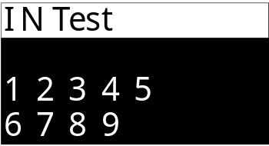
The numbers1to 9 represent IN1toIN9 input ports. When the input is valid, the corresponding ports are displayed in reverse. For example, when IN3 input is valid, it is displayed as shown in the following figure:
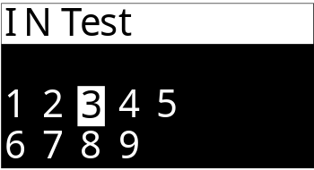

Output test(OUT)
The "Output Test (OUT)" interface is shown as follows:
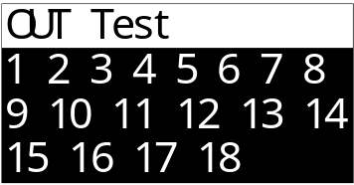
The numbers 1~18 represent the output ports of OUT1~OUT18. If the number 1 flashes, itindicates that pressing can manually switch the on and off of OUT1 output, andpressing will switch to other OUT ports. When the OUT output is enabled, the corresponding port number is displayed in reverse. For example, when the OUT2outputis enabled, it is displayed as shown in the following figure:

High-speed pulse port(HO)
The operation of the "High-Speed Pulse Port (HO)" test function is the same as that of the "Output Test (OUT)", and the interface is shown in the following figure:
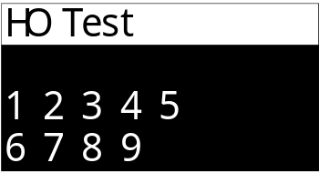
The numbers 1~9 represent the HO1~HO9 output ports. If the number 1 flashes, it indicatesthat pressing can manually switch the on and off of the HO1 output, andpressing will switch to other HO ports. When the HO output is enabled, the corresponding port number is displayed in reverse on the scale. For example, whentheHO2 output is enabled, it is displayed as shown in the following figure:
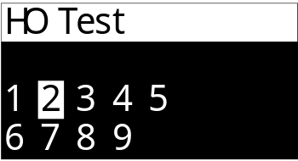
Note: The output test of the high-speed pulse port outputs the level signal of a common switch quantity, not a pulse signal.

Multiplexing port(M)
The "Multiplexing Port (M)" test interface is shown in the following figure:
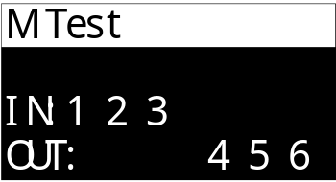
The ports configured for input functions will be displayed after the input title.
The ports configured for output function will be displayed after the output title.
As shown in the above figure, M1,M2, and M3 are configured as input ports, while M4, M5, and M6 are configured as output ports.
The test operation method for the multiplexed port (M) is the same as the ordinary "input test (IN)" and "output test (OUT)" operation methods, and will not be described here.

Analog quantity
Set the range of the analog output of the controller and perform related operations for analog calibration and calibration.

Analog range
Set the minimum and maximum values of the analog output.
number | Parameter | Explanation | Init value
8.1 | Analog output range
8.1.1 | Analog Min | 0.000~5.000V; The min value of the analog output. | 0.000
8.1.2 | Analog Max | 0.000~5.000V; The max value of the analog output. | 5.000

Analog calib
The calibration operation of analog quantities: When there is a deviation between the output value of the analog quantity and the actual value, the analog quantity calibration function can be used to calibrate the output of the analog quantity.
The following takes the calibration of the analog quantity U1-1 as an example to illustrate the operation method of analog quantity calibration.
Analog quantity calibration method
- Enter the [8.2.1 U1-1 Calibration] interface.
- Enter the [8.2.1.1 [0V]] option interface. At this point, use a multimeter to measure the voltage magnitude of the analog quantity U1-1 output (normally it should be around 0V), input the measured value into the interface and press Confirm.
- Enter the [8.2.1.2 [2.5V]] option interface. At this point, use a multimeter to measure the voltage output of the analog quantity U1-1 (normally it should be around 2.5V), input the measured value into the interface and press Confirm.
- Enter the [8.2.1.3 [5V]] option interface. At this point, use a multimeter to measure the voltage output of the analog quantity U1-1 (normally it should be around 5V), input the measured value into the interface and press Confirm.
- Enter the [8.2.1.4 Maximum Voltage] option interface. At this point, use a multimeter to measure the voltage output of the analog quantity U1-1 (normally it should be above 5V), input the measured value into the interface and press Confirm.
- After the above operations, the calibration operation of the analog quantity U1-1 can be completed.
When measuring the output voltage of U1-1, please ensure that the multimeter is in the DC voltage range. Connect the positive test lead to the output port of the U1-1 terminal of the controller and the negative test lead to the output port of the GND terminal of the controller.
number | Parameter | Explanation | Init value
8.2.1 | U1-1 calibration
8.2.1.1 | 0V Set | -1.000~5.000V; Analog output 0V calibration point. | 0.000
8.2.1.2 | 2.5 Set | -1.000~ 15.000V; Analog output 2.5V calibration point. | 2.500
8.2.1.3 | 5V Set | -1.000~ 15.000V; Analog output 5V calibration point. | 5.000
8.2.1.4 | Max Set | -1.000~15.000V; Max voltage calibration point for analog output. | 5.200
The calibration operations for other analog quantities are the same as those in U1-1. For specific operation instructions, please refer to the analog quantity calibration instructions in U1-1.

Analog Testing
The analog quantity test function enables control of the corresponding analog quantity value output from the analog quantity port by inputting numerical values, which can be used to test whether the analog quantity output is normal.
Serial number | Parameter | Explanation | Initial value
8.3 | Analog quantity testing
8.3.1 | U1-1 test | 0.000~5.000V; The input value can control the output size of the analog quantity U1-1. | 0.000
8.3.2 | U1-2 test | 0.000~5.000V; The input value can control the output size of the analog quantity U1-2. | 0.000
8.3.3 | U2-1 test | 0.000 ~5.000V; The input value can control the output size of the analog quantity U2-1. | 0.000
8.3.4 | U2-2 test | 0.000~5.000V; The input value can control the output size of the analog quantity U2-2. | 0.000
8.3.5 | U3-1 test | 0.000 ~5.000V; The input value can control the output size of the analog quantity U3-1. | 0.000
8.3.6 | U3-2test | 0.000~5.000V; The input value can control the output size of the analog quantity U3-2. | 0.000
8.3.7 | U4-1 test | 0.000 ~5.000V; The input value can control the output size of the analog quantity U4-1. | 0.000
8.3.8 | U4-2 test | 0.000~5.000V; The input value can control the output size of the analog quantity U4-2. | 0.000
8.3.9 | U5-1 test | 0.000 ~5.000V; The input value can control the output size of the analog quantity U5-1. | 0.000
8.3.10 | U5-2 test | 0.000~5.000V; The input value can control the output size of the analog quantity U5-2. | 0.000
8.3.11 | U6-1 test | 0.000 ~5.000V; The input value can control the output size of the analog quantity U6-1. | 0.000
8.3.12 | U6-2 test | 0.000~5.000V; The input value can control the output size of the analog quantity U6-2. | 0.000

ACC data
Cumulative viewing and clearing, as well as the setting of batch counts.
number | Parameter | Explanation | Init value
9.1 | Batch and Cumulative
9.1.1 | Batch set | 0-9999,Set the preset batch count. Once the set batch count is accumulated, the controller will alarm to indicate that the batch is completed and stop the machine. | 0
9.1.2 | Completed | Check the number of completed batches
9.1.3 | Batch End alarm | ① OFF /② ON  Whether there is an alarm prompt after the batch setting is completed. | ② ON
9.1.4 | Batch End alarm time | 0~60,000ms; The output time of the batch completion alarm is set. The alarm will be automatically cleared when the time is up.  When set to 0, the batch completion alarm will be continuously output and can only be manually cleared. | 0ms
9.1.5 | Total num/Wt | Display the total cumulative number of packages and the total cumulative weight.
9.1.6 | 1# Cumulative | Display the cumulative package count and cumulative weight of Channel 1#~6#
9.1.6 | 1# Cumulative
9.1.7 | 2# Cumulative
9.1.8 | 3# Cumulative
9.1.9 | 4# Cumulative
9.1.10 | 5# Cumulative
9.1.11 | 6# Cumulative
9.2 | Formula accumulation
9.2.1 | Formula 1 | Display the cumulative number of packs and cumulative weight of Formula 1~20
9.2.1 | Formula 1
9.2.2 | Formula 2
9.2.3 | Formula 3
9.2.4 | Formula 4
9.2.5 | Formula 5
9.2.6 | Formula 6
9.2.7 | Formula 7
9.2.8 | Formula 8
9.2.9 | Formula 9
9.2.10 | Formula 10
9.2.11 | Formula 11
9.2.12 | Formula 12
9.2.13 | Formula 13
9.2.14 | Formula 14
9.2.15 | Formula 15
9.2.16 | Formula 16
9.2.17 | Formula 17
9.2.18 | Formula 18
9.2.19 | Formula 19
9.2.20 | Formula 20

Comm Setting

Serial Port 1 Settings
Serial Port 1 is the standard RS485 communication serial port for the controller. For the wiring ports, please refer1.3to the section. The relevant parameters are as follows:
num | parameter | explain | starter
10.1 | Serial Port 1 setting
10.1.1 | Slave ID | Set the communication address of the device (slave station number). | 1
10.1.2 | protocol | ① [Modbus-RTU-H]:  two-word data high word first.  ②[Modbus-RTU-L]:  two-word data low word first. | ①MODBUS-RTU-H
10.1.3 | Baud rate | Set the baud rate for the serial port communication  ①4800  ②9600  ③19200  ④38400  ⑤57600 | ④38400
10.1.4 | data format | ① [7-E-1]: 7 data bit, even check, 1 stop bit  ② [7-O-1]: 7 data bit, odd check, 1 stop bit  ③ [8-N-1]: 8 data bit, no check, 1 stop bit  ④ [8-E-1]: 8 data bit, even check, 1 stop bits  ⑤ [8-O-1]: 8 Data bit, odd check, 1 stop bit | ③8-N-1

Serial Port2 Settings
Serial Port 2 is the standard RS485 communication serial port for the controller. For wiring ports, please refer to1.3the section. For relevant parameter Settings, you can refer to Serial Port 1.

Password
Each item in the main menu interface and menu can be set with a separate password and password switch.
By default, all factory passwords are: 000000.
You need to enter the password twice when changing it.
number | Parameter | Explanation | Init value
11.1 | Main menu
11.1.1 | PW switch | ① OFF② ON | ②ON
11.1.2 | PW Set
11.2 | Calibration
11.2.1 | PW switch | ① OFF② ON | ②OFF
11.2.2 | PW Set
11.3 | Weighing Para
11.3.1 | PW switch | ① OFF② ON | ②OFF
11.3.2 | PW Set
11.4 | Ctrl Para
11.4.1 | PW switch | ① OFF② ON | ②OFF
11.4.2 | PW Set
11.5 | Step Motor
11.5.1 | PW switch | ① OFF② ON | ②OFF
11.5.2 | PW Set
11.6 | Recipe setting
11.6.1 | PW switch | ① OFF② ON | ②OFF
11.6.2 | PW Set
11.7 | AI Packing
11.7.1 | PW switch | ① OFF② ON | ②OFF
11.7.2 | PW Set
11.8 | IO
11.8.1 | PW switch | ① OFF② ON | ②OFF
11.8.2 | PW Set
11.9 | Analog
11.9.1 | PW switch | ① OFF② ON | ②OFF
11.9.2 | PW Set
11.10 | Acc Data
11.10.1 | PW switch | ① OFF② ON | ②OFF
11.10.2 | PW Set
11.11 | Comm setting
11.11.1 | PW switch | ① OFF② ON | ②OFF
11.11.2 | PW Set
11.12 | Password
11.12.1 | PW switch | ① OFF② ON | ②ON
11.12.2 | PW Set
11.13 | Logic
11.13.1 | PW switch | ① OFF② ON | ②OFF
11.13.2 | PW Set
11.14 | System
11.14.1 | PW switch | ① OFF② ON | ②OFF
11.14.2 | PW Set

Logic programming
The controller supports the 6-way logic programming function. When the existing functions of the controller cannot meet the control requirements of the device, it can try to use the logic programming function to define auxiliary logic output signals outside the operation process of the controller to control the action of the device.
The logical programming setting parameters are as follows:
num | parameter | explain | starter
12.1 | Logic 1
12.1.1 | logic type | Select the type of the logic programming.  ① [close]: Turn off the logical output function.  ② [Delay on]  ③ [Delay off]  ④ [delay on and off]  ⑤ [OFF-ON Edge]  ⑥ [ON-OFF Edge]  ⑦[self Hold]  ⑧[pulse]  See Section 2.12.1 | ①[close]
12.1.2 | Trig type | ① [Signal trigger]: The logical output is triggered by a certain signal.  ② [Conditional trigger]: a logic output is triggered by reaching a condition.  ③ [Comm trigger]: The logical output is triggered by the communication command. | ① [Signal trigger]
12.1.3 | Sig output | Select the logical output signal to define to an OUT output port. | NONE
12.1.4 | ON Time | Time when the logical output signal is switched on. | 0.0
12.1.5 | off Time | The time of the logical output signal delay disconnection. | 0.0
12.1.6 | Signal 1 | Select the signal 1 used to trigger the logic output. | None
12.1.7 | Sig logic | Select the logical relationship between the trigger signal 1 and the trigger signal 2 used to trigger the logic output.  1. [or]: trigger signal 1 and trigger signal 2 either signal can trigger the logical output.  2. [and]: Trigger signals 1 and trigger signal 2 need to be fully valid to trigger the logic output.  3. [XOR]: the trigger signal is between the trigger signal 1 and the trigger signal 2. | 1. [or]
12.1.8 | output time | [12.1.1 Logical type] This parameter is set when set to item 5 / 6. The effective time of output after the logical signal is triggered, and the logical output after the time to end.  When this time is set to 0, the logical output signal will only end by the reset signal. | 0.0
12.1.9 | Init signal | [12.1.1 Logical type] This parameter is set when set to item 5 / 6. After the logical output is valid, the reset signal can reset the logical output to make the logical output signal invalid and end the logical output process. | None
12.1.10 | Init type | 1.[ON Init]: When the reset signal is effective, the reset logic output.  2.[Off Init]: When the reset signal is invalid, the reset logic output. | 1. [ON Init]
12.1.11 | conditions | Select the conditions that trigger the logical output.  1. [More set value]  2. [less set Value]  3. [Inside Range]  4. [outside range] | 1. [More set value]
12.1.12 | value 1 | Used to set the weight value for the corresponding trigger condition. | 0
12.1.13 | value 2 |  | 0
12.1.14 | need state | 2. [On]: After the weight meets the trigger condition and requires stability to trigger the logical output.  1. [Off]: The logical output can be triggered after the weight meets the trigger condition, without stability. | 1. [OFF]
12.1.15 | signal 2 | Select the signal 2 used to trigger the logical output. | None
12.1.16 | Wt Choose | 1# Weight/2# Weight/3# Weight/4# Weight/5# Weight/6# Weight  Select which scale weight setpoint to trigger. | 1# Weight

Logic output timing diagram
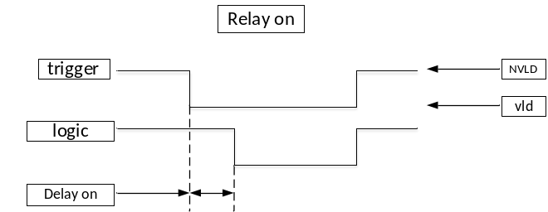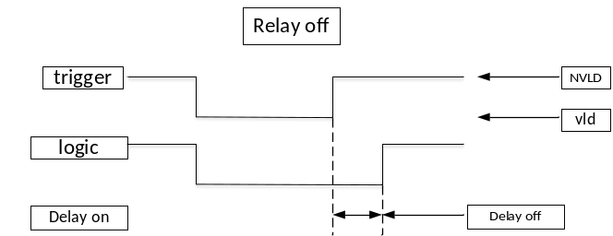
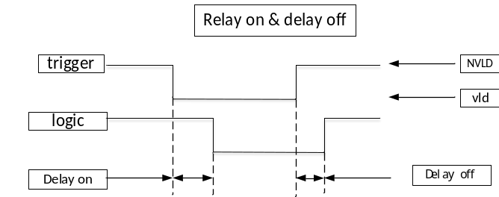
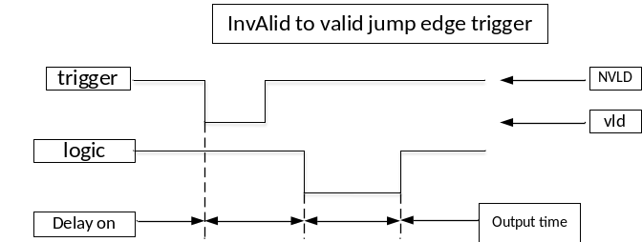
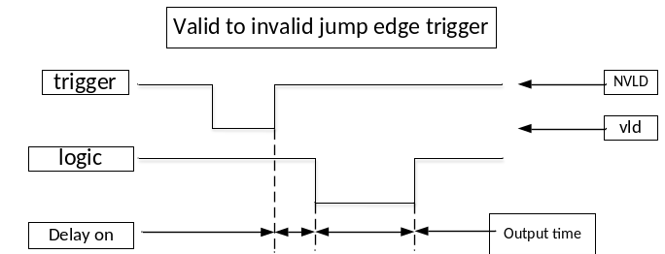
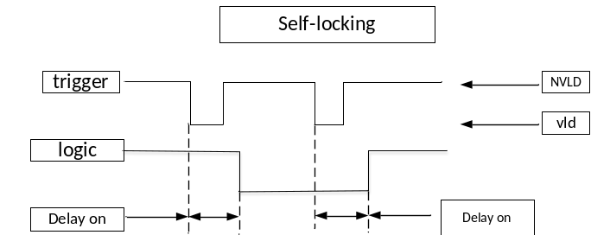
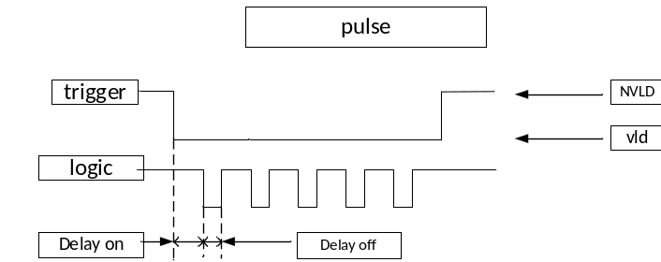

illustrate
The coding function is realized through logical programming: after the output signal of the bag is effective, the delay is 1s, and then the output OUT12 lasts for 2s, which is used to control the coding machine to print the code on the bag after the bag is completed.
The setting is as follows:
[12.1.1 Logic type]: Invalid-valid jump edge trigger
[12.1.4 Delayed connection]: 1s
[12.1.8 Output time]: 2s
[12.1.2 Trigger type]: Signal trigger
[12.1.6 Signal 1 setting]: pouch
[12.1.3 Signal output port]: OUT12

Through the coordination between different trigger signals, trigger conditions and logical programming signals, very flexible logical signals can be combined.
For example, the following logic should be implemented: the real-time detection weight is higher than 100kg, namely, the output OUT10 for alarm indication. And the alarm delay is 2s, and the output OUT11 for 3s is used to control the discharge mechanism to unload the material.
The setting is as follows:
Logical programming 1: realize the detection weight above 100kg, the output OUT10.
[12.1.1 Logic type]: delay connection
[12.1.4 On time]: 0s
[12.1.2 Trigger type]: conditional trigger
[12.1.11 condition]: Weight is greater than the set point
[12.1.12 value 1]: 100kg
[12.1.3 Sig output]: OUT10
Logical programming 2: delay 2s after OUT10 is effective, and output O UT11 for 3s.
[12.2.1 Logic type]: Invalid-valid jump edge trigger
[12.2.4 On time]: 2s
[12.2.8 Output time]: 3s
[12.2.2 Trigger type]: Signal trigger
[12.2.6 Signal 1]: Logic output 1
[12.2.3 Sig output]: OUT11

System
number | Parameter | Explanation | Init value
13.1 | Para. Reset | Reset the controller parameters
13.2 | Backup& recovery | It can back up the current controller parameters and restore the backed-up parameters.
13.3 | language | ①Chinese /② English | ①Chinese
13.4 | Boot Screen | ①OFF: The company Logo is not displayed when the device is turned on.  ②ON: The company Logo is displayed upon startup.  ③Custom: Display the imported customized images upon startup. | ② ON
13.5 | screen-off time | 0~600s; When set to 0, the automatic screen-off function is turned off. | 0s
13.6 | About | Check the model and version number of the controller.
Note: When resetting all parameters, the analog parameters will not be reset. If you need to reset the analog parameters, you must perform the reset operation of the analog parameters separately.

Self-check
After entering the self-check page, the device will automatically start to perform the self-check operation. In the self-check state, the equipment simulates the packaging process according to the normal process Settings. Its switch quantity, analog quantity, and unloading step functions will all operate according to the set contents. During self-checking, it will not determine whether there is bag clamping or unloading. It will automatically execute and run in a loop to simulate the packaging process.
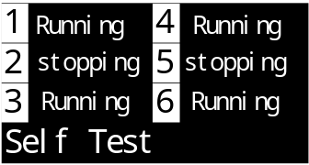
Under this interface, the following operations can be performed by pressing the keys:
Key press
Clicking this button allows you to exit the self-check and return to the previous menu.
2. Long press this key to exit the self-check and return to the main interface.
Clicking this button can clear the current quotation status.
Clicking this button can control the start and stop of the self-check.

Packaging process

Equipment structure diagram
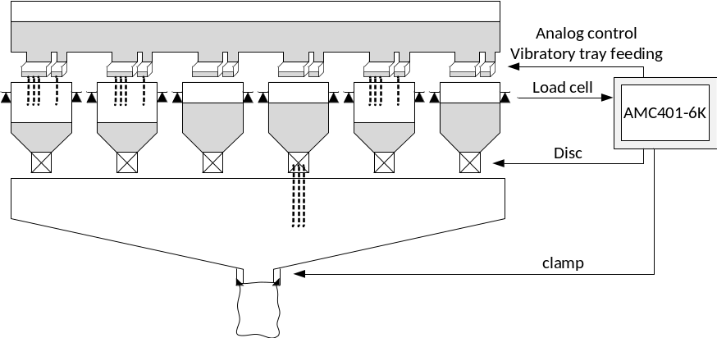
As shown in the above figure, it is a typical interlock mode structure diagram. The controller controls the feeding of six channels. After the bag clamping mechanism at the bottom completes the bag clamping each time, the controller will internally perform the unloading interlock sequence and control the channel that completed the feeding first to unload.

Main process sequence diagram
Taking Channel 1 as an example below, the main signal output timing and weight change trend after the packaging process is initiated are introduced as shown in the following figure:
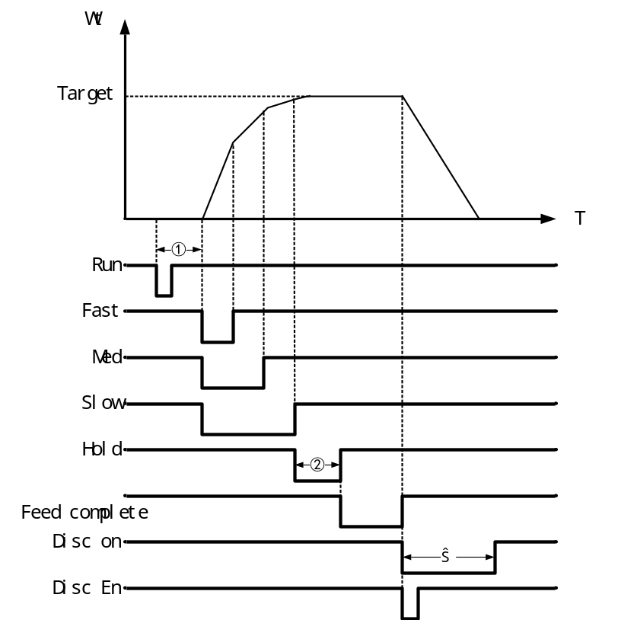
Note
All the signals in the picture are valid at low levels.
The sequence diagrams of the fast, med and slow input signals in the figure are the sequence diagrams under the condition that the "3.2.2 Switch Quantity Feeding Signal Output Mode" is set to "① Combination".
The unloading signal timing diagram in the figure is the timing diagram under the condition that the[3.4.3 Unloading End Condition] is set to "① Time judgment".
The numbers in the figure represent the following contents:
① : [3.2.4 Delay before adding materials].
② : [5.5.7 Fixed value holding time].
③ : [5.5.8 Unloading holding Time].

Process description
- Start running.
- 【3.2.4 Delay before Feed 】 Start feeding after the time ends. fast, med and slow input signals and analog signals .
- When the weight value ≥the target value - the lead amount for the fast feed, close the fast and enter the med.
- When the weight value ≥ the target value - the lead amount of the med feed, turn off the med output and enter the slow output.
- When the weight value ≥the target value – slow feed, close the slow, end the feeding process, and start the [5.5.7result holding time].
- 【5.5.7 result holding time】 After the time ends, record the weight of this feeding result and determine whether to conduct over-limit and under-limit detection based on the control parameter Settings.
- After the setting is completed, outputthe"Q11 feed Complete" signal and wait for the external input of the "Disc En" signal.
- After the external input of the "I14Disc En", the disc process is initiated.
- After disc is completed, start [3.4.6 Rerun delay].
- After the "3.4.6 rerun Delay" ends, based on the Settings of the "3.4.5 Rerun Conditions", it is determined that the restart conditions are met, and then the next feeding process cycle begins.

Note
① : Based on the Settings in [5.2feed speed] and [3.2.1 Feed Signal Set], determine whether to output fast, med and slow feeding switch or analog signals.
② : According to the Settings in [3.4.2 Disc Start Conditions], you can choose to wait for the "I7 Disc En" signal to effectively unload, or unload directly without waiting for the allow Disc signal, or wait until the bag clamping is completed before Disc.
③ : For the specific functions of the unloading process, please refer2.3.4.1to the description in the chapter.

Alarm information
When the controller triggers an alarm, it will display the alarm information in the bottom line, as shown in the following figure:
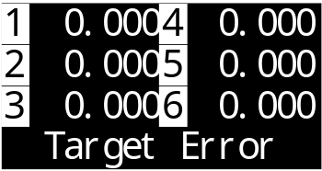
Pressingthe button or entering the "Clear Alarm" signal can clear the alarm.
For detailed instructions on specific alarms, please refer to the table below
num | "Content | Explanation
1 | target Error | The recipe parameter [target] cannot be started if it is not set.  The target value must be set before it can be started.
2 | OFL cannot run | It cannot be started when the weight overflows.
3 | over zero range | When performing the zeroing operation, if the weight exceeds the zeroing range, it cannot be zeroed.  The parameter Settings of "2.1.1 zero Range" can be adjusted.
4 | motion zeroing | During the zeroing operation, the weight is unstable and cannot be zeroed.  It is necessary to investigate the cause of the unstable weight jump and whether it is due to mechanical vibration. The determination of stability conditions can also be adjusted by modifying the "2.2.1 Stable Range" and the "2.2.2 Stable Time".
5 | OFL zeroing | When the weight overflows, it cannot be reset to zero.
6 | Run zeroing | Manual zeroing operation is not allowed during the running state.
7 | Ove/und alarm | The controller enabled the "3.3.4 3.3.4 Over/Under Func ", and the feeding connection result showed an over-limit and under-limit situation.
8 | Ove/und Pause | The controller enabled the "3.3.4 Over/Under Func" function and the "3.3.6 Over/Under Pause" function. However, when the feeding result showed an over/under situation, the controller paused and waited for the user to handle it.
9 | Batch completed | When [9.1.1 Batch Settings] is set and the set number of batches has been completed, an alarm will be triggered.
10 | The stop signal is valid | When starting up, if the "Stop" signal is detected to be in an effective state, it cannot be started and an alarm prompt will be given.
11 | Switch quantity test status | The controller is in the switch quantity test state and cannot be started.  The switch quantity test state needs to be turned off before starting.
12 | Not stable when clb | When performing the quick zero point calibration operation, the weight must be stable for the calibration to be successful; otherwise, an alarm will be triggered.
13 | Disc close timeout | When the motor unloading door closes [3.4.8Disc close timeout], if the "unloading door closed in place" signal input is still not detected as valid after the time limit is reached, it is considered that the unloading door has closed for a time limit and an alarm prompt will be issued.
14 | AI pack error | When self-learning the slow drop value, an error occurred and no material fell. Please check whether the feeding mechanism is normal.
15 | The Disc interlock buffer is full | An error occurred in the unloading interlock cache.
16 | The interlock channel for disc is incorrect | An error occurred in the handling of the unloading interlock channel.
17 | It cannot be started during calibration | It is not allowed to start when in the calibration state.
18 | feed timeout Alarm | The feeding time exceeded the set [3.7.1 Feeding timeout]. For detailed function descriptions, please refer to the corresponding parameters.
19 | Disc timeout alarm | The unloading time exceeded the set [3.7.4 disc timeout ]. For detailed function descriptions, please refer to the corresponding parameters.
20 | Reset timeout alarm | The zeroing waiting time before feeding exceeded the set [3.7.7 auto zero timeout]. For detailed function descriptions, please refer to the corresponding parameters.
21 | The disc door is not fully closed | 【3.7.10 check Disc Close】 When the function is turned on, if the signal "Unloading door closed in place" is invalid before feeding, an alarm will be triggered. For detailed functional descriptions, please refer to the corresponding parameters.

Troubleshooting Common Faults
When the controller is in operation, thesingle-channel display interface 1# to 6# can be switched by pressing a key. When the single-channel interface is in operation, the bottom line of the display will provide real-time prompts on the current function and process being executed by the controller. Through this prompt, the current operation process of the controller can be determined, which helps to troubleshoot. As shown in the following figure, the controller is in the rapid feeding process:
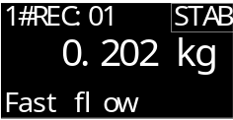
Some possible faults that the controller may encounter during use and their troubleshooting methods are shown in the following table:
num | content | explain
1 | A DOFL / -ADOFL | Sensor signal is abnormal.  - The sensor line is misconnected and has poor contact.  (Note the four-wire system and six-wire connection method)  - Sensor damage.  - Overload range of the sensor.
2 | OFL / -OFL | Weight overflow, and OFL is indicated when the hopper weight exceeds the [1.4 capacity] set value. If the empty scale shows the OFL, please check:  - [1.4 capacity] Is it set correctly.  - Calibration is abnormal, re-calibrate.  - Whether the sensor is damaged.
3 | The static state weight of the device is abnormal and unstable | - Whether the sensor line connection is correct and reliable, and whether the line is rusty and oxidized.  - Whether the weighing mechanism is affected by external force or vibration.  - Whether the sensor is damaged.  - The sensor or controller is disturbed by the electrical equipment around the site, such as the motor, frequency converter, etc.  - [Filter] Whether the setting is appropriate.
4 | Unable to start | - Whether the input line such as the external start button is normally connected to the controller (it can be viewed through the switching volume test).  - Whether the input port of starting signal access is correctly defined as startup.
5 | The result of feeding is not allowed | - The results displayed by the controller after the feeding are inaccurate:  - Adjust the setting of fast and med investment advance amount of formula parameters. Ensure that the slow casting process has a long enough time to ensure the accuracy.  - Whether the feeding mechanism is normal, whether the following material outlet is blocked, and whether the material flow is smooth.  - The results displayed by the controller are accurate, but the actual reweighing results are inaccurate.  - Display has a deviation from the actual weight and needs to be calibrated.  - It is best to use weights or materials of the same weight as the target value for calibration, and pay attention to the uniform force of the scale table, and do not bias the load.
6 | Accumulation is not allowed | When recording the cumulative value, the controller records the cumulative value at the end of the fixed value process, so check whether the time setting of [5.57 result hold time] is sufficient. At the end of the fixed value holding time, the controller shows that the weight has stabilized and no longer beats significantly, so as to record the accurate cumulative result of the feeding.

