AMC501-H
instruction Manual for Single-scale Electric Integrated Machine

©2018 Shenzhen Accurate Measurement and processing Technology Co ltd, copyright ownership.
Without permission from Shenzhen Accurate Measurement and processing Technology Co ltd, No unit or individual shall reproduce, disseminate, transcribe or translate into another language in any form or by any means.
As our products have been continuously improved and updated, we reserve the right to revise this manual without further notice. To do this, visit the company's website frequently to get timely information.
Company web site：http://www.szamp.com.cn/

This product carries out the standard:
GB/T 7724-2008 National standard of <electronic weighing instrument>
JJF1624-2017 Type evaluation outline of <digital weighing indicator (weighing indicator) >
JJG649-2016 Verification regulation of digital weighing indicator (weighing indicator)

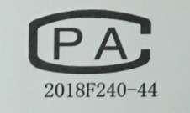

contents
1 Basic information 1
1.1 Features and Specifications 1
1.2 Connection Port 3
1.3 Sensor wiring method 4
1.4 IO wiring and definition 4
1.5 Extension interface 6
1.5.1. Dual serial ports（RS232+RS485） 6
1.5.2. 5-channel IO(2 IN & 3 OUT) expansion board 7
1.5.3. 5-channel IO(5-OUT) expansion board 7
1.6 Mounting Dimension 8
2 Main interface 9
3 System maintenance 10
3.1 Wt Cal 11
3.1.1 Weights Cal 12
3.1.2 Material Cal 13
3.1.3 No Wt Cal 13
3.2 Basic weighing parameters 14
3.2.1 Basic Wt 14
3.2.2 Batch and Sum 16
3.3 Pack Para 17
3.4 Recipe set 18
3.4.1 Recipe 18
3.4.2 Target set 18
3.4.3 Time set 21
3.4.4 Flap 22
3.4.5 Fall Over/under 24
3.4.6 Others 25
3.5 IO 27
3.5.1 In port 27
3.5.2 Output definition 30
3.5.3 Ho Port 32
3.5.4 IO test 34
3.6 Functions and electric parameters 34
3.6.1 Moto Flow 35
3.6.2 Moto Disc 37
3.6.3 Moto clamp 39
3.6.4 Sew cut set 41
3.6.5 Tractor set 44
3.6.6 Event programming 51
3.7 Logic programming 59
3.7.1 Logical output sequence diagram 60
3.8 Self Test 62
3.9 Comm para 63
3.10 System 64
3.10.1 Parameter reset 65
3.10.2 Date/Time 65
3.10.3 Registration 65
3.10.4 Backup/recovery 66
3.10.5 Data import and export 67
3.10.6 Home page Definition 68
3.11 Admin Pass Change 68
3.12 AI Ipack 69
3.12.1 Func set 69
3.12.2 Speed ctrl 70
3.12.3 AI choose 73
3.12.4 Initial value 73
4 Packaging control 74
4.1 Packaging process for the bucket scale 74
4.2 Packaging process of the bucket-less scale 76
4.3 Bulk material scale process 77
4.4 Belt(conveyor) 77
4.5 Feeding control 78

Basic information

Features and Specifications
The AMC501-H is a single-channel quantitative packaging controller instrument specifically designed for gas-electric scales, based on a Chinese touch screen. It supports various modes such as bucket-less scales, bucket-with scales, and bulk grain scales. It is equipped with an internal stepper motor PWM output, which can be directly connected to the stepper motor driver without the need for an external PLC program. The setup and debugging are extremely simple. The AMC501-H is implemented with a high-color TFT touch screen, supporting Chinese input and display. It features an elegant graphical interface and a well-structured functional classification and layout.
The AMC501-H human-machine interface has the following basic characteristics:
●PWM output, which can be directly connected to the stepper motor driver without the need for an external PLC program
●TFT high-color touch screen, with Chinese input and display
● Beautiful interface, reasonable functional classification and layout, easy to use
● Weighing channel: Single channel
● Working voltage: DC24V
● Sensor: DC5V/4-6 wire compatible
● Switch quantities: up to 14 inputs and 21 outputs
● Installation method: Cabinet installation (tray installation)
● Dimensions: 203×149×50 (length, width, height, mm)

The detailed technical specifications are as follows：
Transducer Excitation | DC5V±10%/120mA Drive current/can receive eight Ω 350 specifications of the sensor
Adaptive Sensor Sensitivity | 2mV/V or 3mV/V
Input Signal Range | 0～15mV
Minimum Input Sensitivity | 0.5uV/d
Nonlinearity | 0.02%FS（3mV/V hour）
Zero Drift | ＜0.5μV/℃
Gain Drifting | ＜10PPM/℃
AD Rate | 960Times/S
Maximum Accuracy of Display | 1/100000
Product Accuracy Grade | 
Working Voltage | DC24V（18V～30V compatibility）
Product Power Consumption | ＜5W
Operating Temperature Range | -10℃~45℃
Storage Temperature | -20℃~60℃
Humidity | Within 90%RH（No Condensation）

Connection Port
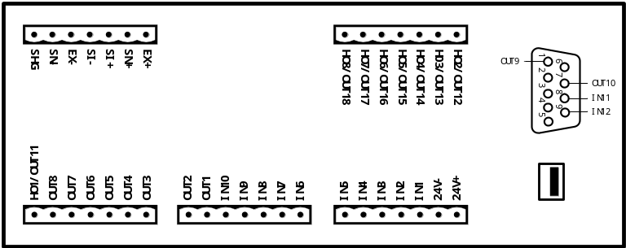
Interface definition
interface | instructions |  | interface | instructions
24V+ | DC24V + |  | 24V- | DC24-
In port
IN1 | I1.Running(pul) |  | IN7 | I20.Disc closed Rdy
IN2 | I4.Urgently stop |  | IN8 | I21.clamp off Rdy
IN3 | I5.Zeroing(pul) |  | IN9 | I18.Sew Guard
IN4 | I7.Clamp alt |  | IN10 | I17.cut in point
IN5 | I11.Disc(pul) |  | IN11 | I0.NC
IN6 | I19. Flow closed rdy |  | IN12 | I0.NC
Out port
OUT1 | Q1.Running |  | OUT10 | Q0.NC
OUT2 | Q22.feed Dir |  | OUT11 | Q0.NC
OUT3 | Q23.Disc Dir |  | OUT12 | Q0.NC
OUT4 | Q24.Clamp Dir |  | OUT13 | Q0.NC
OUT5 | Q20.Sewing bale |  | OUT14 | Q0.NC
OUT6 | Q25.Cut Dir |  | OUT15 | Q0.NC
OUT7 | Q27.Ttr Move Dir |  | OUT16 | Q0.NC
OUT8 | Q29.Ttr Clamp Dir |  | OUT17 | Q0.NC
OUT9 | Q0.NC |  | OUT18 | Q0.NC
HO Port
HO1 | P1.feed | opened | HO5 | Ttr move | opened
HO2 | P2.clamp/unclamp | opened | HO6 | Ttr clamp | opened
HO3 | P3.Disc | opened | HO7 | P0.NC | opened
HO4 | P4.Cut string | opened | HO8 | P0.NC | opened
Sensor interface
EX+ | Load Cell Excitation+ |  | EX- | Load Cell Excitation-
SN+ | Load Cell Sense+ |  | SN- | Load Cell Sense-
SI+ | Load Cell Signal+ |  | SI- | Load Cell Signal-
SHG | Load Cell Shielded Wire

Sensor wiring method
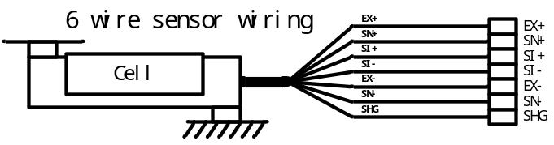
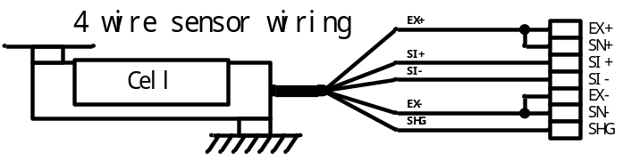

IO wiring and definition
Schematic diagram of IO，For example, IN1, IN2, and IN5 are shown as follows:
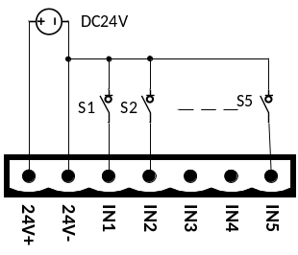
The external circuit drive input switching quantity should meet two points, as follows:
1. The external circuit must be co-located with the controller；
2. When the input power of the external circuit is low, the input is valid; otherwise, the input is invalid.
The wiring diagram of the output switch quantity is as follows (OUT6, OUT7, OUT8, and OUT12 are used as examples) :
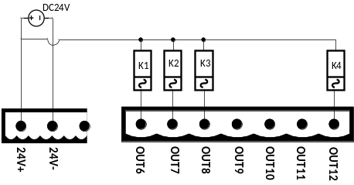
The external circuit driven by output switching quantity should meet two main points:
1. The external circuit should be co-located with the controller;
2.Low level when switching quantity output is active.
Note: the maximum driving capacity of each switch output is 500mA. Please pay attention to the power of the load when connecting the load. If the power exceeds the driving capacity of the output, the switch output may be damaged.

Please refer to the following diagram for stepper motor wiring, taking feeding as an example. The wiring for other functions such as Disc and bag clamping is the same, except that different digital I/O ports are used.
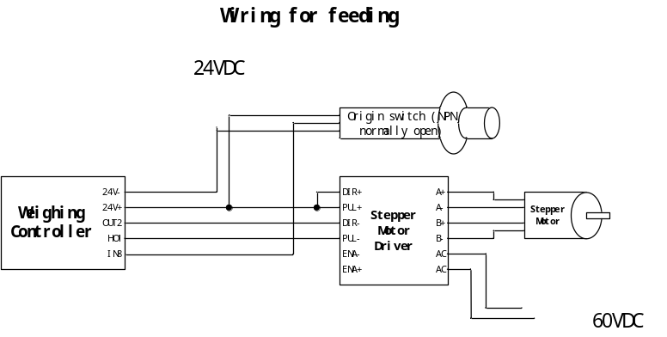

Extension interface
The controller can be optionally equipped with four types of expansion boards:
① Dual serial ports (RS232+RS485)
②5IO(2inputs and 3 outputs) expansion board wiring port
③5IO(5-out)expansion board wiring port
The expansion interface form is a DB9 type plug, and the controller can automatically recognize the expansion board.。

Dual serial ports（RS232+RS485）
When the expansion board ① dual serial ports (RS232+RS485) are selected, the interface definition is as follows:
DB9 lead foot | specification
NO.1 lead foot | empty
NO.2 lead foot | RS232(TXD)
NO.3 lead foot | RS232(RXD)
NO.4 lead foot | RS485(B-)
NO.5 lead foot | RS232(GND)
NO.6 lead foot | RS485(A+)
NO.7 lead foot | empty
NO.8 lead foot | empty
NO.9 lead foot | SHG
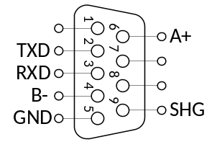

RS485 Wiring Diagram：
Device 1
A+
B-
Device 2
A+
B-
Device N
A+
B-
Computer/PLC
A+
B-
RS232 Wiring Diagram：
Device
RXD
TXD
GND

Computer/PLC

RXD
TXD
GND

5-channel IO(2 IN & 3 OUT) expansion board
When the 5-channel IO(2 IN & 3 OUT) expansion board ② is selected, the interface definition is as follows：
DB9 lead foot | specification
NO.1 lead foot | OUT9
NO.2 lead foot | IN14
NO.3 lead foot | IN13
NO.4 lead foot | OUT21
NO.5 lead foot | HOC/OUT20
NO.6 lead foot | OUT19
NO.7 lead foot | OUT10
NO.8 lead foot | IN11
NO.9 lead foot | IN12
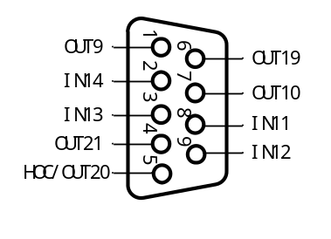

5-channel IO(5-OUT) expansion board
When the expansion board ③with 5 channels (5 out) is selected for expansion, the interface definition is as follows：
DB9 lead foot | specification
NO.1 lead foot | OUT9
NO.2 lead foot | OUT23
NO.3 lead foot | OUT22
NO.4 lead foot | OUT21
NO.5 lead foot | HOC/OUT20
NO.6 lead foot | OUT19
NO.7 lead foot | OUT10
NO.8 lead foot | IN11
NO.9 lead foot | IN12
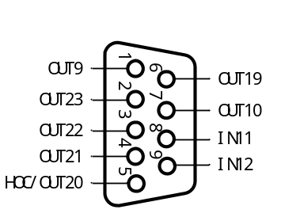

Mounting Dimension
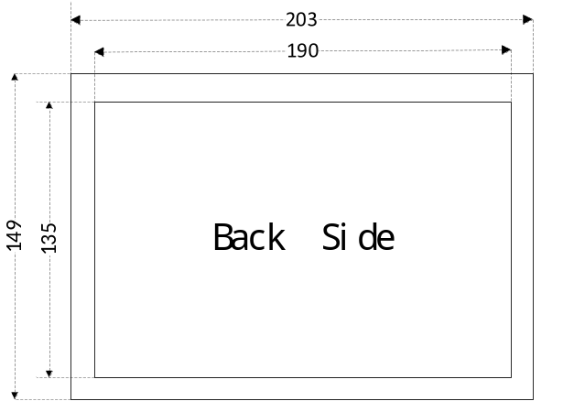
The image above is the bottom view of the product，data unit：mm
Recommended installation hole size：192mm×138mm

Main interface
After the power-on startup is completed, you will enter the main interface, which is shown in the following figure:
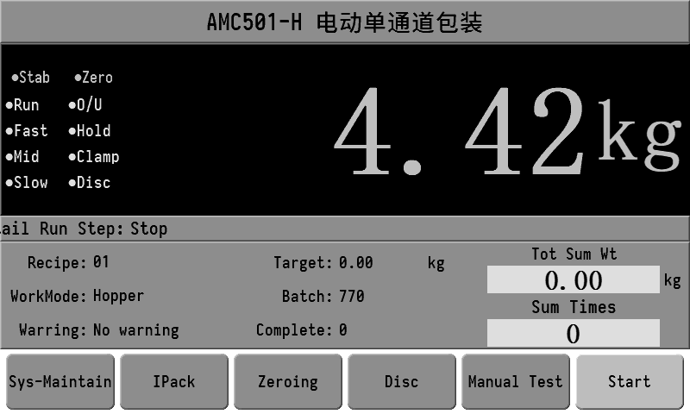
The current weight value, weight stability, zero point, operating status and other status markers are displayed at the top of the main interface, as well as the detailed operating steps of the controller.
The content displayed in the middle information bar is described as follows:
The "Recipe" display the currently selected recipe number and name. Click to select the Recipe.
【 WorkMode 】 The currently set working mode.
【 Warring 】 Displays the current alarm information. Clicking on it allows you to clear the alarm.
The target value refers to the target packaging weight of the current Recipe.
【 Batch】 The number of packages to be packaged. After the batch setting is completed, the controller will automatically shut down. Click to directly set the batch number.
【Completed】 The number of batches that have been completed.
【Tot Sum Wt 】 The total weight of the completed packaging.
【Sum Times 】 The total number of completed packages.
Note: Clicking on the cumulative data display position allows you to clear the cumulative data.
The bottom column contains the function keys.
Sys-Maintain: Enter the main interface for controller system maintenance.
Ipack: Enter the interface for setting some Recipe parameters.
Zeroing: Perform a reset operation on the current weight. When the key is gray, it indicates that it is unavailable. For example, it is gray when in operation.
Disc: Click to turn on and off the Disc signal.
Manual test: It can manually control fast feeding, mid feeding, small feeding, bag clamping and Disc, and has real-time status display of switch quantity ports.
Start: A gray color indicates a stop status. Click Start. If no error is reported, the system will start the packaging workflow.

System maintenance
On the main interface, click Sys-Maintenance to enter the main menu interface of system maintenance, as shown in the following figure:
(Initial password for system maintenance: 000000
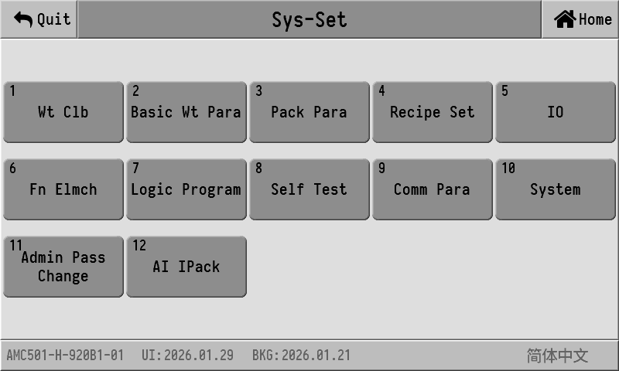
All the parameter setting option entries of the controller are listed in this interface.
The model of the controller and the software date are displayed at the bottom of the screen. Click the English and 简体中文 buttons displayed at the lower right corner to switch between Chinese and English display.
The following provides a detailed explanation of each major item in system maintenance.

Wt Cal
Before using the new equipment, the weight needs to be calibrated and the unit, point, mini div, max range and other parameters need to be set.
There are three ways to calibrate weight. You can choose any one of them according to the actual situation
There are three ways to calibrate weight. You can choose any one of them according to the actual situation
- Weights Clb: Place weights or objects of known weight on the scale platform for calibration.
- Material Clb: Directly add the material to the weighing packaging bag or weighing hopper, then release it and weigh the actual weight of the material for calibration.
- No Wt Clb: Directly input the zero-point voltage value, the gain voltage value and the corresponding weight for calibration.

Weights Cal
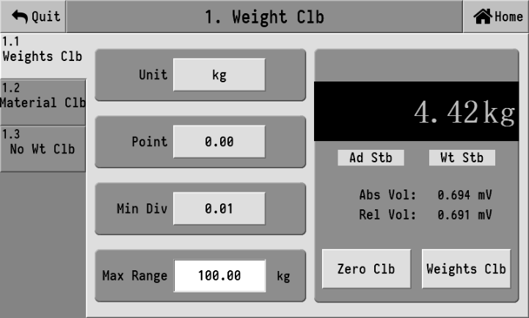
The sensor voltage displayed in the right column refers to the absolute voltage value of the current sensor. The normal range of this value is 0 to 15mV. If this value exceeds this range, it indicates that the signal of the weight sensor is abnormal. Check whether the sensor is damaged or whether the circuit connection is normal and reliable.
The relative voltage, on the other hand, refers to the difference between the current absolute voltage of the sensor and the voltage value at zero point calibration, which is equivalent to the voltage value generated by the gain weight.
The calibration process can be completed in just two steps: zero-point calibration and gain calibration. The operation is as follows:
- Empty the scale platform. After the signal stabilizes (the sensor voltage does not fluctuate), click the empty scale calibration button. Once successful, the current weight will be displayed as 0.
- Place the weights or objects of known weight on the scale platform. After the signal stabilizes (the sensor voltage does not fluctuate), click the weight calibration button. At this time, an input box will pop up. Enter the exact weight of the placed object and click Confirm.
After the above two steps are completed, the weight calibration process is finished, and the controller will display the accurate weight value on the scale platform.

Material Cal
On the weight calibration interface, click on the left menu "1.2 Material Cal" to enter the material calibration interface, as shown in the following figure:
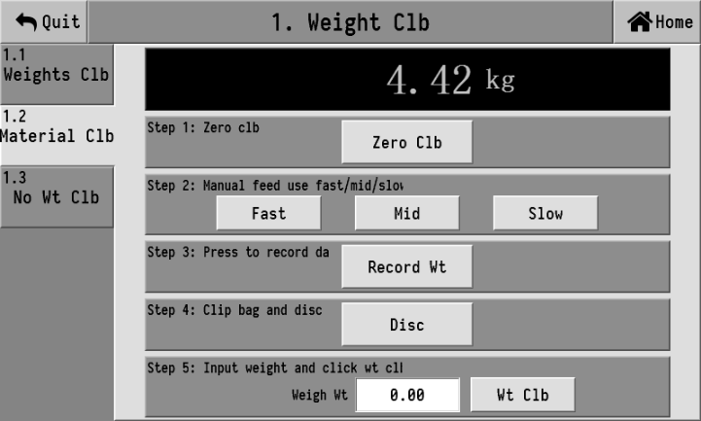
The material calibration steps are as follows:
1. Click "Zero clb";
2. Click "fast", "Med", and "slow" to add materials into the metering hopper.
3. Click "Record Wt";
4. Put on the bag and then click "Disc" to unload the materials into the bag.
5. Place the materials on the platform scale for weighing, and input the weighing result (minus the weight of the bag) into the "Weigh Wt" field. Finally, click "Weight Calibration" to complete the calibration process.

No Wt Cal
Click on the left menu "1.3 No Wt Cal" to enter the calibration interface without weights, as shown in the following figure:
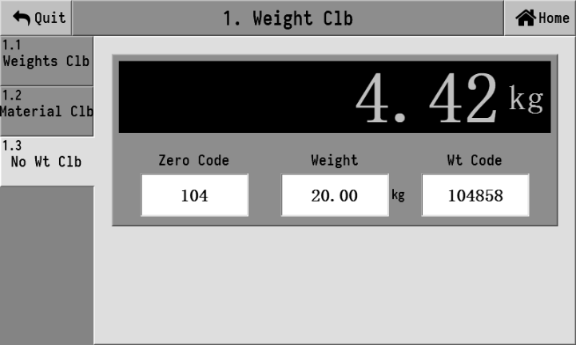
For calibration without weights, simply enter [Empty scale internal weight], [Weight of weights], and [Internal Weight of Weights].

Basic weighing parameters
On the system maintenance interface, click the "2. Basic Wt Para" button to enter the setting interface of basic weighing parameters. The interface is as follows:

Basic Wt
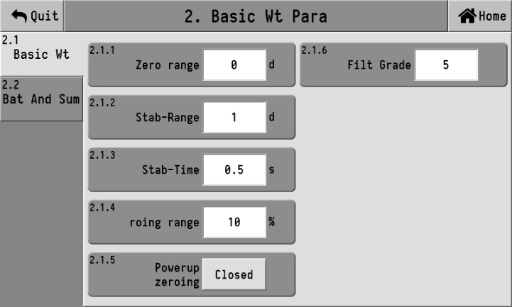
2.1.1 | Zero range | 0-9d; It only works in the stopped state. When the weight value stabilizes within the positive or negative range of this set value ×d (min div), it automatically performs zeroing.
2.1.2 | Stab-range | 1~9d | These two parameters work together to determine whether the weight is stable.  Take all the weight values within the " Stab-time ". If the difference between the maximum and minimum values is ≤ the " Stab-range ", it is considered that the weight value is stable at this time.
2.1.3 | Stab-time | 0.1 ~ 9.9 s
2.1.4 | Zeroing range | 0-99% When performing the zeroing operation, the weight must be less than or equal to "max range × zeroing range" to allow zeroing.
2.1.5 | Powerup zeroing | After being turned on, the controller will automatically perform a zeroing operation each time it is powered on and started.
2.1.6 | Filt grade | 0 to 9; The intensity level of software digital filtering should be set according to the actual debugging effect of the equipment, with appropriate filtering level parameter values.  0: The weakest filtering effect, fast weight response, and poor anti-vibration performance;  9: It has the strongest filtering effect, slow weight response, and good anti-vibration performance.

Batch and Sum
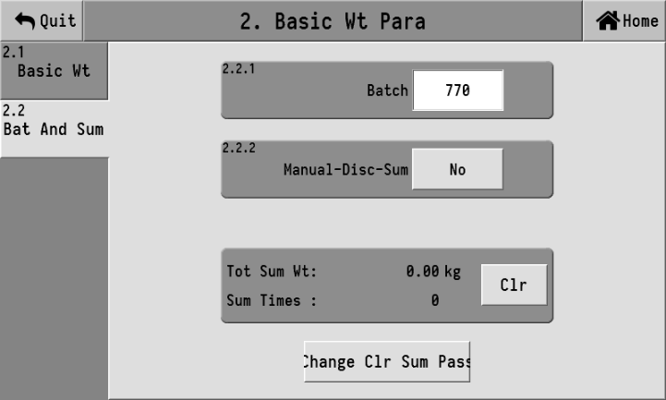
2.2.1 | Batch | 0-9999, It is used to set the quantity of packaging. When the number of runs reaches the set batch number, the packaging process will be stopped and an alarm will be triggered to remind. Turn off this function when it is set to 0
2.2.2 | Manual-Disc-sum | NO/YES.
The cumulative weight is the sum of the weights of each packaging result, while the cumulative number of times is the number of times the weight is accumulated. Clicking "Clr" will clear the cumulative weight and cumulative times to 0.
If it is necessary to prevent the accumulation data from being cleared due to accidental operations, a password for clearing the accumulation can be set. When setting up, it can only be successful if the two inputs are consistent. When you need to turn off the password switch, simply press "OK" twice when changing the password.

Pack Para
Click the "Pack Para" button on the system maintenance interface to enter the setting interface of packaging scale parameters.
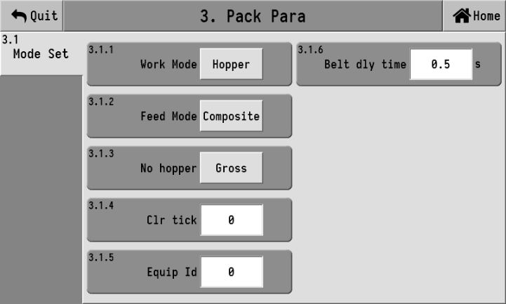
3.1.1 | Work mode | No bucket scale, bucket scale, bulk material scale is available as an option
3.1.2 | Feed mode | Combined feeding and independent feeding are available
3.1.3 | No-hopper | It is only effective in the No-hopper, with gross weight packaging/net weight packaging. During net weight packaging, tare operation is carried out in each process, while in gross weight packaging, there is no tare operation
3.1.4 | Clr tick | 0-99, It is only effective in the bucket scale mode and bulk material mode. It is used to set the zeroing operation every number of packages. This function is turned off when it is set to 0
3.1.5 | Equip ID | 0 to 7; Only for multi-scale interlocking
3.1.6 | Belt dly time | 0.0 to 99.9s; The delay time before starting the belt.

Recipe set
In the system maintenance interface, click on "Recipe Set" to enter the recipe Settings interface, which supports up to 20 recipes. Users can set the parameters of commonly used Recipes in advance and switch to the corresponding Recipes when in use.

Recipe
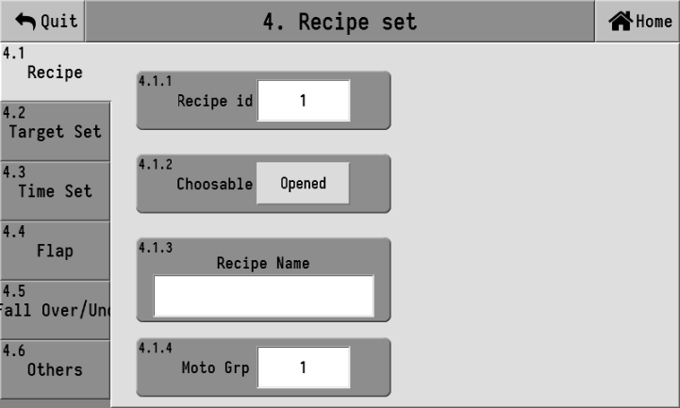
4.1.1 | Recipe id | 1 to 20, for selecting the currently used Recipe
4.1.2 | Choose able | opened/closed  Used to set whether the current recipe number is available for operation
4.1.3 | Recipe name | Used to identify a recipe. Display the recipe name under the current recipe number.
4.1.4 | Moto Grp | 1 to 5, moto parameter groups.

Target set
Click on the left target [4.2 Target set] to enter the target value Settings interface, as shown in the following figure:
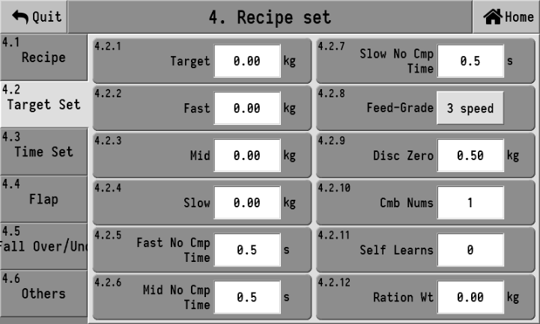
4.2.1 | Target | Set the target weight that the packaging aims to achieve.
4.2.2 | fast | When adding materials, if the weight value is greater than or equal to target-fast, close the fast output.  When set to 0, it indicates that the fast output process will not be initiated.
4.2.3 | Med | When adding materials, if the weight value is greater than or equal to the target value - the med, turn off the med output.  When set to 0, it indicates that the mid-input output process will not be initiated.
4.2.4 | Slow | When adding materials, if the weight value is greater than or equal to the target value - slow, close the slow output.
4.2.5 | Fast No Cmp time | 0.0 to 99.9 s; The vibration elimination time at the beginning of the fast throw. During this time, the fast throw signal remains valid and is not affected by weight. Only after this time ends is it determined whether the weight has reached the lead time for the fast throw, and thus the fast throw ends.
4.2.6 | Mid no cmp time | 0.0 to 99.9 s; The vibration elimination time at the beginning of the mid-range operation, during which the mid-range operation signal remains valid and is not affected by weight. Only after this time ends is it determined whether the weight has reached the mid-range operation lead quantity, and thus the mid-range operation ends.
4.2.7 | Slow no cmp time | 0.0 to 99.9 s; The vibration elimination time at the beginning of the small throw, during which the slow throw signal remains valid and is not affected by weight. Only after this time ends is it determined whether the weight has reached the slow throw drop value, and thus the slow throw ends.
4.2.8 | Feed-grade | Three feeding speeds: fast, mid and slow feeding  Feeding speed: Mid and low dosages
4.2.9 | Disc Zero | 【3.1.1 Work Mode 】 It works when set to have a bucket scale or a bulk material scale.  When Disc, if the current weight is detected to be less than or equal to the zero zone value for Disc, it is considered that the Disc is complete and the Disc door is ready to be closed.
4.2.10 | Cmb Nums | It is used to set how many times the bucket scale needs to unload before releasing the bag once. When set to 0, it can unload directly without bag clamping
4.2.11 | Self learns | When set to 0, self-learning is turned off; when set to other numbers, self-learning is turned on
4.2.12 | Ration Wt | For bulk material scale mode, an alarm will be triggered and the machine will stop when the material reaches the set [quantitative weight].  When the quantitative weight is set to 0, the quantitative function is turned off

Time set
Click on the left target [4.3 Time Set] to enter the time setting interface, as shown in the following figure:
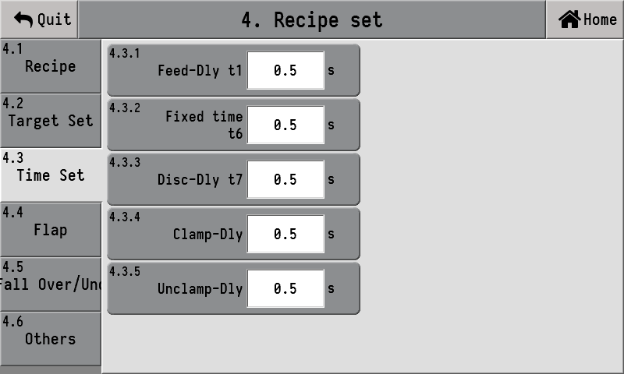
4.3.1 | Feed-Dly t1 | 0.0 to 99.9 s; In the metering hopper mode, when the quantitative process begins, after a delay of t1 time, if the zeroing interval condition is met, the instrument will determine stability and reset to zero (if the zeroing interval condition is not met, it will not determine stability and will not reset to zero), and then the feeding process will start. In the mode without a metering hopper, after operation, wait for the bag clamping signal. Once the bag clamping is completed, delay for t1 time, and the instrument will determine the stability and remove the tare. If the bag clamping has been completed before operation, remove the skin directly.
4.3.2 | Fixed time t6 | 0.0 to 99.9 s; After closing the slow throw, start t6. In the metering hopper mode, output the Disc signal when the t6 time is up. In the mode without a metering bucket, if the bag-patting mode is "or" when the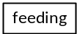t6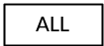time is up, the bag-patting will start. If the bag-patting mode is set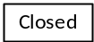toOR, the unclamp delay will be initiated when time t6 arrives
4.3.3 | Disc-Dly t7 | 0.0 to 99.9 s; In the metering hopper mode, during the Disc process, when the weight inside the scale hopper is less than the near-zero value, the delay t7 is initiated. After the t7 time is up, the instrument turns off the Disc signal
4.3.4 | Clamp-dly | 0.0 to 99.9 s; The effective start delay of the bag-clamping input signal is reached. When the delay time is up, the instrument considers the bag-clamping action to be completed. When there is a defined bag-clamping position signal, this delay time is invalid. After the bag-clamping input signal is valid, the bag-clamping position signal is directly determined
4.3.5 | Unclamp-Dly | 0.0 to 99.9 s; In the hopper mode, when the instrument turns off the Disc output, this delay is initiated. Once the delay is reached, the instrument outputs a bag release signal, meaning the bag clamping signal is invalid, and one hopper packaging is completed. In the no-bucket mode, if there is no bag-patting function, the bag-releasing delay will be initiated after the fixed value holding time ends, and the bag will be released after the delay ends. If there is a bag-patting function, a bag-releasing delay will be initiated after the last low-level bag-patting ends, and the bag will be released after the delay ends.

Flap
Click on the left target [4.4 flap] to enter the flap Settings interface, as shown in the following figure:
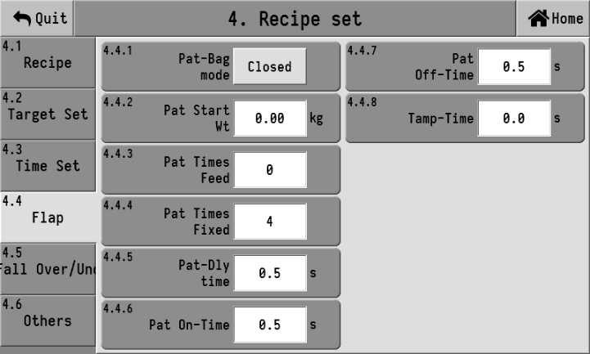
4.4.1 | Pat-bag mode | closed: Disable the bag patting function.  feeding: Only perform bag patting during feeding  fixed: Bag patting will only be carried out after the retention time of the set value ends  All: After adding materials, neutralizing and setting the value, all are bagged
4.4.2 | Pat start Wt | This setting is only valid during feeding and in all bag-patting modes. During the feeding process, when the weight is greater than or equal to the initial weight of the bag, start patting the bag
4.4.3 | Pat times feed | 0-99 This setting is only valid during feeding and in all bag-patting modes. Once bag-patting starts during feeding, stop bag-patting after the number of times this setting is reached
4.4.4 | Pat times fixed | 0-99 The setting is only valid after the fixed value and in all bag modes. After setting, stop patting the bag when the number of times you reach this setting. After the bag-patting is completed, the unclamp delay and bag-piling time will be initiated
4.4.5 | Pat-Dly time | 0.0 to 99.9 s; The setting is only valid after the fixed value and in all bag modes. If the number of bag-patting times is not 0, the bag-patting signal will be output after a delay of this time. After the bag-patting is completed, the unclamp delay and bag-piling time will be initiated. If the number of bag-patting times after setting the value is 0, then this time will also be ineffective. After setting the value, the bag-patting function will be in the off state, and the instrument will directly start the unclamp delay and bag-piling time
4.4.6 | Pat On-time | 0.0 to 99.9 s; The number of times the bag is tapped is not 0. This delay is the valid time for patting the bag
4.4.7 | Pat off-time | 0.0 to 99.9 s; If the number of times the bag is tapped is not 0, this delay is the invalid time for patting the bag
4.4.8 | Tamp-time | 0.0 to 99.9 s; When the bag release delay is initiated, the additional bag patting time is also started simultaneously. When both the unclamp delay and the bag-piling delay are reached and the unloading delay is also reached, one bucket-less packaging is completed

Fall Over/under
Click on the left target [4.5 Fall Over/under] to enter the drop and excess/deficiency setting interface, as shown in the following figure:
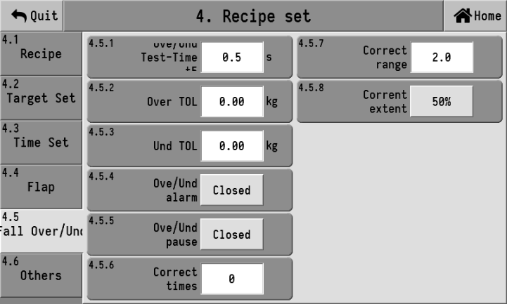
4.5.1 | Over/und test-time t5 | 0.0 to 99.9 s; When the alarm switch is turned on, after the material feeding is completed, a delay is initiated. After the t5 delay, the weight stabilizes and an out-of-tolerance detection is carried out
4.5.2 | Over TOL | During the valuation process, if the weighing value is greater than or equal to the target value + Over TOL, it will be judged as over
4.5.3 | Und TOL | During the quantification process, if the weighing value is ≤ the target value - Und TOL, it is judged as under
4.5.4 | Ove/und Alarm | Closed: The alarm function has been turned off  opened: The alarm function is enabled. When there is an over-limit or under-limit error, an alarm output will be generated.
4.5.5 | Ove/und pause | It is valid when 4.5.4 Ove/und Alarm switch is effective.  Closed: Disable the function of pausing the quantitative process for Ove/und deviations.  opened: When opened, if the instrument exceeds or falls short of the limit, the quantitative process will be paused.
4.5.6 | Correct time | The average of the difference values of the set number of times is used as the basis for the difference correction
4.5.7 | Correct range | 0.0-99.9% ,The percentage of the target value. When the current drop exceeds the set range, this drop will not be included in the arithmetic mean range.
4.5.8 | Current extent | 25%, 50%, 75%, 100% are optional. The extent of correction for each drop.

Others
Click on the left target [4.6 Others] to enter the other Settings interface, as shown in the following figure:
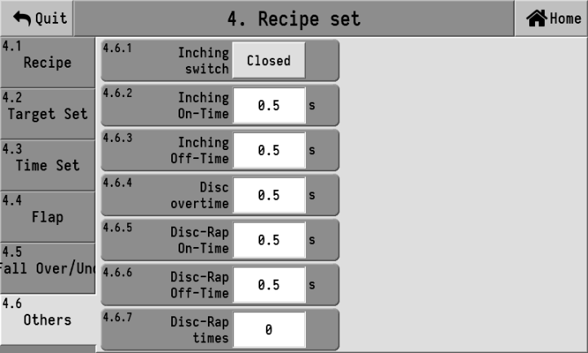
4.6.1 | Inching switch | Closed: When turned off, it has a small tap function  opened: The slow feeder is added in a jog mode.
4.6.2 | Inching On-time | 0.0 to 99.9 s; This time is the effective time when adding materials in a small jog.
4.6.3 | Inching off-time | 0.0 to 99.9 s; When adding materials with a small jog, this time is invalid.
4.6.4 | Disc overtime | 0.0 to 99.9 s; 3.1.1 The working mode is effective when there is a bucket scale. It is valid when the number of unloading vibration strikes is not 0. This delay is initiated when the unloading output signal is valid. If the weight is lower than the zero zone value within this delay, the unloading delay is initiated. If the delay reaches and the current weight is still greater than the zero zone, the shaking function will be activated. During the vibration period, if the weight is lower than the zero zone, the unloading delay will be initiated; otherwise, an alarm will be triggered.
4.6.5 | Disc-rap on-time | 0.0 to 99.9 s; Effective time of the striking action
4.6.6 | Disc-rap off-time | 0.0 to 99.9 s; The invalid time of the striking action
4.6.7 | Disc-rap times | 0 ~ 99; After completing the set number of vibration strikes, the unloading vibration strike is completed

IO

In port
Define the functions corresponding to the switch input ports IN1 to IN12. Click on the input port of the switch quantity you want to set, and in the pop-up option box, select the function you want to define.
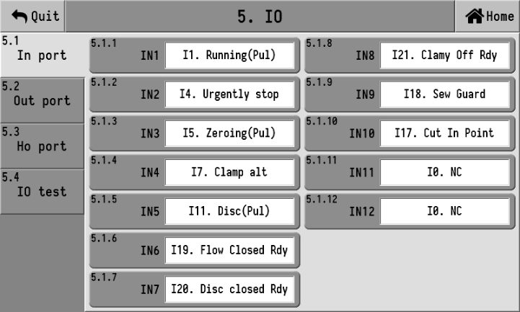
The list of selectable functions for switch input is as follows:
Num | Function | Description
I0 | NC | No function definition.
I1 | Run/stop(pul) | When stopping, input is valid and start. It is valid to stop the operation once when it stops.
I2 | Run/stop(lvl) | Running when the input is valid and stops when the input is invalid.
I3 | Running(pul) | In the stopped state, start running after inputting it as valid once.
I4 | Slowly stop | Enter the Slowly stop process, that is automatically stop running after the completion of this packaging.
I5 | Urgently stop | Stop running.
I6 | Zeroing(pul) | Once valid, perform a reset operation once.
I7 | Clr alarm | Clear the alarm status.
I8 | Clamp alt | Input signal for bag clamping/ unclamp operation.
I9 | Upper level | Input signal for material level detection on the storage hopper.  When effective, it is considered that the material has reached the feeding level.
I10 | Mid level | Input signal for material level detection in the storage hopper.  When effective, it is considered that the material has reached the mid material level
I11 | Lower level | Input signal for detecting the discharge level of the storage hopper.  When effective, it is considered that the material has reached the discharge level
I12 | Disc(pul) | It is used for manually clearing the materials in the metering hopper.  This input effectively opens the discharge door once and effectively closes it again.
I13 | Disc(lvl) | It is used for manually clearing the materials in the metering hopper.  When the input is valid, open the discharge door; when the input is invalid, close the discharge door.
I14 | Interlock in | It works in conjunction with the "Q19 Interlock out " to achieve a multi-channel packaging system
I15 | Safe run/stop | When in the stop state, if this input is valid, it will enter the running state and hold the bag. When in operation, this input effectively stops directly and unclamp the bag.
I16 | Cmbs select | When the input is valid, the bucket scale mode operates at high speed, and the material is unloaded once after each package is completed. When the input is invalid, the bucket mode operates in a combined manner.
I17 | Cut in point | Detection input for tangential action in place.
I18 | Sew guard | The detection input signal for the activation of the sewing bag function.
I19 | Flow closed Rdy | Detection input for the feeding door being fully closed
I20 | Disc closed Rdy | The detection input signal for the discharge door pipe being in place
I21 | Clamy off Rdy | Detection input for unclamp bags in place
I22 | Material block | Do not unload when the input is valid
I23 | TtrMoveBackPlace | The slider moves back to the detection input of the position.
I24 | TtrMoveoutPlace | The slider is moved out of the detection input in place.
I25 | TtrClampOffPlace | Detection input for pulling unclamp bags into place.
I26 | Tractor close | Turn off the traction machine function when the input is valid
I27 | Logic program In | Backup function, temporarily invalid

Output definition
Click the corresponding output switch quantity editing box, and the output switch quantity function selection interface will pop up, as shown in the following figure:
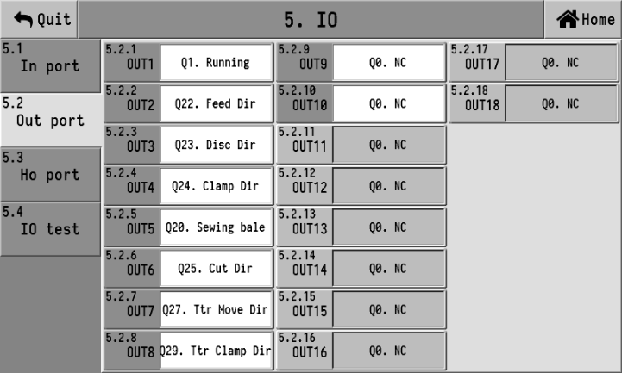
The list of selectable functions for switch output is as follows:
Number | Function | Description
Q0 | NC | No function definition.
Q1 | Running | The output is valid when in operation.
Q2 | Stop | The output is valid when in the stopped state.
Q3 | Fast | Rapid feeding control signal.
Q4 | Mid | Mid-speed feeding control signal.
Q5 | Slow | Slow feeding control signal.
Q6 | Fixed | When the feeding is completed, the output is valid, indicating that the feeding has been completed. The duration can be set with the parameter [4.3.2 Fixed holding Time]. After the fixed holding time ends, the current weight will be recorded as the packaging result of this time.
Q7 | Over/und | The over-limit and under-limit function is enabled. When an over-limit and under-limit alarm occurs in the feeding result, this output is valid.
Q8 | Warning | The output is effective when the controller has an alarm.
Q9 | Clamp | Control signal of the bag clamping mechanism: When effective, the bag is clamped; when ineffective, the bag is released.
Q10 | Patting | Control signal for the bag patting function.
Q11 | Disc | The Disc door of the weighing hopper is controlled by a bucket scale mode.
Q12 | Zero | The output is effective when the current weight is lower than the [4.2.9 Disc zero Zone value].
Q13 | Filling | Feed control output signal.  When the signal is valid, start the feeding device to supply materials to the storage hopper.
Q14 | Batch completed | The signal output becomes valid after the cumulative completion of the set batches.
Q15 | Starving | Output signal for material shortage status.  When the "I11 material level" signal input is invalid, it is in a state of material shortage.
Q16 | Disc Hit | Discharge vibration output control signal.
Q17 | Sever | The output is effective when feeding.
Q18 | Belt | The belt function outputs control signals.
Q19 | Interlock out | It works in conjunction with interlock input to achieve a multi-channel packaging system
Q20 | Sewing bale | The sewing bag outputs control signals.
Q21 | Tangent out | Tangential output control signal.
Q22 | Feed Dir | When the stepper motor controls feeding, this signal serves as the direction signal of the stepper motor driver.
Q23 | Disc Dir | When the stepper motor controls the Disc, this signal serves as the direction signal of the stepper motor driver.
Q24 | Clamp dir | When the stepper motor controls the bag clamping, this signal serves as the direction signal of the stepper motor driver.
Q25 | Cut Dir | When the stepper motor controls the tangential line, this signal serves as the direction signal of the stepper motor driver.
Q26 | Ttr Move | Control signal for the slider mechanism of the traction machine
Q27 | Ttr move Dir | When the stepper motor controls the traction slider, this signal serves as the direction signal of the stepper motor driver
Q28 | Ttr Clamp | Control signal of the bag clamping mechanism of the traction machine
Q29 | Ttr Clamp Dir | When the stepper motor controls the traction machine, this signal serves as the direction signal of the stepper motor driver.
Q30 | Custom ctrl | The OUT port defined for this function can be set by communication to output valid or output invalid
Q31 | Logic program out | The output port of logic programming function
Q32 | Stretch | The extension signal of the traction bag clamping mechanism
Q33 | Pull | The signal for pulling the bag clamping mechanism to both sides
Q34 | Heat seal | Heat sealing signal for packaging bags

Ho Port
The definition interface of the high-speed output switch quantity Ho is as follows:
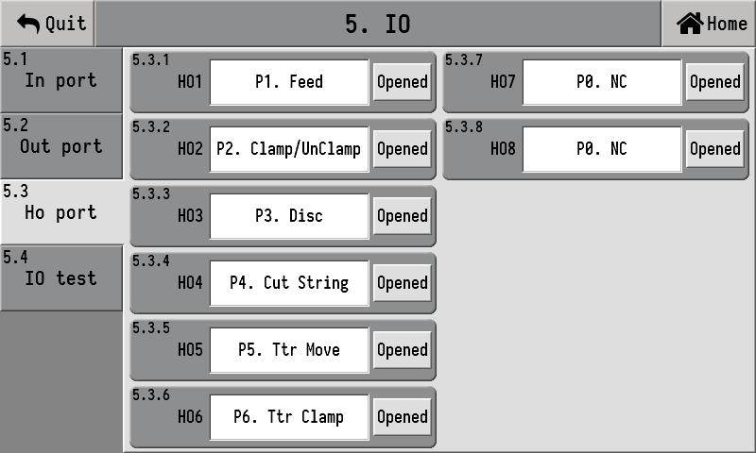
Each high-speed output switch quantity can be turned off. Once turned off, it can be used as a regular output switch quantity port. Displaying "On" indicates that the current high-speed output is turned on. Clicking "On" can switch it to "Off", which means the high-speed output switch quantity is turned off and is used as a regular output switch quantity. Its function can be set in the "5.3 Output Out Definition" interface.
Click the corresponding high-speed switch quantity editing box, and a high-speed output switch quantity function selection interface will pop up. The list of available functions for the high-speed port is as follows:
Num | Function | Description
P0 | NC | No function definition.
P1 | Feed | Control the action of the feeding stepping motor
P2 | Clamp/unclamp | Control the action of Clamp/unclamp stepper motor
P3 | Disc | Control the action of the Disc stepping motor
P4 | Cut string | Control the action of the tangential stepping motor
P5 | Ttr move | Control the action of the stepper motor of the traction machine slider
P6 | Ttr clamp | Control the action of the bag-holding stepping motor of the traction machine

IO test
The IO testing function can be used to test whether the input of the current common input is effective and whether the output of the common output is effective, as shown in the following figure:
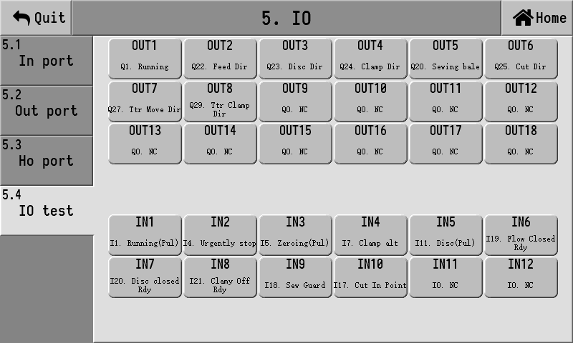
Click OTU1 to OUT18, and you can set the corresponding output as valid or invalid.
2. IN1 to IN12 will display in real time whether the current corresponding input port is valid.

Functions and electric parameters
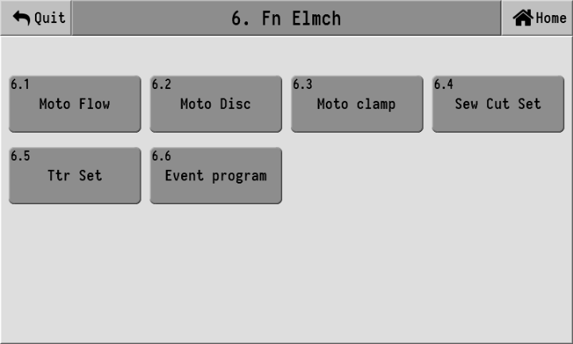

Moto Flow
"6.1.1 Moto Flow" Setting interface:
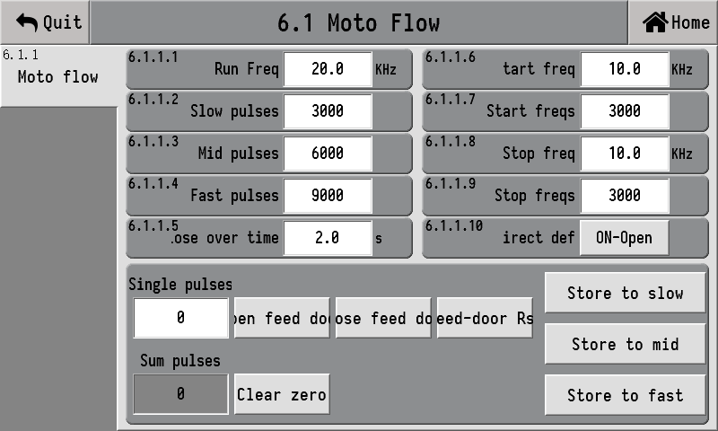
6.1.1.1 | Run Freq | The rotation frequency of the electric feeding door
6.1.1.2 | Slow pulses | The number of pulses required to open the door from the closing position to the slow switch. When set to 0, there is no slow switch opening/closing action
6.1.1.3 | Mid pulses | The number of pulses required to open the door from the closing position to mid-range opening. When set to 0, there is no mid-range opening/closing action
6.1.1.4 | Fast pulses | The number of pulses required to open the door from the closing position to the fast switch. When set to 0, there is no fast switch opening/closing action
6.1.1.5 | Lose over time | The signal for the feeding door to be fully closed only takes effect. After outputting the door closing pulse, if the fully closed signal is not detected within this time, it is considered that the fully closed switch is damaged and the pulse output will be directly stopped
6.1.1.6 | Start freq | The frequency at which the electric feeding door starts to accelerate
6.1.1.7 | Start freqs | The number of frequencies that the electric feeding door undergoes during acceleration from the "start-up frequency" to the "operating frequency"
6.1.1.8 | Stop freqs | The frequency after the deceleration of the electric feeding door is completed
6.1.1.9 | Stop freqs | The number of frequencies that the moto flow undergoes from the "start freq" to the "stop freq"
6.1.1.10 | Direct definition | "On-close" indicates that the output is in the closing direction when it is valid, and "on-Open" indicates that the output is in the opening direction when it is valid
The data box below the parameters can input the number of single pulses, and clicking the button on the right side of the input box can make the stepping motor act according to the set number of pulses. It can be used to test whether the action of the stepping motor is abnormal.
The electric scale supports three feeding modes: 1. Ordinary switch mode, 2. Fixed pulse mode, 3. In-place switch mode
①Ordinary switch quantity mode
In the traditional mode, the corresponding fast, mid and slow input signals are output at the common output switch quantity port. It is only necessary to define the corresponding output switch quantity to use this mode. In this mode, the high-speed switch quantity is set to undefined.
②Fixed pulse mode
Output a mode with a fixed number of pulses, without setting a position switch, and stop when the number of pulses is completed. Note that in this mode, the normal output switch quantity will remain in synchronous output. After power-on, it will output the closing pulse according to the "maximum pulse input number" and "deceleration frequency". If it is already in the closing position at this time, Noise hindering the door process will occur.
③In-place switch mode
Input the switch quantity to set the feeding door to close the switch in place. It will stop when the switch is found to be effective, or it will also stop when the time limit is exceeded. Note that in this mode, the normal output switch quantity will remain in synchronous output. After power-on, if it is detected that the switch is not in place, a closing pulse will be output according to the [deceleration frequency]. If the switch is already in the closed position, no closing pulse will be output.
Other notes
1. The current output status of fast, mid and slow investment is determined by the ordinary switch quantity of fast, mid and slow investment output. Even if the ordinary switch quantity of fast, mid and slow investment output is not defined, it does not affect this judgment.
2. When outputting fast, mid and slow feedings, if it is found that the current output material speed is the same as the new material speed, no high-speed pulse will be output. For example, if the current output is fast and a fast input is output again, no high-speed pulse will be output.
3. After receiving the reset command of the feeding door, if it is detected that the current feeding door closing switch is effective, no pulse will be output. If it is detected that the current feeding door closing switch is ineffective, output the pulse number until the feeding door is effectively closed or the door closing timeout time is up. If the switch for closing the feeding door in place is not defined, a fast number of feeding pulses will be directly output in the direction of closing the door.
4. When the slow throw pulse is 0, when closing the fast throw/mid throw and switching to the slow throw, it will directly go through the closing process. At this time, if there is a position switch, it will not go through a fixed number of pulses. When both the slow throw pulse number and the middle throw pulse number are 0, when closing the fast throw, it will directly go through the closing process. At this time, if there is a position switch, it will not go through the fixed pulse number.
5. When resetting the feeding door upon power-on, output pulses according to the set "deceleration frequency". If the "deceleration frequency" is 0, output pulses according to the "operating frequency".

Moto Disc
"6.2.1 Electric Disc" Setting interface:
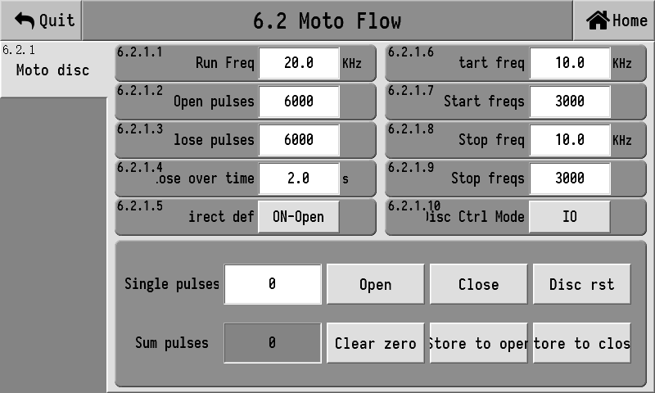
6.2.1.1 | Run Freq | The rotation frequency of the electric discharge door
6.1.1.2 | Open pulses | The number of pulses required from the closing position to the opening position
6.1.1.3 | Close pulses | The number of pulses required from the opening position to the closing position
6.1.1.4 | Close over time | This time only takes effect when the discharge door is configured with a fully closed signal. After outputting the door closing pulse, if the fully closed signal is not detected within this time, it is considered that the fully closed switch is damaged and the pulse output will be directly stopped
6.1.1.5 | Direct def | "On-close" indicates that the output is in the closing direction when it is valid, and "on-Open" indicates that the output is in the opening direction when it is valid
6.1.1.6 | Start freq | The frequency at which the electric discharge door starts to accelerate
6.1.1.7 | Start freqs | The number of frequencies that the electric discharge door undergoes to accelerate from the "starting frequency" to the "operating frequency"
6.1.1.8 | Stop freq | The frequency after the deceleration of the electric discharge door is completed
6.1.1.9 | Stop freqs | The number of frequencies that the electric discharge door undergoes from the "operating frequency" to the "deceleration frequency"
6.1.1.10 | Direct ctrl mode | 1. I/O; 2. Step moto;
The data box below the parameters can input the number of single pulses, and clicking the button on the right side of the input box can make the stepping motor act according to the set number of pulses. It can be used to test whether the action of the stepping motor is abnormal.
The Disc mode supports three modes, the same as the electric scale feeding, and the control method is electric feeding.

Moto clamp
"6.3.1 moto Clamping" Setting interface:
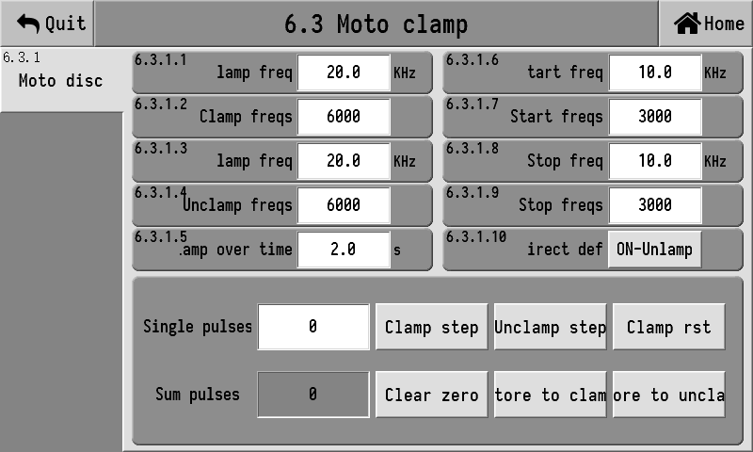
6.3.1.1 | Clamp freq | The rotation frequency of the electric bag clamping door
6.3.1.2 | Clamp freqs | The number of pulses required from bag unclamping to bag clamping is set to 0, and there is no small opening/closing action
6.3.1.3 | Unclamp freq | The rotation frequency of the electric unclamp bag door
6.3.1.4 | Unclamp freqs | The number of pulses required from the completion of bag clamping to the completion of bag release, when set to 0, there is no opening/closing action
6.3.1.5 | Clamp over time | It only takes effect when the electric bag release and closing signal is defined. After the bag release pulse is output, if the bag release and closing signal is not detected within this time, it is considered that the closing switch is damaged and the pulse output will be directly stopped
6.3.1.6 | Start freq | The frequency at which the electric bag clamp starts to accelerate
6.3.1.7 | Start freqs | The number of frequencies that an electric bag clamping door undergoes to accelerate from the "starting frequency" to the "operating frequency"
6.3.1.8 | Stop freq | The frequency after the deceleration of the electric bag clamp is completed
6.3.1.9 | Stop freqs | The number of frequencies experienced by the electric bag clamp from the "operating frequency" to the "deceleration frequency"
6.3.1.10 | Direct def | "On-close" indicates that when the output is valid, it is in the bag clamping direction, and "On-Open" indicates that when the output is valid, it is in the bag unclamp direction
The data box below the parameters can input the number of single pulses, and clicking the button on the right side of the input box can make the stepping motor act according to the set number of pulses. It can be used to test whether the action of the stepping motor is abnormal.
The electric bag clamping mode supports three modes, just like the electric scale feeding, and the control method is electric feeding.

Sew cut set

Sewing bag Settings
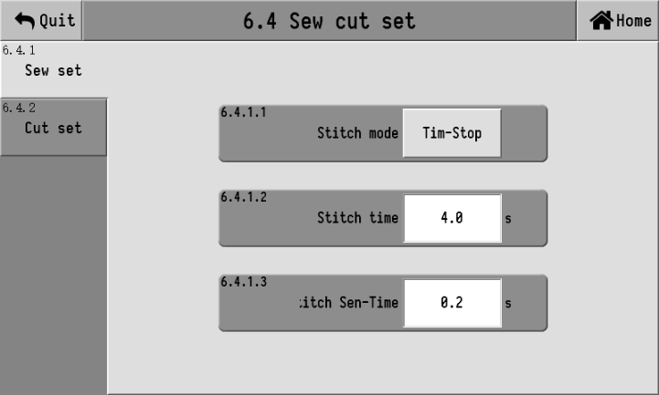
6.4.1.1 | Stitch mode | Start timing: Start timing once the bag is detected to have arrived  Timing at the end: Timing starts only after the bag has passed through
6.4.1.2 | Stitch time | 0.0 to 99.9 s; The duration of continuous output of the suture signal
6.4.1.3 | Stitch sen-time | The packaging bag detection filter is used within the range of 0.0 to 99.9 s. The packaging bag is considered to have arrived only when the effective signal exceeds this time. Similarly, the packaging bag is considered to have passed only when the sewing signal disappears for more than this time

Cut set
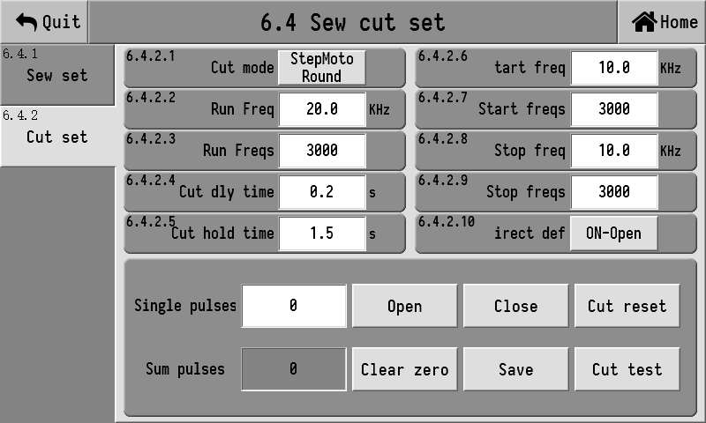
6.4.2.1 | Cut mode | ① Normal IO: Output (tangential output) signal and maintain it for a period of time  ② Step turnover: The tangential method for controlling the step motor to rotate one full circle  ③ Step forward and reverse rotation: The tangential method for controlling the forward rotation and then reverse rotation of the stepping motor  ④ Ordinary motor rotation: The tangential method for controlling the rotation of an ordinary motor once. This method uses (tangential output) signals to control the rotation of the ordinary motor
6.4.2.2 | Run freq | The rotational frequency of tangential motors
6.4.2.3 | Run freqs | When in the "step turnover" mode, the number of frequencies corresponds to the number of pulses required for one full rotation. When using the "step forward and reverse rotation" mode, the same number of frequencies is used for both forward and reverse rotations
6.4.2.4 | Cut dly time | After the sewing of the bag is completed, the tangential signal is output only after passing through this delay signal
6.4.2.5 | Cut hold time | In the "Normal I/O" tangential mode, after the tangential output takes this time, the output is turned off. In the "stepper motor" mode, if the origin switch is not detected after the stepper motor has been rotating for this period of time, the motor will stop rotating
6.4.2.6 | Start freq | 0.0-60.0KHz; The frequency at which acceleration begins
6.4.2.7 | Start freqs | 0-250,000 The number of frequencies experienced from the "start-up frequency" to the "operating frequency" during acceleration
6.4.2.8 | Stop freq | 0.0-60.0KHz; The frequency after deceleration is completed
6.4.2.9 | Stop freqs | 0-250,000 The number of frequencies experienced from the "operating frequency" to the "deceleration frequency"
6.4.2.10 | Direct def | ON- Move out; It indicates the direction of the output when it is valid.  ON- Move back; When the table output is valid, it is shifted back in direction
When in the "step turnover" and "step forward and reverse rotation" modes, the tangential output of the ordinary switch quantity will be synchronously output.
Other explanations
The sewing bag cutting line is equipped with a multi-cache function. That is, while this bag is still being cut, the next bag can start sewing, without having to wait until this bag is completely finished before starting the sewing of the next bag. This can improve efficiency.
Under the tangential mode of "step turnover", "step forward and reverse rotation" and "motor turnover", if it is detected that it is not at the tangential origin after power-on, it will automatically reset to the origin.
3. The sewing bag cutting line setting interface has a "cutting line Test" function. Clicking on it will start a cutting line action once to check whether the current cutting line function is normal. It should be noted that the "tangential start delay" will also be effective in the test. If the start delay time is set too large, it may take a relatively long time to see the tangential action output after clicking the test.
4. The "step forward and reverse rotation" tangential mode supports applications without origin switches. It will automatically reset upon power-on, but there may be a jamming phenomenon.

Tractor set

Ttr process
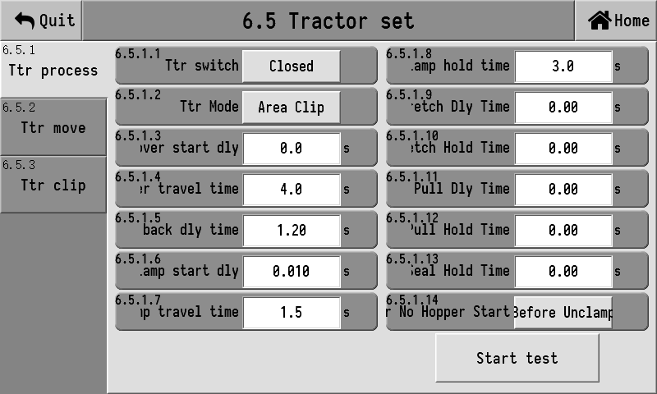
6.5.1.1 | Ttr switch | Turn on/off the traction machine function
6.5.1.2 | Ttr mode | ① Full-sided clip  ② Stretching on both sides
6.5.1.3 | Mover start dly | 0.0 to 99.9 s; The delay time before the start slider moves out towards the packaging scale
6.5.1.4 | Mover travel time | 0.0 to 99.9 s; When using the "normal pneumatic" slider control mode, this time is used to determine the completion of the removal
6.5.1.5 | Move Back dly time | The delay time from 0.0 to 99.9 s before the slider moves back to the action output
6.5.1.6 | Clamp start dly | 0.0 to 99.9 s; Output the delay time before the bag clamping action of the traction machine
6.5.1.7 | Clamp travel time | 0.0 to 99.9 s; When using the "ordinary pneumatic" bag clamping control mode, this time is used to determine the completion of bag clamping
6.5.1.8 | Clamp hold time | 0.0 to 99.9 s; The traction machine clamps the bag and moves back. After this period of time, the bag is released
6.5.1.9 | Stretch dly time | 0.0 to 99.9 s; The time elapsed before the signal output is extended
6.5.1.10 | Stretch hold time | 0.0 to 99.9 s; Extend the signal, hold for this time and then withdraw
6.5.1.11 | Pull dly time | 0.0 to 99.9 s; The time elapsed before pulling the signal output
6.5.1.12 | Pull hold time | 0.0 to 99.9 s; Pull the signal and hold it for this time before withdrawing
6.5.1.13 | Heat seal hold time | 0.0 to 99.9 s; The heat seal signal is held for this time and then withdrawn
6.5.1.14 | Tractor no hopper start | ① Before unclamp: In the no-bucket mode, the slider of the traction machine is started only before bag release.  ② After clamp: In the no hopper mode, the slider of the traction machine is started only after the bag is clamped.
The basic process of a traction machine
When the bag clamping action is initiated, the slider of the traction machine will be simultaneously started to move out towards the packaging scale (in the no-bucket mode, it can be started before the bag is released).
2. When the slider of the traction machine is moved out of position, wait for the Disc to be completed and the bag to be released. When starting the bag release, the bag clamping of the traction machine will be initiated.
After the bag clamping is completed by the traction machine, it will control the sliding block of the traction machine to move back towards the sewing machine.
4. After the slider of the traction machine has been moved back for a certain period of time, the bag clamp of the traction machine is released.
5. After the slider of the traction machine is moved back to its original position, wait for the next bag clamping.
6. If the slider of the traction machine has not been moved out after Disc is completed, the packaging scale will not release the bag. It will wait until the slider of the traction machine is moved out of place before starting the packaging scale to release the bag and the traction machine to clamp the bag.
7. The traction machine is equipped with a buffer function. If there is a bag clamping during the current conveying process, a new traction will be initiated immediately after the conveying is completed.
The timing diagrams of the stretching modes on both sides are as follows:

Ttr move
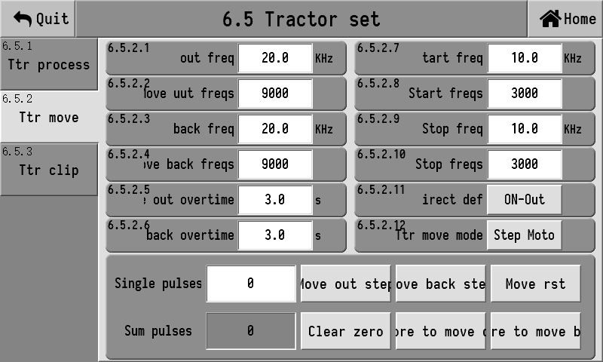
6.5.2.1 | Move out freq | 0.0-60.0KHz; The operating frequency at which the slider moves out towards the packaging machine
6.5.2.2 | Move out freqs | 0-250,000 The number of pulses required for the slider to move out of the packaging machine position
6.5.2.3 | Move back freq | 0.0-60.0KHz; The operating frequency at which the slider moves back towards the sewing machine
6.5.2.4 | Move back freqs | 0-250,000 The number of pulses required for the slider to move back to the position of the sewing machine
6.5.2.5 | Move out overtime | 0.0 to 99.9 s; When a move out (towards the packaging machine position) position switch is installed, this time can be used. If the move out switch position is not reached within this time, the move out action will stop
6.5.2.6 | Move back over time | 0.0 to 99.9 s; When a retracting (moving towards the position of the sewing machine) switch is installed, this time can be used. If the retracting switch position is not reached within this time, the retracting action will be stopped.
6.5.2.7 | Start freq | 0.0-60.0KHz; The frequency at which acceleration begins
6.5.2.8 | Start freqs | 0-250,000 The number of frequencies experienced from the "start-up frequency" to the "operating frequency" during acceleration
6.5.2.9 | Stop freq | 0.0-60.0KHz; The frequency after deceleration is completed
6.5.2.10 | Stop freqs | 0-250,000 The number of frequencies experienced from the "operating frequency" to the "deceleration frequency"
6.5.2.11 | Direct def | ON- Move out; It indicates the direction of the output when it is valid.  ON- Move back; When the table output is valid, it is shifted back in direction
6.5.2.12 | Ttr move mode | 1.valve, 2. Linear motor (i.e., common motor), 3. Stepper motor
Description of the control method for the slider of the traction machine
1. valve
The common pneumatic slider control method uses a common output switch quantity to control the slider's movement out and back. When the output is valid, it indicates that the slider is moving out towards the packaging machine; when the output is invalid, it indicates that the slider is moving back towards the sewing machine. The completion of moving out and moving back is determined by the "slider travel time".
2. Linear motor (ordinary motor)
The slider control mode of the linear motor controls the motor through two common output switch quantities. One rotation signal output and one direction signal output.
The completion of the slider's removal can be determined by the "slider travel time", or by the slider's removal to position switch, or both can be used together. Whichever arrives first will stop.
The completion of the slider's return can be determined by the "slider travel time", or by the slider's return position switch, or both can be used together. Whichever one arrives first will stop.
3. Stepper motor
The slider control methods of stepper motors are divided into moving out and moving back. Moving out has different control modes, as follows:
a. [Fixed Pulse Shift Out Mode] When the shift out position switch is not installed, the shift out operates in this mode. In this mode, after outputting a fixed number of pulses, it is considered that the removal is complete.
b. [Out-of-position Switch Removal Mode] When an out-of-position switch is installed, the out-of-position switch operates in this mode. In this mode, continuously output the number of pulses to control the slider to move out. Once the slider is detected to have moved out in place, it is considered complete and the action stops. If the "Out-of-bounds time" is exceeded and the out-of-bounds position is still not detected, the operation will also stop and it will be considered that the out-of-bounds position has been completed.
There are also different control modes for moving back, as follows
a. [Fixed Pulse Shift Back Mode] When the shift back position switch is not installed, the shift back mode operates in this mode. After outputting a fixed number of pulses in this mode, it is considered that the shift back is complete.
b. [Return to Position Switch Mode] When a return to position switch is installed, the return mode operates in this mode. In this mode, the continuous output of pulse numbers controls the slider to move back. Once it detects that it has moved back to its original position, it is considered complete and the action stops. If the rollback is not detected within the "rollback timeout period", the operation will also stop and it will be considered that the rollback has been completed.

Ttr clip
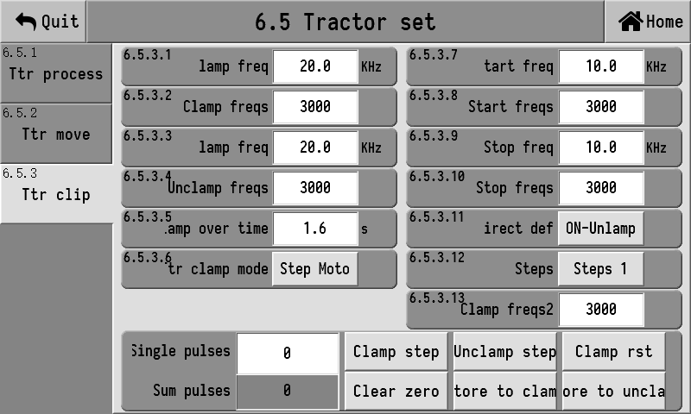
6.5.3.1 | Clamp freq | 0.0-60.0KHz; The operating frequency of the traction machine when clamping bags
6.5.3.2 | Clamp freqs | 0-250,000 The number of pulses required for the traction machine to hold the bag
6.5.3.3 | Unclamp freq | 0.0-60.0KHz; The operating frequency of the traction machine when unclamp bags
6.5.3.4 | Unclamp freqs | 0-250,000 The number of pulses required for the traction machine to release the bag and return it to the origin
6.5.3.5 | Clamp overtime | 0.0 to 99.9 s; When the bag release position switch is installed, this time can be used. If the bag release position switch position is not reached within this time, the bag release action will be stopped
6.5.3.6 | Ttr clamp mode | 1 valve, 2 stepper moto
6.5.3.7 | Start freq | 0.0-60.0KHz; The frequency at which acceleration begins
6.5.3.8 | Start freqs | 0-250,000 The number of frequencies experienced from the " Start freq " to the " Clamp freq " during acceleration
6.5.3.9 | Stop freq | 0.0-60.0KHz; The frequency after deceleration is completed
6.5.3.10 | Stop freqs | 0-250,000 The number of frequencies experienced from the " Clamp freq " to the " Stop freq "
6.5.3.11 | Direct def | ON-clamp: Indicates the direction of bag clamping when the output is effective  ON-unclamp: Indicates the direction of unclamp bag when the output is valid
6.5.3.12 | Steps | Paragraph 1 / Paragraph 2 When in the first stage, directly clamp the bag. When using two sections, first clamp the first section. After the Disc is completed, clamp the second section
6.5.3.13 | Clamp freqs2 | 0-250,000 The number of pulses required for the traction machine to clamp the second section of the bag. This parameter does not work when only one section of the bag is clamped

Description of the bag clamping control mode for the traction machine
1. valve
The common pneumatic bag-clamping control mode uses a common output switch quantity to control the bag-clamping and unclamp of the traction machine. When the output is effective, it is bag-clamping; when the output is ineffective, it is unclamp. The completion of bag clamping and bag release is determined by the "bag clamping travel time".
2. Stepper motor
The clamping and unclamp control methods of stepper motors are divided into clamp and unclamp.
There is only one control mode for bag clamping, which is to fix the number of pulses. After outputting the "number of bag clamping frequencies", it is considered that bag clamping is completed.
There are two ways to unclamp the bag, as follows:
a. [Fixed Pulse Number] When the traction unclamp origin switch is not installed, the unclamp is considered complete after outputting the [unclamp freqs] under the operation of this machine.
b. [Bag Release Mode with In-place Switch] When a traction bag release origin switch is installed, the traction machine operates in this mode for bag release. In this mode, the continuous output of pulse numbers is used to control the bag release until the bag release position is detected and then the action stops. If the bag release is not detected within the "bag release timeout time", the operation will also stop.
Other explanations
1.After power-on and startup, the slider and bag clamp of the traction machine will be automatically reset. In the stepper motor mode, if the slider is not equipped with a return switch, a fixed number of pulses will be output. If it is already in the return position at this time, Noise hindering the door process will occur. Similarly, in the stepper motor mode, if the release bag is not installed with a release switch in place, a fixed number of pulses will be output, and there may also be noise hindering the door process.
2. In the tangential mode of the "stepper motor", if it is detected that it is not at the tangential origin after power-on, it will automatically reset to the origin.
3. The sewing bag cutting line setting interface has a "cutting line Test" function. Clicking on it will start a cutting line action once to check whether the current cutting line function is normal. It should be noted that the "tangential start delay" will also be effective in the test. If the start delay time is set too large, it may take a relatively long time to see the tangential action output after clicking the test.

Event programming
The event function is used to customize high-speed electric actions. When specific high-speed electric actions are required, you can try to implement them using the event function.

Event
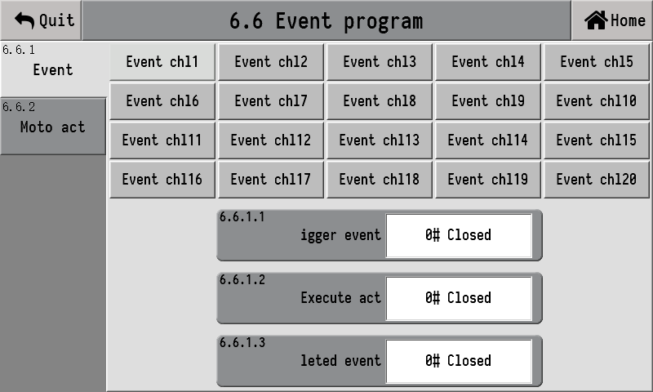
Currently,20 event channels are provided. Each channel can correspond to an event, which then triggers an electric action. After the action is completed, another event is triggered. Its execution process is as shown in the following figure:
【 Trigger Event 】 The event used to trigger an action can be selected as follows:
"Event | Function
0# Closed | Close the event to make it ineffective
User Event 1# | User-defined events
User Event 2# | User-defined events
User Event 3# | User-defined events
User Event 4# | User-defined events
User Event 5# | User-defined events
User Event 6# 6 | User-defined events
User Event 7# | User-defined events
User Event 8# 8 | User-defined events
User Event 9# 9 | User-defined events
User Event 10# | User-defined events
User Event 11# | User-defined events
User Event 12# 12 | User-defined events
User Event 13# | User-defined events
User Event 14# 14 | User-defined events
User Event 15# 15 | User-defined events
16# User Event 16 | User-defined events
User Event 17# | User-defined events
User Event 18# 18 | User-defined events
User Event 19# | User-defined events
User Event 20# 20 | User-defined events
Power on No. 21 has been completed | The event sent after the system is powered on
No. 22 has started operation | The event sent when starting the runtime
No. 23 has stopped running | The event sent when the running stops
Big throw on Scale 24# A | The event sent when Scale A reaches the big throw
Big throw on Scale 25# B | The event sent when Scale B reaches the big throw
Mid-range investment on Scale 26# A | The event sent when Scale A reaches the middle range
Middle range on Scale 27# B | The event sent when Scale B reaches the middle range
28# A scale small throw | The event sent when Scale A reaches the small throw
Small throw on Scale 29# B | The event sent by Scale B when it reaches the slow throw
30# A scale set value | The event sent when Scale A reaches the set value
Scale value for 31# B | The event sent when Scale B reaches its set value
Disc from scale 32# A | The event sent when Scale A starts Disc
Disc from scale 33# B | The event sent when Scale B starts Disc
unclamp on scale 34# A | The event sent when Scale A starts to unclamp the bag
unclamp bag on scale 35# B | The event sent when Scale B starts to unclamp the bag
Move the No. 36 traction slider out | The event sent when the traction slider starts to move out
Move the No. 37 traction slider back | The event sent when the traction slider starts to move back
【 Execution Action 】 High-speed actions executed after triggering an event, with a total of 20 channels, and the action of each channel can be set.
The event sent after the action execution is completed can be used to trigger another event channel.

High-speed action
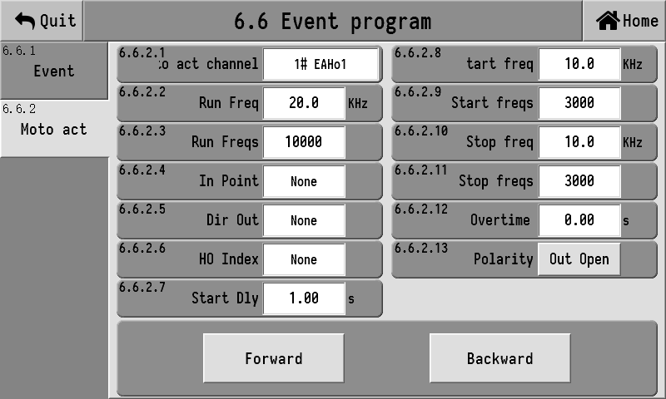
6.6.2.1 | Moto act chan choose | High-speed operation from 1# to 20#
6.6.2.2 | Run freq | 0.0-60.0KHz; The frequency of high-speed action execution
6.6.2.3 | Run freqs | 0-250,000 The number of frequencies output when high-speed actions are executed
6.6.2.4 | In point | If there is an origin switch, select the origin input port. If there is no origin switch, select "Off"
6.6.2.5 | Dir out | Select the OUT port for the direction signal output
6.6.2.6 | Ho index | Select the high-speed port for high-speed pulse output
6.6.2.7 | Start dly | 0.0 to 99.9 s; The delay time before the high-speed action starts
6.6.2.8 | Start freq | 0.0-60.0KHz; The frequency at which acceleration begins
6.6.2.9 | Start freqs | 0-250,000 The number of frequencies experienced from the "start-up frequency" to the "operating frequency" during acceleration
6.6.2.10 | Stop freq | 0.0-60.0KHz; The frequency after deceleration is completed
6.6.2.11 | Stop freqs | 0-250,000 The number of frequencies experienced from the "operating frequency" to the "deceleration frequency"
6.6.2.12 | Overtime | 0.0 to 99.9 s; When there is an origin switch, if the origin switch is not reached within this time, the action will stop. This time does not work when there is no origin switch
6.6.2.13 | polarity | Out open/Out close; When defining the output of the direction signal, determine whether the output is valid or invalid
High-speed action defines the forward movement. When there is no origin switch, it stops running after outputting a fixed number of pulses. When there is an origin switch, the action stops only when it reaches the origin switch. If the current position is already at the origin switch, it will not act.
The high-speed action interface provides a testing function. When the parameters are set, click "Action Forward", and an action will be executed according to the set parameters. If there is an origin switch and the action is already at the origin switch, the action will not be executed.
You can also perform the action in reverse. Just click "Action Backward". The backward movement is not affected by the origin switch and performs a fixed number of pulses. A backward movement will always be executed, regardless of whether it is at the origin position or not.
For example
Here are some examples to illustrate the usage of events. Suppose the following function is to be implemented now:
During the Disc and unclamp process, the traction and clamping should move towards the bag opening for a certain period of time (for example, 3000 pulses) to get closer to the bag opening.
2. When the bag drops, proceed to the second section (for example, 4000 pulses) for clamping.
3. After the traction slider moves back for a period of time (for example, 2 s), the traction strap unclamp and returns to the origin.
4. When powered on and started, if the traction strap is not at the origin, it should return to the origin.
(1) The first section of function implementation
The first function is that when Disc and unclamp the bag, the traction strap moves 3000 pulses towards the bag opening. The "Event Channel 1" and "1# High-Speed Action 1" can be selected to achieve this function.
"1# High-Speed Action 1" is set as follows:
Operating frequency | Set according to actual conditions
Number of operating frequencies | 3000
Start-up frequency | Set according to actual conditions
The number of start-up frequencies | Set according to actual conditions
Deceleration frequency | Set according to actual conditions
Number of deceleration frequencies | Set according to actual conditions
Startup delay | 0. Execute immediately
Timeout period | 0. It doesn't work
Origin input port | Select "None", no origin is needed
Pulse output port | Set according to actual conditions
Directional output port | Set according to actual conditions
Directional polarity | Set according to actual conditions
"Event Channel 1" is set as follows:
Trigger event | unclamp the bag on scale 34# A
Perform an action | # High-speed Action 1
Complete the event | User Event 1#
After completing the above Settings, when starting the bag unclamp process, the "34# A scale Bag unclamp " event will be triggered, and then "1# High-speed Action 1" will be executed. This way, the first section of the function is achieved.
In addition, after the completion of "1# High-speed Action 1", send the completion event "1# User Event 1", which is used to trigger the second action.
(2) The second section of function implementation
The second function is to travel 4,000 pulses and perform clamping. This function can be accomplished by choosing "Event Channel 2" and "2# High-Speed Action 2".
"2# High-Speed Action 2" is set as follows:
Operating frequency | Set according to actual conditions
Number of operating frequencies | 4000
Start-up frequency | Set according to actual conditions
The number of start-up frequencies | Set according to actual conditions
Deceleration frequency | Set according to actual conditions
Number of deceleration frequencies | Set according to actual conditions
Startup delay | Set according to actual conditions
Timeout period | 0. It doesn't work
Origin input port | Select "None", no origin is needed
Pulse output port | Set according to actual conditions
Directional output port | Set according to actual conditions
Directional polarity | Set according to actual conditions
"Event Channel 2" is set as follows:
Trigger event | User Event 1#
Perform an action | 2# High-speed Action 2
Complete the event | 0# Closed
After the above Settings are completed, when "1# User Event 1" occurs, "2# High-speed Action 2" will be executed. In this way, the second section of the function is realized, fulfilling the requirements of the interlocking.
(3) Realization of the third section of functions
The third function is to pull the slider back for a certain period of time (for example, 2 s), and then the traction strap unclamp and returns to the origin. This function can be accomplished by using "Event Channel 3" and "2# High-Speed Action 3".
The Settings for "3# High-Speed Action 3" are as follows:
Operating frequency | Set according to actual conditions
Number of operating frequencies | 7000
Start-up frequency | Set according to actual conditions
The number of start-up frequencies | Set according to actual conditions
Deceleration frequency | Set according to actual conditions
Number of deceleration frequencies | Set according to actual conditions
Startup delay | 2, that is, release and return to the original point after 2 s
Timeout period | Set according to actual conditions
Origin input port | Set according to actual conditions
Pulse output port | Set according to actual conditions
Directional output port | Set according to actual conditions
Directional polarity | Set according to actual conditions
"Event Channel 3" is set as follows:
Trigger event | Move the No. 36 traction slider back
Perform an action | 3# High-speed Action 3
Complete the event | 0# Closed
After the above Settings are completed, when the traction slider moves back, the "36# Traction Slider Moves Back" event will be triggered, and "3# high-speed Action 3" will be executed to bring the strap back to the origin.
(4) The fourth section: Function realization
The fourth function is to bring the traction back to the origin after power-on is completed. This is the same action as the return to the origin in the third section, so there is no need to define a new action. It is only necessary to trigger the "3# high-speed Action 3" in the third section to execute once.
It can be implemented using "Event Channel 4", and the Settings are as follows:
Trigger event | Power on No. 21 has been completed
Perform an action | 3# High-speed Action 3
Complete the event | 0# Closed

Logic programming
Logic programming is used to implement custom functions. There are a total of 6 sets of logic programming, which can achieve 6 custom functions. The interface of Logic Programming 1 (the interfaces of other logic programming are the same and will not be elaborated here) is as follows:
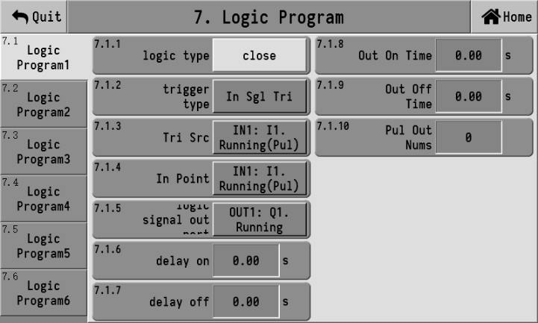
7.1.1 | Logical type | ① Close  ② Delayed connection and delayed disconnection  ③ Invalid - valid jump edge trigger  ④ Valid - invalid jump edge trigger  ⑤ Self-locking  ⑥ Pulse  ⑦ Rotation
7.1.2 | Trigger type | ① In signal trigger: That is, the input signal trigger from In1 to In14 input ports;  ② Out signal trigger: That is, the output signals of the Out1 to Out23 output ports are triggered.  ③ Out function trigger: That is, output function trigger, such as fixed value function trigger. It can be triggered without defining a fixed value function in Out
7.1.3 | Tri src | When the trigger type is [In signal trigger], the trigger source is In1 to In14. When the trigger type is [Out signal trigger], the trigger source is Out1 to Out23. When the trigger type is [Out function Trigger], the trigger source is: run, stop, fast investment... User control and other functions
7.1.4 | In point | It is available when the logic type is [Rotation]
7.1.5 | Logical signal output port | Output for logic programming
7.1.6 | Delay on | 0.0 to 99.9 s; The corresponding logic programming action will be output only after this delay time
7.1.7 | Delay off | 0.0 to 99.9 s; The corresponding logic programming action will not be stopped until after this delay time
7.1.8 | Out on time | The effective duration of logic signal output is 0.0 to 99.9 s
7.1.9 | Out off time | 0.0 to 99.9 s; The duration of invalid logical signal output
7.1.10 | Pul out nums | When the pulse is output, it is used to control the number of output pulses. Set to 0, the pulse is continuously output

Logical output sequence diagram
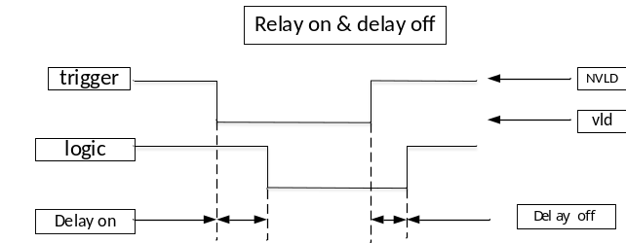
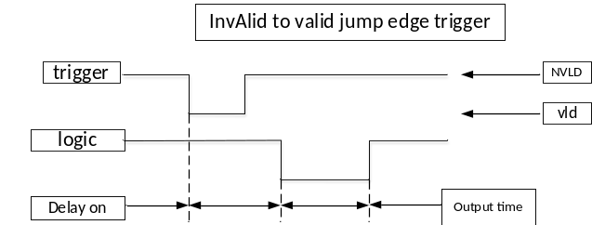
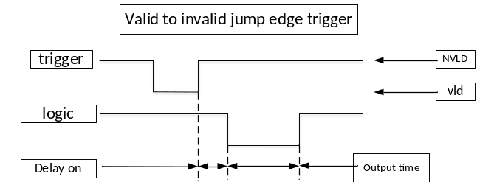
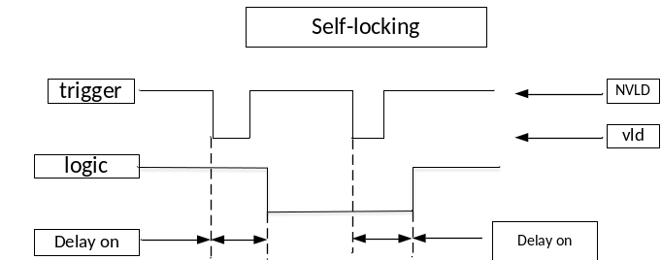
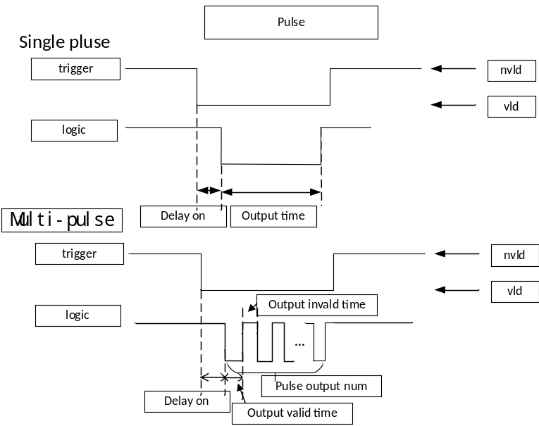
Note
When waiting for the "delayed connection time", if the "invalidation-valid jump" occurs again, the waiting for the "delayed connection time" will be restarted, and all previous waits will be invalidated.
2. The "delayed connection time" can be set to 0, meaning there is no delay.
⑥Rotation
Rotation is the way to control the motor to make one full rotation and then return to the origin. Its operation process is as follows:
1. [Trigger Source] An "invalid - valid jump" occurs;
2. Wait for the "delayed connection time";
3. Output (logic programming output) signal;
4. Wait for the motor to leave the origin, that is, wait for the input at the "Origin Input port" to be invalid;
5. After the motor leaves the origin, when the input at the origin input port is valid, the (logic programming output) signal is turned off to complete the rotation process. Or when the "output valid time" is up, also turn off the (logic programming output) signal to complete the rotation process.

When waiting for the "delay connection time", if a new "invalidation-valid jump" occurs in the "trigger source", the delay will be restarted and all previous delays will be invalidated and not used.
2. [Delayed connection Time] can be set to 0, meaning there is no delay and it outputs immediately.
3. [Output Valid Time] When set to 0, the time stop function is not used; only the origin is detected.

Self Test
The self-check function can get the system running without materials or load cells connected to check if all mechanisms are functioning properly. Click the "Self-Check" button on the system maintenance interface, and you will enter the self-check interface as follows:
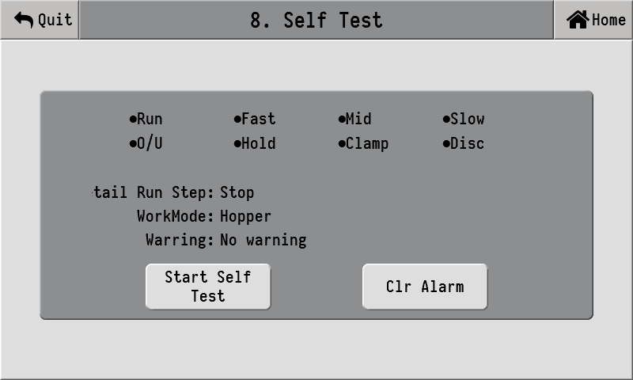
Click "Start Self-Check" to activate the self-check function. Click again to stop the self-check.

Comm para
This electric instrument can be equipped with a communication module for communication. The additional communication options are one RS232 and one RS485.
"9.1 RS232 Settings" interface:
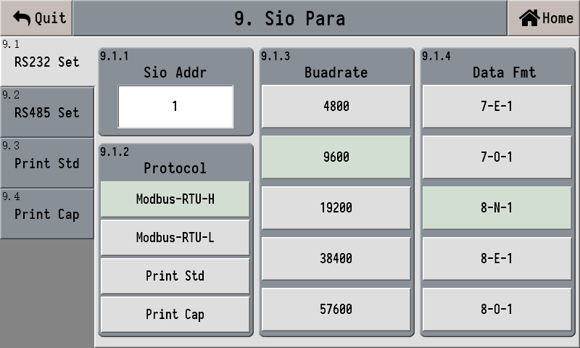
The "9.2 RS485 Settings" interface is connected to the RS232 Settings interface.
9.1.1 | Sio addr | The device address, RS232 and RS485 can be set to different addresses separately
9.1.2 | Protocol | Modbus-RTU-H, Modbus-RTU-L, standard printing, statistical printing
9.1.3 | Baudrate | 4800,9600,19200,38400,57600
9.1.4 | Data fmt | 7-E-1, 7-O-1,8-N-1, 8-E-1, 8-O-1
When the protocol is printed as a standard, its Settings interface is as follows:
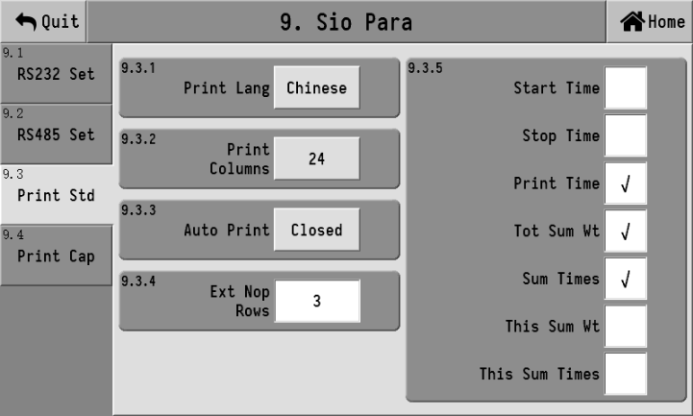
When printing statistics, the Settings interface is as follows:
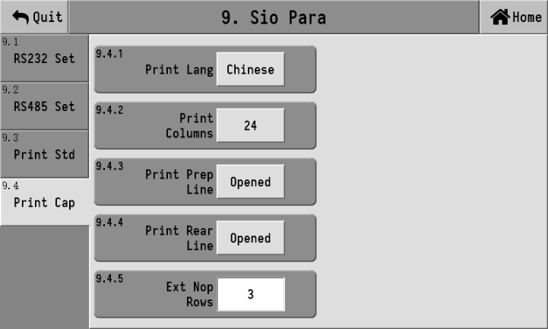

System
The system interface includes functions such as parameter reset, time and date, product registration, parameter backup and recovery, data import and export, as well as home page definition.

Parameter reset
Click the button to reset the corresponding parameter items. The parameter values will be restored to the factory Settings. Please operate with caution.
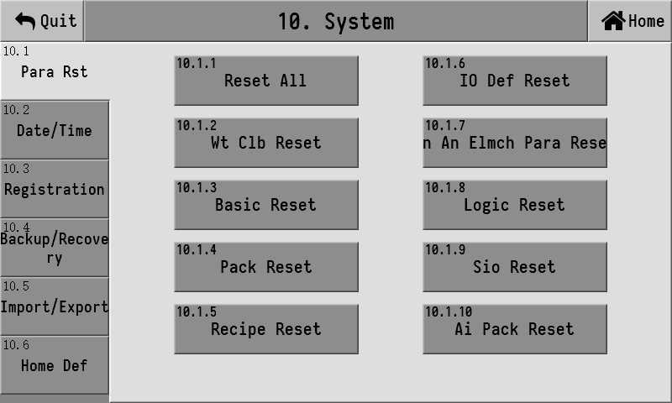

Date/Time
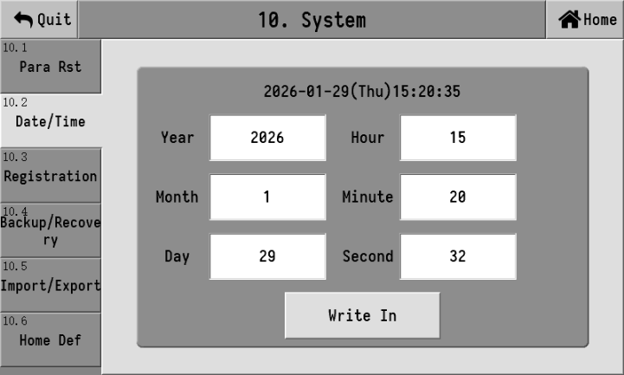

Registration
Product usage registration Settings：
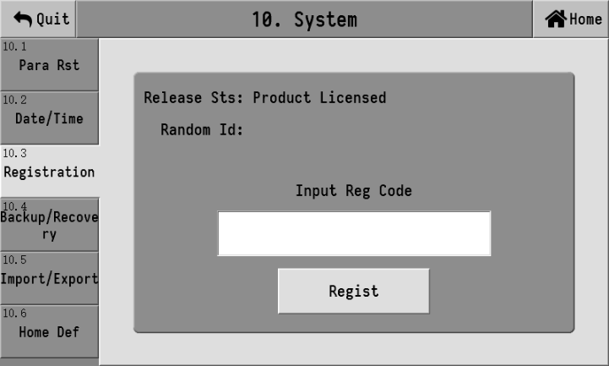

Backup/recovery
The current parameter values set by the controller can be backed up to the local memory, and recovery operations can be performed when needed. To prevent accidental operation, when entering the parameter backup and restore interface, the backup and restore button are disabled by default. Special operations are required to enable the backup and restore functions. The operation method is to click the position shown in the following figure①three times, then click the②position three times, and then③click the position three times. The backup and restore backup functions can be enabled.
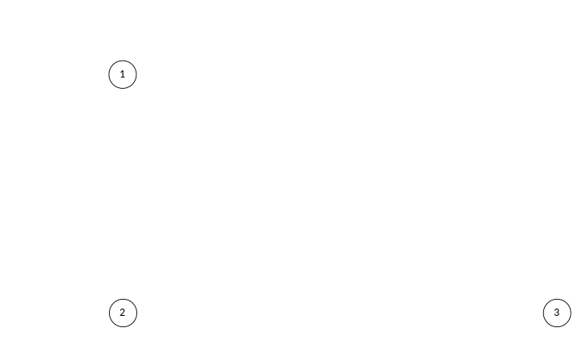

Data import and export
The controller can export the currently set parameters to a USB flash drive, and the exported file is in CSV format.
Data export operation
On the left side of the interface, select the parameter items you need to export. After inserting the USB flash drive, click UDisk Export" to export the selected items to the USB flash drive.
Data import operation
Insert the USB drive with data files. The list on the right side of the interface will display the data files currently existing on the USB drive. Select the data files you need to import and click UDisk Import
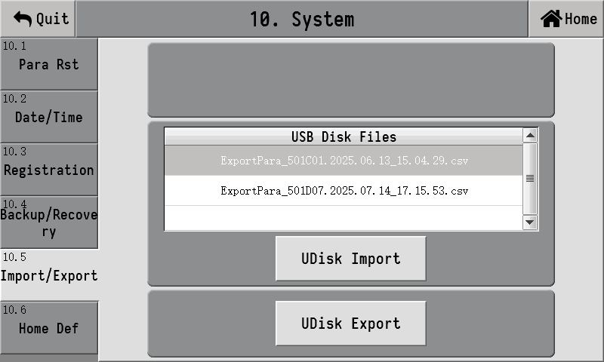

Home page Definition
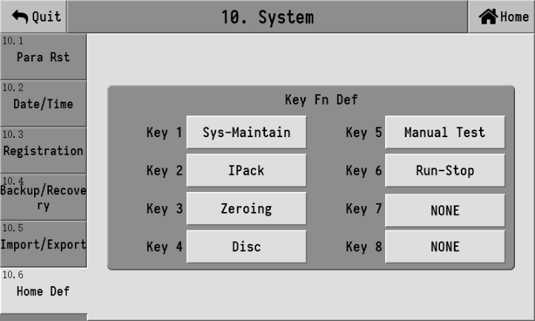
The key function options include: NONE, sys-maintain, Ipack, clear alarm, zeroing, clamp, Disc, manual test, run-stop and print.

Admin Pass Change
When leaving the factory, the default administrator password is six zeros. Under the administrator's authority, the administrator password can be modified. In the system maintenance interface, click on "Administrator Password Modification", then enter the new password in the pop-up interface and click "Confirm". If you click "Exit", the old password will remain unchanged.

AI Ipack
The controller has the AI intelligent packaging algorithm developed by AMP measurement and control company for the packaging process, which can collect the characteristic parameters of each feeding process, calculate and analyze the collected data through the machine learning AI algorithm, and automatically adjust the parameters, so that the packaging scale operation to achieve both fast and accurate.

Func set
AI Intelligent packaging basic function Settings:
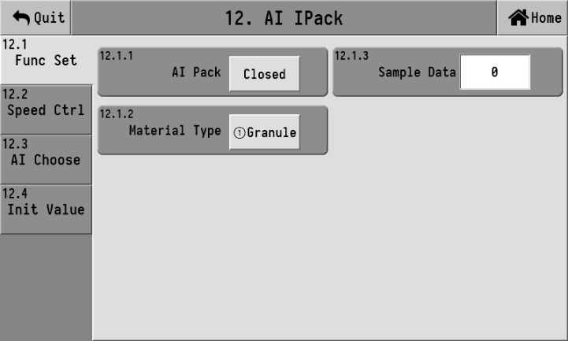
12.1.1 | AI Pack | AI intelligent packaging function of the master switch  When the function is open, the controller automatically adjusts the following parameters:  【4.2.2 fast】  【4.2.3 mid】  【4.2.4 Slow】  【4.2.6mid No Cmp time】  【4.2.7 Slow No Cmp Time】
12.1.2 | Material Type | ①Granule  ②powder  Select the material type of packaging, AI intelligent packaging algorithm can be optimized for different types of materials, get more suitable for the characteristics of the material related parameters.
12.1.3 | Sample Data | The AI intelligent packaging function will save the weighing data of the latest 100 times at most, carry out machine learning AI intelligent packaging algorithm calculation, and get the relevant parameters of feeding suitable for the current state.  This project can view the number of saved sampled data. You can enter 0 to clear the saved sampled data and start statistical sampling again.

Speed ctrl
AI intelligent packaging function Related to packaging speed control parameters, the AI intelligent packaging algorithm can be set to automatically calculate and control the packaging speed, or the customer can manually set the packaging speed to be controlled, and the AI intelligent packaging algorithm can adjust the parameters to achieve the set speed.
Note: If the packaging speed set manually is too fast and exceeds the speed that the equipment can achieve, inaccurate packaging accuracy may occur.
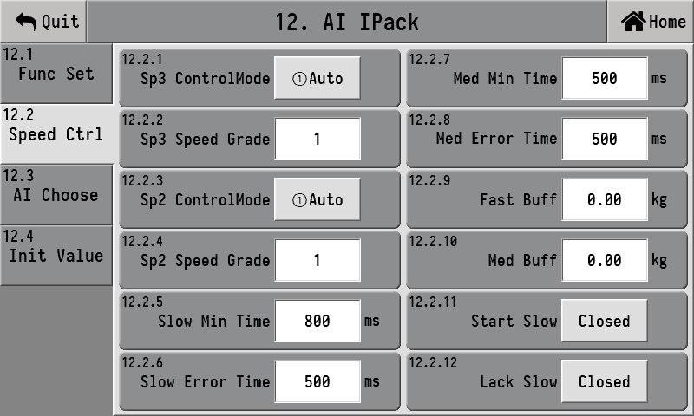
number | Parameter | Explanation | Init value
12.2 | Speed control
12.2.1 | Sp3 control mode | ①Auto: The controller automatically controls the packaging speed  ② Manual: The packaging speed is determined by the set parameters [12.2.5 Slow Min Time] and [12.2.6 Minimum input Error Time]. | ① Auto
12.2.2 | SP3 Speed grade | 0~4; 【12.2.1 SP3 Speed Control Mode 】 It works when set to automatic, and the smaller the number, the faster the speed. | 1
12.2.3 | Sp2 control mode | ①Auto: The controller automatically controls the packaging speed  ② Manual: The packaging speed is determined by the set parameters [12.2.7 Slow Min Time] and [12.2.8 Minimum input Error Time]. | ① Auto
12.2.4 | SP2 Speed grade | 0~4; 【12.2.3 SP2 Speed Control Mode 】 It works when set to automatic, and the smaller the number, the faster the speed. | 1
12.2.5 | Slow Min Time | 0~60,000ms; 【12.2.3 sp2 Speed Control Mode 】 When set to manual, these two time parameters are used to determine the standard time for the slow throw.  The prohibited comparison time for slow investment + the shortest time for slow investment ≤ the standard time for slow investment ≤ the prohibited comparison time for slow investment + the shortest time for slow investment + the error time for slow investment.  The intelligent packaging function controls the slow drop time to always be within the standard time by adjusting the lead parameter. | 800ms
12.2.6 | Slow Error Time |  | 500ms
12.2.7 | Med Min Time | 0~60,000ms; These two time parameters determine the standard time for mid-investment.  The prohibited comparison time for mid-range investment + the shortest mid-range investment time ≤ the standard mid-range investment time ≤ the prohibited comparison time for mid-range investment + the shortest mid-range investment time + the mid-range investment error time.  The intelligent packaging function controls the input time to always be within the standard time by adjusting the lead parameter. | 500ms
12.2.8 | Med Error Time |  | 500ms
12.2.9 | Fast Buff | When decelerating, increase this buffer value on the basis of a fast lead investment. | 0.0
12.2.10 | Med Buff | When decelerating, increase this buffer value on the basis of the mid-range lead. | 0.0
12.2.11 | Start slow | ① OFF  ② ON: When starting up, increase the lead time for Fast feed and med feed to reduce the packaging speed. | ① OFF
12.2.12 | Lack Slow | ① OFF  ② ON: When there is a shortage of materials, increase the fast feed and med feed, and reduce the packaging speed. | ① OFF

AI choose
The correction switches for fast, med and slow investments can be controlled separately. Once turned off, the AI intelligent packaging algorithm will no longer adjust the corresponding lead time.
12.3 | Correction switch
12.3.1 | Fast AI Func | ① OFF: Do not correct the "Fast feed" parameter  ② ON | ②opened
12.3.2 | Med AI Func | ① OFF: Do not correct the "Med feed" parameter  ② ON | ②opened
12.3.3 | Slow AI Func | ① OFF: Do not correct the" Slow feed" parameter  ② ON | ②opened
12.3.4 | Med NoCmp AI | ① OFF: Do not correct the parameter "Med No Cmp time"  ② ON | ②opened
12.3.5 | Slow NoCmp AI | ① OFF: Do not correct the parameter "Slow No Cmp Time"  ② ON | ②opened

Initial value
The AI intelligent packaging algorithm control is divided into two stages: 1. The automatic learning stage, and 2. The automatic correction stage.
The automatic learning stage is further divided into self-learning of the feeding simulation quantity and self-learning of the lead quantity.
12.4 | Learn the initial value
12.4.1 | Fast Init | 1%~99% When the lead amounts for fast, med and slow feed are all set to 0, the controller starts to self-learn the initial values of the lead amounts for fast feed and med feed. | 80%
12.4.2 | Med Init |  | 40%
12.4.3 | Slow time | 0 ~60,000ms; The feeding time of the controller when learning the slow feed. | 2000

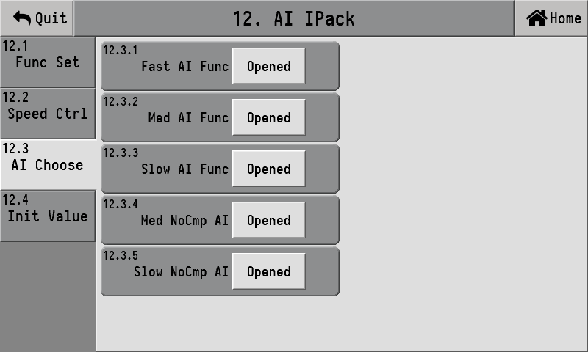

Packaging control

Packaging process for the bucket scale
The basic packaging process is as shown in the following figure
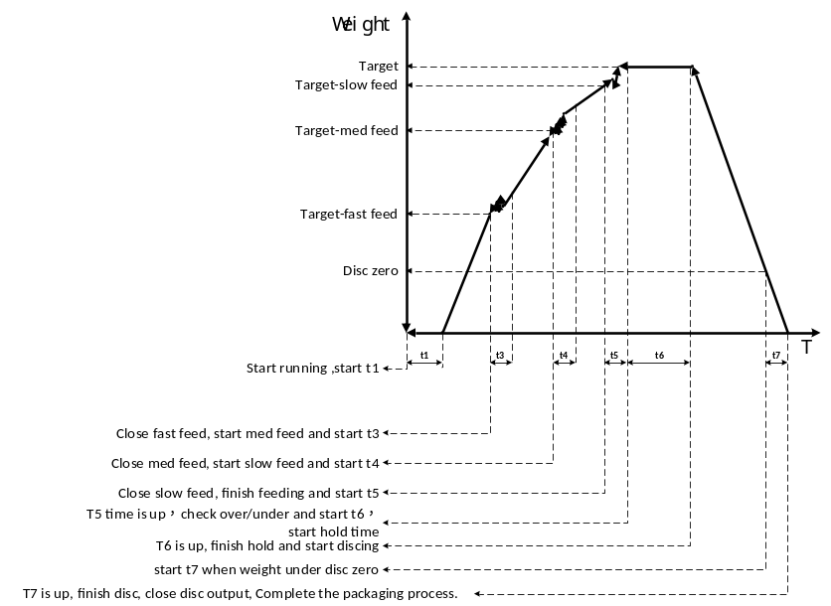
Now, we will explain the basic packaging process of the bucket scale in combination with the above figure
Each time the packaging starts running, it will first wait for a delay time t1.
After t1 time arrives, if the automatic zeroing condition is met, an automatic zeroing will be carried out once, and then the fast investment will be initiated. If not satisfied, a fast investment will be directly initiated.
3. After initiating the big throw;
4. Collect the weight in real time and compare it. When the weight value is greater than or equal to the target value - the lead amount for the fast throw, close the fast throw and start the mid throw.
5. After the middle range is activated, start the middle range to prohibit comparison time t3. Only after t3 time will the weight comparison begin.
6. Collect the weight in real time and compare it. When the weight value is greater than or equal to the target value - the lead amount of the middle range, turn off the middle range and start the slow range.
7. After the slow throw is activated, the comparison time t4 is prohibited when starting the slow throw. Weight comparison should only begin after t4 time.
8. Collect the weight in real time and compare it. When the weight value is greater than or equal to the target value - the drop value of the slow feeder, close the slow feeder and end the feeding.
After the feeding is completed, start the over-limit and under-limit detection time t5. When the instrument is stable and the scale bucket is stable, record the data. In the combination mode, the out-of-tolerance detection will only be carried out if the current scale is the last scale of this packaging. If the detection is out of tolerance or out of tolerance, it may stop for 2 s or be paused directly according to the Settings.
After the over-limit and under-limit detection is completed, start the fixed value holding time t6.
11. After the t6 time is up, the setting process is completed. At this point, it will detect whether the bag has been clamped. If it has not been clamped, wait for it to be clamped. If it has already been clamped, start Disc.
12. When Disc, if the weight is lower than the zero zone value for Disc, start t7 and delay until the Disc is completed. At this point, complete one quantitative packaging process and return to step 1 to start the next packaging process.

Packaging process of the bucket-less scale
The basic packaging process is shown in the following figure:
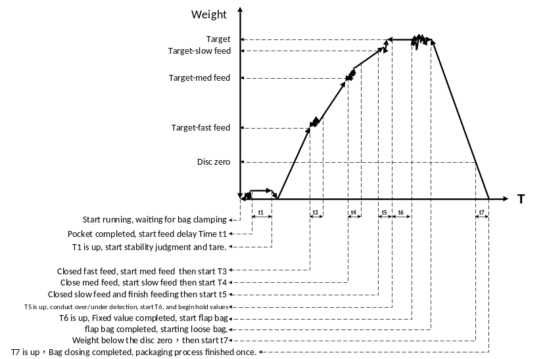
Now, we will explain the basic packaging process of the bucket-less scale in combination with the above figure
1. At the start of operation, first wait for the bag clamp to be effective;
2. After the bag clamping is effective, wait for the feeding delay time t1. After t1, perform the stable peeling.
3. After successful peeling, start the fast-scale feeding.
4. When the weight value is greater than or equal to the target value - the lead time for the fast throw, close the fast throw, start the middle throw, and activate the middle throw to prohibit comparison time t3. Only after t3 will the real-time weight value comparison begin.
5. When the weight value is greater than or equal to the target value - the lead amount of the middle range, turn off the middle range, activate the small range, and start the slow range to prohibit the comparison time t4. Only after t4 will the real-time weight value comparison begin.
6. When the weight value is greater than or equal to the target value - the drop value of the slow input, close the slow input, end the feeding, and start the over-limit and under-limit detection time t5.
7. After t5 time, the instrument determines stability and records the data. If the detection shows an over-tolerance or under-tolerance, it may stop for 2 s or even pause directly according to the Settings. Then start the fixed value holding time t6;
8. After the t6 time is up, the setting process is completed
9. After the setting is completed, if the bag patting has not been initiated, the bag release delay will be activated. If the bag-patting function after setting the value is enabled, the bag-patting will be carried out first. After the bag-patting is completed, the bag release delay will be initiated. When the delay ends, the bag will be automatically released, meaning that the bag clamping is invalid and a bag release signal will be output.
10. When the weight value is less than half of the target value, start the Disc delay time t7. After t7 time, one packaging process is completed and return to step 1 to start a new packaging process.

Bulk material scale process
The basic process of the bulk material scale is the same as that of the hopper scale. Please refer to the process of the hopper scale. The bulk material scale can be set with a "quantitative weight". When the accumulated weight reaches the set "quantitative weight", it will alarm and stop the machine.

Belt(conveyor)
In the bucket-less scale mode, during operation, when starting the additional bag patting, stop the belt (conveyor). While outputting the bag release signal, the belt (conveyor) will be started to convey the bags away. The following relevant parameters need to be set:
For the belt (conveyor) function to be effective, it is first necessary to define the output switch quantity of the "belt (conveyor)" function.
【 Belt Start Delay 】 It is only after one belt start delay time from the start of the belt that the belt signal is truly output at the switch port.

Feeding control
When a cutting level is defined and the input of the cutting level is invalid, output the (supply) and (shortage) signals.
2. When a feeding level is defined and the input of the feeding level is valid, the (supply) and (shortage) signals are turned off.
3. When a mid material level is defined and the input of the mid material level is invalid, output the (supply) signal, but turn off the (shortage) signal.

AMC501-H-920B01-00

