AMC401-T
Tonnage Bag Controller
Module Manual

©2018 Shenzhen Accurate Measurement and processing Technology Co ltd, copyright ownership.
Without permission from Shenzhen Accurate Measurement and processing Technology Co ltd, No unit or individual shall reproduce, disseminate, transcribe or translate into another language in any form or by any means.
As our products have been continuously improved and updated, we reserve the right to revise this manual without further notice. To do this, visit the company's website frequently to get timely information.
Company web site：http://www.szamp.com.cn/

This product carries out the standard:
GB/T 7724-2008 National standard of <electronic weighing instrument>
JJF1624-2017 Type evaluation outline of <digital weighing indicator (weighing indicator) >
JJG649-2016 Verification regulation of digital weighing indicator (weighing indicator)

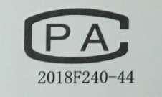
Category
1. Basic Information 5
1.1. Features and Specifications 5
1.2. Front Panel 7
1.3. Wiring Ports 8
1.3.1. Sensor Wiring Method 10
1.3.2. I/O Wiring Method 10
1.3.3. Comm wiring method 11
1.4. Expansion Interface 12
1.4.1. I/O Expansion Board 12
1.4.2. Analog Expansion Board 12
1.4.3. Ethernet Port Expansion Board 13
1.5. Installation dimensions 14
2. Main Interface 16
3. Function Menu 16
3.1. Calibration 17
3.1.1. Weight Calibration Procedure 19
3.1.2. Quick Zero Calibration 20
3.1.3. Calibration Precautions 20
3.2. Weighing Parameters 21
3.3. Ctrl Parameters 22
3.3.1. Clamp/Hook 23
3.3.2. Lift Table 26
3.3.3. Inflate 31
3.3.4. Feed Process 32
3.3.5. Flap bag 34
3.3.6. Fixed Process 37
3.3.7. Conveyor 40
3.3.8. Material level 43
3.4. Recipe setting 47
3.4.1. Recipe 47
3.4.2. Target 47
3.4.3. Flap bag 49
3.4.4. Feeding Analog 51
3.5. I/O 52
3.5.1. IN Setting 53
3.5.2. OUT setting 56
3.5.3. I/O Test 59
3.6. Acc Data 60
3.6.1. Batch &Acc 60
3.6.2. Recipe Acc 61
3.7. Comm setting 62
3.7.1. RS232 62
3.7.2. RS485 Settings 64
3.7.3. Print Settings 64
3.7.4. Network Port Settings 66
3.8. Password 67
3.9. System 69
3.10. Logic Programming 69
3.10.1. Logic Output Timing Diagram 73
3.11. Analog 76
3.11.1. Output Settings 77
3.11.2. Analog Calibration 78
4. Process Description 81
4.1. Ton Bag Scale Packaging Process 81
4.2. Stop, Pause, Slow Stop, and End 84
5. Alarm information 85
6. Common Troubleshooting 87

Basic Information

Features and Specifications
AMC401-T is a single-channel hopper less quantitative tonnage bag controller module, supporting bracket lifting and lowering control, conveyor control, as well as bag inflation and air return functions.
Users can also utilize the touchscreen interface developed by our factory to further enhance the product's ease of use.
AMC401-T has the following basic features:
● Operating Voltage: DC24V
● Weighing Channels: Single channel
● Sensor: DC5V/4-wire, 6-wire compatible
● Digital I/O: 7 inputs/12 outputs (optional expansion with 3 inputs/2 outputs)
● RS232 Communication: 1 port
● RS485 Communication: 1 port
● Communication Protocol: MODBUS-RTU
● Installation Method: Rail (or screw fastening)
● Dimensions: 120×80×61 (length×width×height, mm, excluding protrusions)

The detailed technical specifications are as follows:
Sensor excitation | DC5V ± 10%/120mA driving current/can be connected in parallel with 8 sensors of 350 Ω specification
Adapt to sensor sensitivity | 2mV/V or 3mV/V
Input signal range | 0~15mV
Input sensitivity | 0.5uV/d
nonlinear | 0.02% FS (at 3mV/V)
zero drift | <0.5μV/℃
Gain drift | <10PPM/℃
AD conversion rate | 960 times/second
Highest display resolution | 1/999999
Product accuracy level | 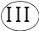
Working Voltage | DC24V (compatible with 18V~30V)
Product power consumption | <5W
Operating Temperature | -10℃~45℃
Storage temperature | -20℃~60℃
humidity | Within 90% RH (no condensation)

Front Panel
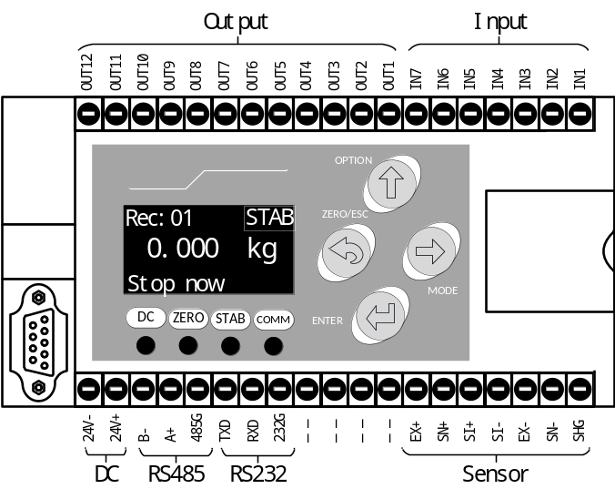
The instrument front panel consists of an LCD display, 4 indicator lights, and 4 buttons. Description is as follows:
Indicator light
Comm | When the serial port receives an instruction and responds, the indicator light will light up once
DC | It remains bright when powered on.
Zero | The zero point of the controller's weight is always on
Stab | The controller's weight is stable and it often lights up
Key press
  ZERO | - Press a key on the menu interface to exit the upper-level menu at one time.  - The standby state key performs a reset operation once.  - Long press in standby mode to perform the zero calibration operation.  - In the numerical input interface, long press to clear the input data.  - The alarm can be cleared when alarm happened.
OPTION | - For the menu and selection interface, move the cursor upwards.  - In the numerical input interface, increase the flashing number by 1.
MODE | - In the menu and selection interface, move the cursor down.  - In the numerical input interface, move the cursor to the right to flash.
ENTER | - Menu and selection interface, confirm entry to the current option.  - In the numerical input and option interface, confirm to save the current data.

Wiring Ports
Wiring port descriptions are as follows:
Category | Inter | Explanation
Power supply | 24V | DC24V power supply positive
Power supply | 24G | DC24V power supply negative
Sensor  Interface | EX+ | Sensor excitation positive
Sensor  Interface | EX- | Sensor excitation negative
Sensor  Interface | SI+ | Sensor signal positive
Sensor  Interface | SI- | Sensor signal negative
Sensor  Interface | SN+ | sensor senses positive.
Sensor  Interface | SN- | Sensor senses negative
Sensor  Interface | SHG | Sensor shielding wire
Serial port  (RS485) | A+ | RS485 A+
Serial port  (RS485) | B- | RS485 B-
Serial port  (RS485) | 485G | RS485 GND
Serial port  (RS232) | TXD | RS232 TXD
Serial port  (RS232) | RXD | RS232 RXD
Serial port  (RS232) | 232G | RS232 GND
output | OUT1 | output 1 | Q1. Running
output | OUT2 | output 2 | Q2. Stop
output | OUT3 | output 3 | Q3. fast
output | OUT4 | output 4 | Q4. Med
output | OUT5 | output 5 | Q5. Fine
output | OUT6 | output 6 | Q8.Hold
output | OUT7 | output 7 | Q10.Warning
output | OUT8 | output 8 | Q11.Clamp
output | OUT9 | output 9 | Q12.Hook On
output | OUT10 | output 10 | Q13.Rise(Air)
output | OUT11 | output 11 | Q20. Inflate
output | OUT12 | output 12 | Q21.Deflate
input | IN1 | input 1 | I1. Running
input | IN2 | input 2 | I2. Stop
input | IN3 | input 3 | I4. Pause
input | IN4 | input 4 | I6. Clear alarm
input | IN5 | input 5 | I8.Clamp/Unclamp
input | IN6 | input 6 | I9.Hook On/Off
input | IN7 | input 7 | I10.Rise/Fall

Sensor Wiring Method
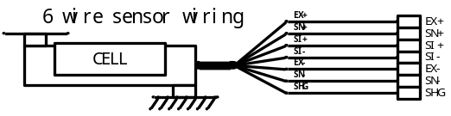
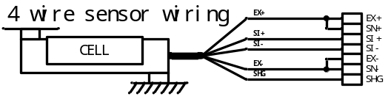

I/O Wiring Method
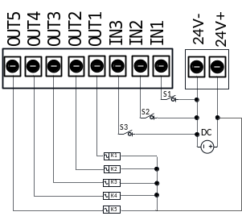
The external circuit driven by the following two points:
- The external circuit should share with the controller;
- When the external circuit is input at a low level, the input is valid, otherwise, the input is invalid.
The external circuit driven by the output switching quantity should meet the following two main points:
- The external circuit should share with the controller;
- The switching output is low.
Note: The maximum driving capacity of each switching output port is 500 mA. Please pay attention to the power of the load when connecting the load. Over the driving capacity of the output port may cause damage to the switching output port.

Comm wiring method
RS 485 Wiring signal:
Instrument 1
A+
B-
GND
Instrument 2
A+
B-
GND
appearance N
A+
B-
GND
computer /PLC
A+
B-
GND
RS232 wiring diagram:
control
RXD
TXD
GND
computer
/PLC
RXD
TXD
GND

Expansion Interface

I/O Expansion Board
The controller can be optionally equipped with a digital I/O expansion board, featuring a DB9 connector interface, which provides an additional 3 inputs/2 outputs for digital signals. The controller automatically detects the expansion board and adds the corresponding digital I/O functions.
The interface definitions are as follows:
DB9 pin | specification
NO.1 lead foot | empty
NO.2 lead foot | empty
NO.3 lead foot | IN8
NO.4 lead foot | IN9
NO.5 lead foot | IN10
NO.6 lead foot | OUT13
NO.7 lead foot | empty
NO.8 lead foot | OUT14
NO.9 lead foot | empty
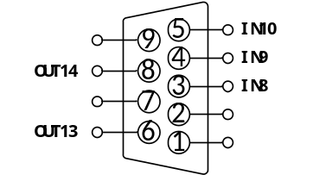

Analog Expansion Board
The controller can be optionally equipped with an analog expansion board, featuring a DB9 connector interface, which provides one analog output channel. The controller automatically detects the expansion board and supports voltage or current output (specify voltage or current output when ordering).
For detailed information, refer to Section 3.11 Analog.
The interface definitions are as follows:
DB9 | specification
NO.1 lead foot | empty
NO.2 lead foot | empty
NO.3 lead foot | U1+/I1+
NO.4 lead foot | empty
NO.5 lead foot | empty
NO.6 lead foot | empty
NO.7 lead foot | empty
NO.8 lead foot | U1-/I1-
NO.9 lead foot | empty
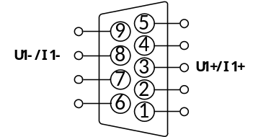
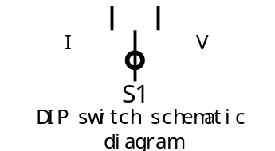

Note:
The DIP switch is located on the power board. Changing the output requires disassembling the instrument. Voltage or current output can be pre-configured during factory ordering.
Analog expansion and digital expansion cannot be selected simultaneously.

Ethernet Port Expansion Board
The controller can be optionally equipped with an Ethernet port expansion board.
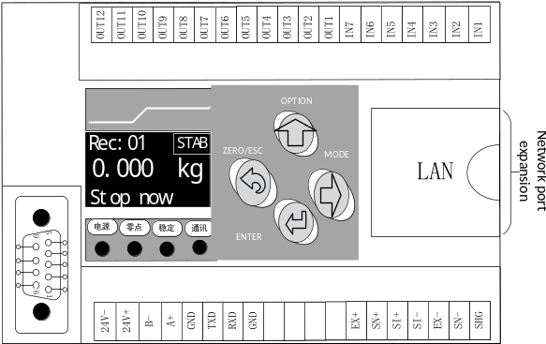

Installation dimensions
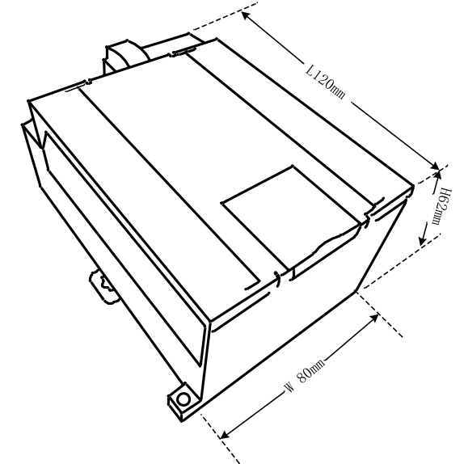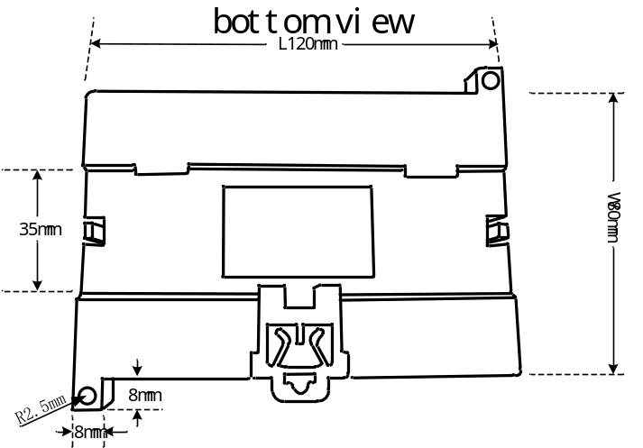

Main Interface
After powering on, the controller screen displays information such as the model and version date, then enters the main interface after 2 seconds, as shown below:
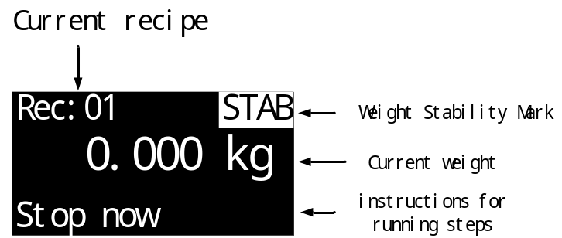
Operations available in the main interface:
key: Enter the main menu.
key: Clear/reset alarm (when an alarm is present).
Long press key: Quick zero calibration.

Function Menu
Press the key in the standby interface to enter the function menu selection interface, where user can set and view various function configurations of the controller. The main menu is shown in the table below:
Num | Item | Description
1 | Calibration | Operations related to weight calibration.
2 | Weighing para | Basic parameters for weight acquisition and processing.
3 | Ctrl Para | Parameters related to the functional flow control of ton bags scales.
4 | Recipe setting | 20 sets of product recipe parameters.
5 | I/O | Discrete I/O function definition and port testing.
6 | Acc Data | Viewing and setting accumulated data and preset batches.
7 | Comm setting | Settings for communication interface-related parameters.
8 | Password | Set entry passwords for each item.
9 | System | Parameter reset, system language settings, etc.
10 | Logic | Parameters related to logic programming.
11 | Analog | Analog I/O-related parameters.
Each item has a password function; user can choose whether to enable the entry password for that item.
All passwords are factory-set to "000000".

Calibration
This item involves operations related to weight calibration. When using the product for the first time after installation or if there are any changes to the scale structure, such as replacing the sensor or weighing platform, a weight calibration operation should be performed to ensure accurate weight display.
Num | Parameter | Description | Initial
1.1 | Unit | ①g/②kg/③t; Select the unit for the system's weight display. | ②kg
1.2 | point | ①0/②0.0/③0.00/④0.000/⑤0.0000  Select the number of decimal places for the system weight display. | ①0
1.3 | Mini-divi | ①1d = 1/②1d = 2/③1d = 5/④1d = 10  ⑤1d = 20/⑥1d = 50  Select the minimum graduation value that the system weight can display. | ①1d= 1
1.4 | Max range | Set the maximum weighing range.  If the displayed weight exceeds the set maximum range, it will show that the weight has exceeded "OFL". | 100000
1.5 | Sensor Vol | Displays the magnitude of the voltage signal currently input from the sensor.  Absolute: The absolute voltage magnitude of the current sensor signal.  Relative: The voltage magnitude of the current sensor signal relative to the calibrated zero point.
1.6 | Zero Cal | Clear the scale platform and press to confirm zero calibration.  Press to manually input the zero voltage for calibration.
1.7 | Gain Cal | Place a known-weight calibration weight or object on the weighing platform for gain calibration.  After pressing to confirm, enter the accurate weight of the placed object.  Press to manually input the gain voltage and corresponding weight for calibration.

Weight Calibration Procedure
- Set parameters such as weight decimal point, unit, minimum division, maximum range, etc., for system use.
- Zero cal.
Enter the [1.6 Zero Cal] interface as shown below:
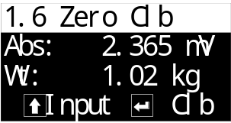
The main display shows the absolute voltage of the current sensor and the current weight. At this point, clear the scale platform, wait for the displayed sensor voltage value to stabilize, then press to confirm to complete zero calibration, setting the current sensor voltage signal as the zero point.
- Gain cal.
Enter the [1.7 Gain Cal] interface as shown below:
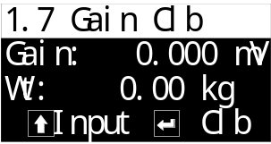
The main display shows the voltage of the current sensor relative to the zero point and the current weight. Place the calibration weight on the scale platform, and the relative voltage value of the sensor will increase. Wait for the displayed relative voltage value to stabilize, then press to confirm. In the input box below, enter the weight of the placed calibration weight, then press to confirm to complete weight calibration.

Quick Zero Calibration
In the stop state, press and hold the controller key for about 3 seconds until a long beep is heard, then release to quickly calibrate the current state as the zero point.
Note: Weight must be stable during quick zero calibration.

Calibration Precautions
- During empty scale calibration and weight calibration, if the weight display shows ADOFL, it indicates abnormal sensor signal. Check the sensor wiring connection, installation, and whether the sensor is damaged.
- During zero calibration and gain calibration, calibration can only be performed when the displayed sensor voltage is stable without fluctuation. If abnormal continuous voltage fluctuation is observed, check the sensor wiring connection, installation, and whether the sensor is damaged.
- Empty scale calibration and weight calibration support manual input of sensor voltage values for calibration. Simply press the key as prompted on the calibration interface.

Weighing Parameters
This item sets parameters related to weight signal acquisition and processing functions.
Num | Parameter | Description |  | Initial
2.1 | Weighing para
2.1.1 | Zero track | 0~9d; It only works in the stopped state. When the weight value stabilizes within the positive or negative range of this set value ×d (the minimum division value), it automatically performs zeroing. |  | 0
2.1.2 | Zero range | 0~99%; When performing the zeroing operation, the weight must be less than or equal to "maximum range × zeroing range" to allow zeroing. |  | 10%
2.1.3 | Stab range | 1~9d | These two parameters work together to determine whether the weight is stable.  Take all the weight values within the "stab time". If the difference between the maximum and minimum values is less than or equal to the "stab range", it is considered that the weight value is stable at this time. | 2d
2.1.4 | stab time | 0.01 ~ 9.9 s |  | 0.8
2.1.5 | Weighting Filter | 0~9; The intensity level of software digital filtering should be set according to the actual debugging effect of the equipment, with appropriate filtering level parameter values.  0: Weakest filtering, fast weight response, and poor anti-vibration effect;  9: Strongest filtering, slow weight response, and excellent anti-vibration effect. |  | 5
2.16 | Zero on startup | ① Off/② On  After opening, the controller will automatically perform a zeroing operation each time it is turned on. |  | ① Off

Ctrl Parameters
According to the functions and control flow of the ton bag scale, these parameters are divided into 8 major categories.

Clamp/Hook
Relevant functional parameters for bag clamping and hook control can be set.
Num | Parameter | Description | Initial Value
3.1 | Clamping/Hook
3.1.1 | Clamping Delay time | 0.0~99.9s; After the "bag clamping" signal is input, wait for this duration to consider the bag clamping action completed, allowing subsequent processes to proceed. | 0.5
3.1.2 | Delay before auto unclamp | 0.0~99.9s; During operation, after meeting the bag release condition, wait for this duration to start releasing the bag. | 0.5
3.1.3 | Clamp ctrl when stop | 1.[Ignore]: After the stop signal becomes valid, the controller does not change the current bag clamping mechanism status.  2. [Unclamp]: After the stop signal becomes valid, the bag clamping mechanism returns to the bag release state.  3. [Clamp]: After the stop signal becomes valid, the bag clamping mechanism returns to the bag clamping state. | 1.[Ignore]
3.1.4 | Hook delay time | 0.0~99.9s; After the "hook" signal is input, wait for this duration to consider the hooking action completed, allowing subsequent processes to proceed. | 0.5
3.1.5 | Delay before auto hook off | 0.0~99.9s; After meeting the unhooking condition, wait for this duration to start unhooking. | 0.5
3.1.6 | Hook output type | 1.[Positive]: Hook when the hook output signal is valid, unhook when invalid;  2.[negative]: Unhook when the hook output signal is valid, hook when invalid. | 1. [Positive]
3.1.7 | Hook ctrl when stop | 1.[Ignore]: After the stop signal is valid, the controller does not change the current hook mechanism state.  2.[Hook off]: After the stop signal is valid, the hook mechanism returns to the unhooked state.  3.[Hook on]: After the stop signal is valid, the hook mechanism returns to the hooked state. | 1.[Ignore]
3.1.8 | Hook off Judgment | 1.[Under Near Zero]: After packaging is completed and the support begins to descend, if the current weight is detected to be below the set 'Zero Zone Value', automatic unhooking begins.  2. [TBL fall end]: After packaging is completed and the support descent is finished, automatic unhooking begins.  3. [Manual]: After packaging is completed and the support descent is finished, wait for the manual input of the 'I9 Hook/Unhook' signal before unhooking.  4. [TBL Fall Start]: When the support descent starts, automatic unhooking begins. | 1. [Under Near Zero]
3.1.9 | Auto Hook on | When the function is enabled, after hook off, the [Auto Hook on Delay time] will be activated. | 1. [off]
3.1.10 | Auto Hook on Delay time | 0.0~99.9s; After the delay time elapses, the hook signal is automatically output. | 3.0
3.1.11 | Unclamp Judgment | 1.[Under Near Zero]: After packaging is completed and the support starts fall, if the current weight is detected to be below the set 'Zero Zone Value', automatic bag release begins.  2.[ TBL fall end]: After packaging is completed and the support descent is finished, automatic bag release begins.  3.[Manual]: After packaging is completed and the support descent is finished, wait for manual input of the 'I8 Clamp/Unclamp' signal before releasing the bag.  4.[ TBL Fall Start]: When the support descent begins, automatic bag release starts. | 1. [Under Near Zero]

Lift Table
Parameters related to controlling the weighing support's ascent and descent.
Num | Parameter | Description | Initial
3.2 | Lift table
3.2.1 | Lift table ctrl mode | 1.[Air]: Support lifting and lowering are controlled by Air signals. The support ascends when the 'rise(Air)' is active and descends when it is inactive.  2.[Motor 2 Limit]: Support lifting and lowering are controlled by electric signals, with rise and fall limit signals input to the controller to determine if the support has rise or fall to the correct position.  3. [Air 2 Limit]: The lifting and lowering of the bracket is controlled by pneumatic signals. When the "Rising (Air)" is active, the bracket rises; when the "Rise(Air)" is inactive, the bracket lowers. Additionally, rise and fall limit signals must be input to the controller to determine whether the bracket has reached the rise or fall limit.  4. [Motor]: The lifting and lowering of the bracket is controlled by electric signals. When the "Rise(motor)" is active, the bracket rises; when the "Fall(motor)" is inactive, the bracket lowers. | 1. [Air]
3.2.2 | Rise Time | 0.0~99.9s; After the Rise(Air) output becomes active, the bracket begins to rise, and after this time, it is considered that the bracket has completed rising and can proceed to the next process. | 5.0
3.2.3 | fall Time | 0.0~99.9s; After the Rise(Air) output becomes inactive, the bracket begins to lower, and after this time, it is considered that the bracket has completed lowering and can proceed to the next process. | 5.0
3.2.4 | Rise Timeout | 0.0~99.9s; After the bracket rises and this time has elapsed without detecting that the rise limit signal of the bracket is active, it is considered that the bracket has timed out during rising and an alarm will be triggered.  Note: When the timeout time is set to 0, the timeout alarm function is Off. | 8.0
3.2.5 | Fall Timeout | 0.0~99.9s; After the bracket descends and this time elapses without detecting a valid Fall limit signal, it is considered a bracket descent timeout and triggers an alarm.  Note: When the timeout time is set to 0, the timeout alarm function is Off. | 8.0
3.2.6 | Lift table auto | 1. [close]: After the controller starts and bag clamping and hook actions are completed, a manual input of the 'Raise/fall' signal is required for the bracket to rise and proceed with subsequent steps. After packaging is completed, a manual input of the 'Raise/fall' signal is required for the bracket to descend and proceed with subsequent steps.  2. [A Rise A Fall]: After the controller starts, when all bag clamping and hook actions are detected as completed, the bracket automatically begins to rise, and after packaging is completed, the bracket automatically begins to descend.  3. [A Rise M fall]: After the controller starts, when all bag clamping and hook actions are detected as completed, the bracket automatically begins to rise, but after packaging is completed, the bracket cannot descend automatically; a manual input of the 'Raise/fall' signal is required for descent.  4. [M Rise A fall]: After the controller starts, when all bag clamping and hook actions are detected as completed, a manual input of the 'Raise/fall' signal is required for the bracket to rise, and after packaging is completed, the bracket automatically begins to descend. | 2. [A Rise A Fall]
3.2.7 | Delay Before Autom Rise | 0.0~99.9s; When the automatic lift function of the bracket is enabled, after the bag clamping and hooking actions are completed, the bracket will automatically start to rise after this time. | 0.5
3.2.8 | Delay before auto fall | 0.0~99.9s; When the automatic descent function of the bracket is enabled, after the feeding is completed, the bracket will automatically start to descend after this time. | 0.5
3.2.9 | Lift table ctrl when stop | 1.[Ignore]: After the stop signal is valid, the controller does not change the current status of the bracket mechanism.  2.[fall]: After the stop signal is valid, the bracket mechanism returns to the ascending state.  3.[rise]: After the stop signal is valid, the bracket mechanism returns to the descending state. | 1.[Ignore]
3.2.10 | Lift table motor reset | [on]: Enable automatic reset of the electric bracket to the Fall limit position after power-up.  [off]: Disable this function. | [on]

Inflate
Set parameters related to the bag inflation and return air functions, which can achieve inflating the bag before packaging starts, and opening the return air valve after inflation is completed to exhaust air from the bag during the feeding process.
Num | Parameter | Description | Initial
3.3 | Inflate
3.3.1 | Inflation Func SW | 1.[Off]: Disable this function.  2.[On]: Enable the function to inflate the bag before packaging starts and open the return air valve after inflation is completed. | 1. [Off]
3.3.2 | Inflate Start | 1.[Rise start]: The inflation process begins at the start of ascent.  2.[Rise end]: The inflation process begins after the ascent ends. | 1.[ Rise start]
3.3.3 | Inflate time | 0.0~99.9s  Set the duration of the "inflate" signal output. After inflation ends, the "deflate" signal starts outputting and continues until it becomes invalid after feeding ends. | 4.0

Feed Process
Set the relevant parameters for each function during the feeding process.
Num | Parameter | Description | Initial
3.4 | Feed Process
3.4.1 | Pack Mode | 1.[Net pack]: Before feeding, perform stability judgment and tare removal, then start feeding.  2.[Gross pack]: Before feeding, do not remove tare; start feeding directly. | 1.[Net  pack]
3.4.2 | Feed Mode | 1.[Combined]:  Fast: Fast, medium, and Fine feed signals are valid.  Medium: Medium and Fine feed signals are valid.  Slow: Fine feed signal is valid.  2.[Independent]:  Fast: Fast feed signal is valid.  Medium: Medium feed signal is valid.  Slow: Fine feed signal is valid. | 1.  [Combined]
3.4.3 | Delay before feed | 0.0~99.9s; Delay time after the support rises completely and before feeding starts. | 0.5
3.4.4 | Fast delay time | 0.0~99.9s; Vibration elimination time at the start of Fast feeding, during which the Fast feed signal remains valid and is unaffected by weight. After this time ends, it is determined whether the weight has reached the Fast feed advance amount to end Fast feeding. | 0.5
3.4.5 | Med delay Time | 0.0~99.9s; Vibration elimination time at the start of medium feeding, during which the medium feed signal remains valid and is unaffected by weight. After this time ends, it is determined whether the weight has reached the medium feed advance amount to end medium feeding. | 1.0
3.4.6 | Slow delay time | 0.0~99.9s; Vibration elimination time at the start of Fine feeding, during which the Fine feed signal remains valid and is unaffected by weight. After this time ends, it is determined whether the weight has reached the Fine feed drop amount to end Fine feeding. | 1.0

Flap bag
Set related parameters for the flap bag function.
Num | Parameter | Description | Initial
3.5 | Flap Bag
3.5.1 | Flap Func SW | Flap bag Function Settings.  1.[Off]: Turn off the flap bag function.  2.[On]: Turn on the flap bag function.  3.[Ctrl by Recipe]: The flap bag function is controlled by the recipe parameter [4.3 flap bag].  Note: When option 3.[Ctrl by Recipe] is selected, the flap bag function parameters in this interface will not take effect. The flap bag function will be controlled by the related parameters in the [4.3Flap bag] interface. | 1.[Off]
3.5.2 | Flap Output Ctrl | Functions to control during flap bag setup:  1.[rise/fall]: Directly control bracket rise/fall during flap bag to achieve the flap bag purpose.  2.[flap]: Output flap bag signal during flap bag to control a separate flap bag mechanism.  3.[ rise/fall& flap]: Control bracket lifting/lowering and also output flap bag signal during flap bag.  Note: When feeding enters the Fine feed process, if the flap bag during feeding is not yet completed, it will be forcibly terminated to prevent the flap bag action from affecting feeding accuracy. | 1.[rise/  fall]
3.5.3 | Flap on Time | 0.0~99.9s; Valid time for flap bag signal output during flap bag process. | 5.0
3.5.4 | Flap off Time | 0.0~99.9s; Invalid time for flap bag signal output during flap bag process. | 5.0
Flap bag During Feeding Function
3.5.5 | Flap times when feed1 | 0~99; Set the count for the 1st flap bag required during the feeding process. | 1
3.5.6 | Flap Start Weight 1 | When feeding weight reaches this set weight value, trigger the 1st flap bag during feeding. | 0.00
3.5.7 | Flap times when feed 2 | 0~99; Set the number of times for the second flap bag during the feeding process. | 0
3.5.8 | Flap Start Weight 2 | When the feeding weight reaches this set value, the second flap bag during feeding is triggered. | 0.00
3.5.9 | Flap times when feed 3 | 0~99; Set the number of times for the third flap bag during the feeding process. | 0
3.5.10 | Flap Start Weight 3 | When the feeding weight reaches this set value, the third flap bag during feeding is triggered. | 0.00
3.5.11 | Feed Pause when Flap | 1.[Off]: Feed during flap bag.  2.[On]: Do not feed during flap bag. | 1. [Off]
3.5.12 | Weight stop flap | When this parameter is not set to 0, flap bag during feeding ends when the feeding weight reaches this set value; when set to 0, this function is Off. | 0.00
Flap bag Function After Fixed Value
3.5.13 | Flap time after feed | 0~99; Set the number of times for flap bag after the feeding fixed value is completed. | 0
3.5.14 | Flap start delay | 0.0~99.9s; Delay time after feeding ends and before starting the fixed-value bag-tapping function. | 0.5

Fixed Process
Set the relevant functional parameters for the fixed-value process after feeding completion.
Num | Parameter | Description | Initial
3.6 | Fixed Process
3.6.1 | Hold keep Time | 0.0~99.9s; After feeding ends, wait for this time before performing functions such as result accumulation, over/under deviation detection, and drop correction. | 1.0
3.6.2 | Hold need Stab SW | 1.[Off]: After Hold keep Time, the weight does not need to be stable to proceed to the next process.  2.[On]: After Hold keep Time, the weight must be stable to proceed to the next process. | 1. [Off]
Over/Under Deviation Detection Function
3.6.3 | Over/Under Func | Master switch for the over/under function  1.[Off]: Over/under deviation detection is not performed.  2.[On]: Over/under deviation detection will be performed on the feeding result after each feeding cycle.  Over/under deviation is a combined term for over-deviation or under-deviation. In the packaging process, if the packaging result exceeds the target value by a certain range, it is considered over-deviation, and if it falls below a certain range, it is considered under-deviation. This range is set based on production requirements. | 1. [Off]
3.6.4 | Over tolerance | During over/under deviation detection, if the weighing result > target value + over tolerance, it is judged as over; | 0.00
3.6.5 | Under tolerance | During over/under deviation detection, if the weighing value < target value – under tolerance, it is judged as under. | 0.00
3.6.6 | Over/Under Pause | When both the over/under deviation alarm switch and the over/under deviation pause switch are turned on, if an over/under deviation occurs, the controller will alarm and wait for user handling. After clearing the alarm, it can continue running, or a stop signal can be given to return to the stop state for handling. | 1. [Off]
Fall Correction Function
In some cases, the drop correction function may be needed to improve packaging accuracy. The drop correction function continuously adjusts the Fine feed advance during operation. Its principle is as follows:
1. Target deviation = current weighing result – target value
2. Average target deviation = (target deviation 1 + target deviation 2 + … + target deviation drop correction time) / drop correction time;
3. New Fine feed drop = previous Fine feed drop + average target deviation × drop correction depth;
3.6.7 | Fall Correct SW | Master switch for the fall correction function.  1.[Off]: Drop correction is not performed.  2.[On]: Automatically calculates and corrects the Fine feed drop value after feeding is completed. | 1. [Off]
3.6.8 | Fall Correct times | 0~99; The average of the drop values over the set number of times is used as the basis for drop correction. | 1
3.6.9 | Fall Correct Range | 0.0%~99.9%; Percentage of the target value. When the current drop value exceeds the set range, this drop will not be included in the arithmetic average range. | 10.0%
3.6.10 | Fall Correction depth | Options: 25%, 50%, 100%, representing the magnitude of each drop correction. | 25%

Conveyor
Set parameters related to conveyor control functions.
This controller supports controlling two conveyor sections (Conveyor 1 and 2). Upon startup, Conveyors 1 and 2 run simultaneously. Conveyor 1 stops automatically after its runtime ends, while Conveyor 2 runs until a valid 'Conveyor 2 in Position Signal' input is detected before stopping.
Num | Parameter | Description | Initial
3.7 | Conveyor Control
3.7.1 | Conveyor Ctrl Func SW | Master switch for the conveyor control function.  1.[Off]: The conveyor control function is turned off, and the corresponding conveyor switch inputs and outputs are inactive.  2.[On]: The conveyor control function is turned on. | 1. [Off]
3.7.2 | Conveyor Auto Start SW | 1. [Off]: Conveyor start/stop is entirely manually controlled. Custom signals such as 'Conveyor Start/Stop' or 'Conveyor Start/Stop & Hook/Unhook' can be defined to control conveyor actions. 2. [On]: The conveyor starts automatically after bag release and unhooking are completed. | 1. [Off]
3.7.3 | Delay before Conveyor start | 0.0~99.9s; After bag release and hook disengagement are completed, the conveyor will start running after this delay time. | 1.0
3.7.4 | Conveyor1 running time | 0.0~99.9s; The duration of Conveyor 1's forward signal output. After this time, it is considered that Conveyor 1 has completed the conveying process. | 5.0
3.7.5 | Conveyor2 Func SW | 1.[Off]: Conveyor 2 function is turned off.  2.[On]: Conveyor 2 function is turned on. | 1. [Off]
3.7.6 | Conveyor2 timeout | 0.0~99.9s; If this setting is not 0, Conveyor 2 will be forced to stop if it runs continuously beyond this time. | 0.0
Incomplete hook disengagement alarm function
3.7.7 | hook off failed alarm | 1.[Off]: No detection for incomplete hook disengagement alarm.  2.[On]: If the hook disengagement is incomplete and the bag remains hooked, the conveyor pulling may cause abnormal weight increase by tugging the weighing support. After the conveyor forward signal starts, the controller monitors the weight during conveyor operation. If the weight increases beyond the set value compared to the weight at conveyor start, an alarm is triggered and the conveyor stops. (During support lifting to prevent hooking, the weight during support lifting is also monitored.) | 1. [Off]
3.7.8 | Failed alarm weight check | If the weight increases by more than this set value compared to the weight when the conveyor started, an alarm will be triggered and the conveyor will stop. | 0.00
3.7.9 | Alarm Conveyor1 BW time | 0.0~99.9s; if this time is set to a non-zero value, after a decoupling alarm, the controller will control conveyor 1 to reverse for this duration. | 0.0
Support rise anti-hooking function
To prevent bags from hooking onto the weighing support after decoupling during conveyor operation, when the support rise anti-hooking function is On, before starting the conveyor, the controller will control the support to rise, moving it away from the bags. After the set support rise anti-hooking time elapses during the rise process, the conveyor will start to transport the bags away, and then the support will begin to descend.
3.7.10 | Prevent Hook lift rise SW | 1.[Off]: Support rise anti-hooking function is off.  2.[On]: Support rise anti-hooking function is on. | 1. [Off]
3.7.11 | Prevent Hook lift rise time | 0.0~99.9s;Before the conveyor starts, the support rises first for this time, then the conveyor starts. | 5.0

Material level
Set material level sensor signal input and feeding-related function parameters.
Num | Parameter | Description | Initial
3.8 | Material level
3.8.1 | Material level Type | 1.[None]: No level sensor.  2.[only lower]: 1 level sensor (lower level).  3.[Upper & lower]: 2 level sensors (lower level, upper level).  4.[only upper]: 1 level sensor (upper level).  Note: If a mode including the lower level is selected, feeding will not start when the lower level signal input is invalid. | 1.[None]
3.8.2 | Supply trigger | 1.[Off]: Turns off the feeding output function.  2.[Lower trigger]: Triggers the feeding function when the lower level input is invalid.  3.[Upper trigger]: Triggers the feeding function when the upper level input is invalid.  Note: When the level mode is set to [Upper & lower levels], the feeding function continues until the upper level signal becomes valid. | 1.[Off]
3.8.3 | Supply delay on time | 0.0~99.9s; After the feeding function is triggered, the feeding signal is output after this delay time. | 0.0
3.8.4 | Supply delay off time | 0.0~99.9s; After feeding ends, the feeding signal output is turned off after this delay time. | 3.0
3.8.5 | Supply work time | 1.[Run& stop].  2.[only run]. | 1.[Run& stop]
3.8.6 | Signal debounce time | 0.00~9.99s; Debounce time for "I16. Upper level" and "I17. Lower level" signal inputs.  Signal considered valid after continuous validity for this duration;  Signal considered invalid after continuous invalidity for this duration.  Prevents interference from occasional momentary signal interruptions or conduction. | 0.50

- Detailed explanation of feeding function
- Material level mode: single feed level; feed trigger: feed level trigger.
The timing diagram is as follows:
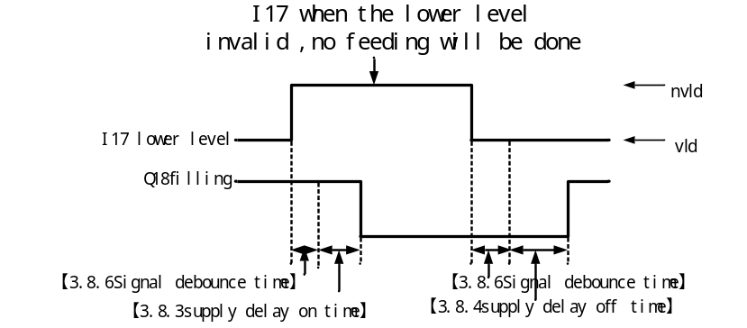
- Material level mode: upper and lower material level; feeding trigger: lower feeding level trigger.
The timing diagram is as follows:
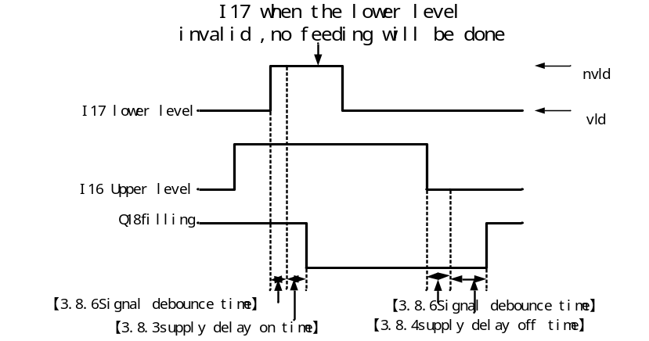
- Material level mode: upper and lower material level; feed trigger: feeding level trigger.
The timing diagram is as follows:
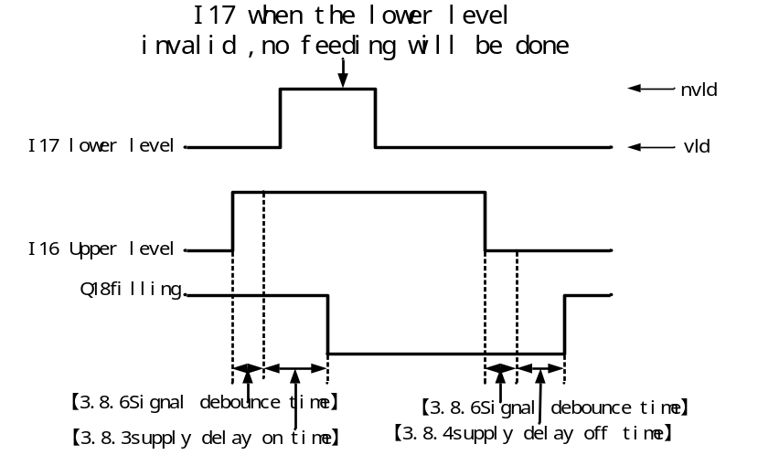
- Material level mode: single loading level; feed trigger: loading level trigger.
The timing diagram is as follows:
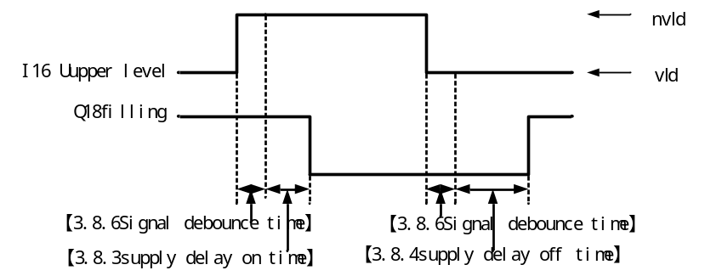

Recipe setting
The controller has 20 recipe parameter groups available for setting. Users can preset commonly used recipe parameters and switch to the corresponding recipe when using.

Recipe
Num | Parameter | Description | Initial
4.1 | Recipe
4.1.1 | Selected Recipe | 1~20; Set the recipe number currently used. | 1

Target
This interface sets recipe parameters such as the target value for this recipe number.
Num | Parameter | Description | Initial
4.2 | Target
4.2.1 | Target | Set the target weight to be achieved for packaging. | 0.00
4.2.2 | Fast feed | During feeding, when weight value ≥ target - Fast feed, close Fast feed; | 0.00
4.2.3 | Med feed | During feeding, when weight value ≥ target - med feed, close med feed; | 0.00
4.2.4 | slow feed | During feeding, when weight value ≥ target - slow feed advance, close Fine feed; | 0.00
4.2.5 | Zero area | Used to determine the start of bag loosening and hook detachment actions when [3.1.8 Bag Loosening, Hook Detachment Judgment Condition] is set to "Zero area". | 0.50
4.2.6 | Tare Value | These two parameters are used to determine the tare range.  Tare range = [4.2.6 Tare Value] ± [4.2.7 Tare Error Value].  When taring before starting feeding, if the current weight is not within the tare range, taring will not be performed and a prompt "Tare out of range, unable to tare." will appear.  Note: If [4.2.6 Tare Value] and [4.2.7 Tare Error Value] are both set to 0, the tare range detection function during taring is Off, allowing taring at any weight. | 0.00
4.2.7 | Tare Error Value |  | 0.00

Flap bag
Set related parameters for the flap bag function.
Note: When the [3.5.1 Flap Func SW] parameter is set to 3.[ Ctrl by Recipe], the relevant parameters in this interface will take effect; otherwise, the flap bag function will be controlled by the parameters in the [3.5 Flap bag Function] interface.
Num | Parameter | Description | Initial
4.3 | Flap bag Function
4.3.1 | Flap Func SW | Flap bag Function Settings.  1.[Off]: Turn off the flap bag function.  2.[On]: Turn on the flap bag function. | 1.[Off]
4.3.2 | Flap Output Ctrl | Functions to control during flap bag setup:  1.[rise/fall] bracket rise/fall during flap bag to achieve the flap bag purpose.  2.[Flap]: Output flap bag signal during flap bag to control a separate flap bag mechanism.  3.[rise/fall& flap]:Control bracket rise/fall and also output flap bag signal during flap bag.  Note: When feeding enters the Fine feed process, if the flap bag during feeding is not yet completed, it will be forcibly terminated to prevent the flap bag action from affecting feeding accuracy. | 1.[ rise  /fall]
4.3.3 | Flap on Time | 0.0~99.9s; Valid time for flap bag signal output during flap bag process. | 5.0
4.3.4 | Flap off Time | 0.0~99.9s; Invalid time for flap bag signal output during flap bag process. | 5.0
Flap bag During Feeding Function
4.3.5 | Flap times when feed1 | 0~99; Set the count for the 1st flap bag required during the feeding process. | 1
4.3.6 | Flap Start Weight 1 | When feeding weight reaches this set weight value, trigger the 1st flap bag during feeding. | 0.00
4.3.7 | Flap times when feed 2 | 0~99; Set the number of times for the second flap bag during the feeding process. | 0
4.3.8 | Flap Start Weight 2 | When the feeding weight reaches this set value, the second flap bag during feeding is triggered. | 0.00
4.3.9 | Flap times when feed 3 | 0~99; Sets the number of times the third flap bag is required during the feeding process. | 0
4.3.10 | Flap Start Weight 3 | When the feeding weight reaches this set value, the third flap bag during feeding is triggered. | 0.00
4.3.11 | Feed Pause when Flap | 1.[Off]: Feed during flap bag.  2.[On]: Do not feed during flap bag. | 1. [Off]
4.3.12 | Weight stop flap | When this parameter is not set to 0, flap bag during feeding ends when the feeding weight reaches this set value; when set to 0, this function is Off. | 0.00
Flap bag Function After Fixed Value
4.3.13 | Flap time After feed | 0~99; Set the number of times for flap bag after the feeding fixed value is completed. | 0
4.3.14 | Flap Start delay | 0.0~99.9s; Delay time after feeding ends and before starting the flap bag function after fixed value is set. | 0.5

Feeding Analog
Analog output function requires optional analog output expansion.
When the controller is equipped with analog expansion, analog output can be used to control feeding. Fast, medium, and Fine feedings can correspond to three analog signal levels, allowing analog control of inverter frequency or vibratory feeder output voltage for feeding at different material speeds.
Num | Parameter | Description | Initial
4.7 | Feeding Analog Signal
4.7.1 | large Analog | 0.000~100.000%; Analog output size during Fast feeding. | 0
4.7.2 | Med Analog | 0.000~100.000%; Analog output size during med feeding. | 0
4.7.3 | Slow Analog | 0.000~100.000%; Analog output size during Fine feeding. | 0

I/O
Custom can define the functions corresponding to digital input and output ports, and use the digital test function to check whether external digital circuits are functioning properly.
Num | Parameter | Description | Initial
5.1 | IN
5.1.1 | IN1 | Definition of switch input functions.  Refer to the option list in section 3.5.1.1 for details | I1. Running
5.1.2 | IN2 |  | I2. Stop
5.1.3 | IN3 |  | I4. Pause
5.1.4 | IN4 |  | I6. Clear alarm
5.1.5 | IN5 |  | I8.Clamp/Unclamp
5.1.6 | IN6 |  | I9.Hook On/Off
5.1.7 | IN7 |  | I10.Rise/Fall
5.1.8 | IN8 | When the optional switch expansion is installed, settings can be configured. | I0. None
5.1.9 | IN9 |  | I0. None
5.1.10 | IN10 |  | I0.None

IN Setting
Define the functions corresponding to digital input ports IN1~IN7. Select the digital port to be set and choose the function to define from the option box list.

Digital Input Function List
Num | Function Name | Description
I0 | None | No function defined.
I1 | Running | Start operation.
I2 | Stop | Stop operation.
I3 | Slowly Stop | Enter the soft stop process, which automatically stops operation after completing the current packaging.
I4 | Pause | Pause operation. Operation can resume after receiving the start signal again.
I5 | Zeroing | Perform a clear operation.
I6 | Clear Alarm | Clear the alarm status.
I7 | Change Rec. | When active once, automatically switch to the next recipe whose target value is not 0.
I8 | Clamp/Unclamp | Input signal for clamp/unclamp operation.
I9 | Hook on/off | Input signal for hook/unhook operation.
I10 | Raise/fall | Input signal for raise/lower bracket operation.
I11 | Manual Fine | Activate Fine feed when active; deactivate Fine feed when active again.
I12 | Manual med | Enable medium feed when active, disable medium feed when active again.
I13 | Manual Fast | Enable Fast feed when active, disable Fast feed when active again.
I14 | Clr total Acc | Clear total accumulated data.
I15 | Clr Rec. Acc | Clear current recipe accumulated data.
I16 | Upper level | Upper level detection input signal.  Consider material has reached loading position when active.
I17 | Lower level | Lower level detection input signal.  Consider material has reached Lower level when active.  Consider material has fallen below Lower level and is in a material shortage state when inactive.
I18 | Rise limit | Support rise limit input signal.  Consider support has moved to rise limit position when active.
I19 | Fall limit | Support Fall limit input signal.  Consider support has moved to Fall limit position when active.
I20 | Running/Stop | Start operation when active.  Stop operation when inactive.
I21 | R/Slow stop | Start operation when active.  Enter slow stop process when inactive.
I22 | R/Pause | Start operation when active.  Enter pause state when inactive.
I23 | Fine (lvl) | Enable Fine feed when active, disable Fine feed when inactive.
I24 | med (lvl) | Enable medium feed when active, disable medium feed when inactive.
I25 | Fast (lvl) | Enable Fast feed when active, disable Fast feed when inactive.
I26 | Clamp ok | This signal can be used when the bag clamping device has a position switch for detection.  When active, it is considered that the bag clamping action has been completed.
I27 | Conveyor start | Start the conveyor when active, and stop the conveyor when active again.
I28 | Conveyor  &Hook | Equivalent to simultaneously giving the 'Conveyor start/stop' signal and the 'Hook/Unhook' signal.
I29 | Conveyor 2 in Ps | Input signal for detecting Conveyor 2 in position.
I30 | Motor stop | Effective when [3.2.1 Lift Support Control Method] is set to [2. Motor 2 limit] or [4. motor]. | Control the lift support motor to stop.
I31 | Motor rise |  | Control the lift support motor to rise.
I32 | Motor fall |  | Control the lift support motor to lower.
I33 | End | Automatically stop after completing the ton bag process.
I34 | Print Acc | Print total accumulated data when active.
I35 | Print All rec | Print all recipe accumulated data when active.

OUT setting
Define the functions corresponding to the digital output ports OUT1~OUT12. Select the digital output port to be set, and choose the function to define from the option list.
Num | Parameter | Description | Initial
5.2 | Output
5.2.1 | OUT1 | Definition of switch output functions.  Refer to the option list in section 3.5.1.2 for details | Q1. Running
5.2.2 | OUT2 |  | Q2. Stop
5.2.3 | OUT3 |  | Q3. fast
5.2.4 | OUT4 |  | Q4. Med
5.2.5 | OUT5 |  | Q5. Fine
5.2.6 | OUT6 |  | Q8.Hold
5.2.7 | OUT7 |  | Q10.Warning
5.2.8 | OUT8 |  | Q11.Clamp
5.2.9 | OUT9 |  | Q12.Hook On
5.2.10 | OUT10 |  | Q13.Rise(Air)
5.2.11 | OUT11 |  | Q20. Inflate
5.2.12 | OUT12 |  | Q21.Deflate
5.2.13 | OUT13 | When the optional switch expansion is installed, settings can be configured. | Q0.None
5.2.14 | OUT14 |  | Q0. None

Digital Output Function List
Num | Function | Description
Q0 | None | No function defined.
Q1 | Running | Output is active when in running state.
Q2 | Stop | Output is active when in stop state.
Q3 | Slow Stop | Output is active during the soft stop process.
Q4 | Pause | Output is active when in pause state.
Q5 | Fast | Fast feeding control signal.
Q6 | Med | Medium-speed feeding control signal.
Q7 | Fine | Slow feeding control signal.
Q8 | Hold | Output is active when feeding is completed, indicating that feeding is currently finished. Duration can be set via parameter [3.6.1 Target Value Hold Time].
Q9 | Over/Under | Output is active when the over/under deviation function is On and an over/under deviation alarm occurs in the feeding result.
Q10 | Warning | Output is active when the controller has an alarm.
Q11 | Clamp | Bag clamping mechanism control signal. Active for clamping, inactive for releasing.
Q12 | Hook on | Hooking mechanism control signal. The output state during hooking is set via parameter [3.1.6 Hooking Output Signal Logic Type].
Q13 | Rise (Air) | Air support raising control signal.  The support rises when effective and descends when ineffective.
Q14 | Rise (motor) | Control signal for electric support rising.
Q15 | fall (motor) | Control signal for electric support descending.
Q16 | Flap bag | Output signal for flap bag function.
Q17 | Starving | Output signal for material shortage status.  Material shortage status occurs when the "lower level" signal input is invalid.
Q18 | Supply fill | Output control signal for feeding.  When the signal is effective, activate the feeding device to supply material to the storage hopper.
Q19 | Batch Complete | This signal outputs effectively after batch completion.
Q20 | Inflation | Output signal for inflation. | For details on inflation and air return functions, refer to section 3.3.3.
Q21 | Deflate | Output signal for air return.
Q22 | Conveyor 1 Forward | Control signal for conveyor 1 forward rotation.
Q23 | Conveyor 1 BW | Control signal for conveyor 1 reverse rotation.
Q24 | Logic 1 | Output signal for logic programming 1 function.
Q25 | Logic 2 | Output signal for logic programming 2 function.
Q26 | Logic 3 | Output signal for logic programming 3 function.
Q27 | Logic 4 | Logic programming 4 function output signal.
Q28 | Logic 5 | Logic programming 5 function output signal.
Q29 | Conveyor2 Running | Conveyor 2 running control signal.

I/O Test
The digital I/O test is used to check whether the digital I/O function is normal, divided into input digital I/O test and output digital I/O test. After entering the interface, the input digital I/O test is first, as shown in the figure below:
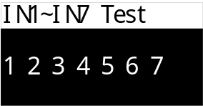
Numbers 1~7 represent IN1~IN7. When an input is active, it is displayed with inverted background, for example, when IN3 input is active, the display is as shown in the figure below:
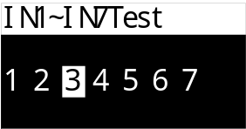
Press to switch to the output digital I/O test. The output digital I/O test allows manual setting of the ON and OFF states for the output of each OUT port. The display interface is as shown in the figure below:
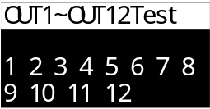
Numbers 1~12 represent OUT1~OUT12. When number 1 is flashing, it means pressing can manually set the ON and OFF states of OUT1 output. Press to switch to other OUT ports. Press to switch to the input digital I/O test. When the OUT output is set to ON, it is displayed with inverted background, for example, when OUT2 output is set to ON, the display is as shown in the figure below:
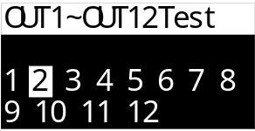
Note: When the digital I/O expansion option is selected, the added input/output digital I/O will be displayed.

Acc Data
View the controller's batch and cumulative data as well as recipe cumulative data.

Batch &Acc
View the control cumulative values, and set the number of running batches. The interface is as shown in the figure below:
Num | Parameter | Description | Initial
6.1 | Batch and Acc
6.1.1 | Batch Set | Set the number of batches. When the number of runs reaches the set batch count, the packaging process will stop, and an alarm will be triggered. This function is Off when set to 0. | 0
6.1.2 | Completed | If the batch count is set, this item displays the number of batches that have been completed so far. | 0
6.1.3 | Total Acc | View total cumulative data. Press the key to clear cumulative data and restart accumulation.

Recipe Acc
View Acc data for each recipe and clear the Rec data.
Num | Parameter | Description | Initial
6.2 | Recipe Acc
6.2.1 | Rec 1 | View cumulative data for each recipe. Press the key to clear its cumulative data.
6.2.2 | Rec 2
6.2.3 | Rec 3
6.2.4 | Rec 4
6.2.5 | Rec 5
6.2.6 | Rec 6
6.2.7 | Rec 7
6.2.8 | Rec 8
6.2.9 | Rec 9
6.2.10 | Rec 10
6.2.11 | Rec 11
6.2.12 | Rec 12
6.2.13 | Rec 13
6.2.14 | Rec 14
6.2.15 | Rec 15
6.2.16 | Rec 16
6.2.17 | Rec 17
6.2.18 | Rec 18
6.2.19 | Rec 19
6.2.20 | Rec 20

Comm setting

RS232
RS232 is the RS232 communication serial port of the controller, with the following related parameters:
Num | Parameter | Description | Initial
7.1 | RS232 settings
7.1.1 | Slave ID | 1~99;Set the communication address (slave number) of the device. | 1
7.1.2 | protocol | 1.[Modbus-RTU-H]: Modbus-RTU communication protocol (double-word data with high word first).  2.[Modbus-RTU-L]: Modbus-RTU communication protocol (double-word data with low word first).  3.[YH-CONT]: Display protocol for connecting to Yaohua screens (baud rate must be set to 2400).  4.[Print]: printing Acc data or recipe data. | 1.[Modbus-RTU-H]
7.1.3 | Baud Rate | Set the baud rate for serial communication | 38400
7.1.4 | Data Format | 1.[7-E-1]:7 data bits, even parity, 1 stop bit  2.[7-O-1]:7 data bits, odd parity, 1 stop bit  3.[8-N-1]:8 data bits, no parity, 1 stop bit  4.[8-E-1]:8 data bits, even parity, 1 stop bit  5.[8-O-1]:8 data bits, odd parity, 1 stop bit | 3.[8-N-1]

      - Detailed Communication Protocol Description
When the communication protocol is set to 3. [YH-CONT], it can be used to connect to Yaohua's LED display, with the communication format as follows:
For example, if the current weight is "12.9", the instrument will send the string "9.21000=".
When the communication protocol is set to 4. [Print], please refer to 3.7.3.1 Detailed Print Function Description section.

RS485 Settings
Refer to RS232 Settings for configuration method.

Print Settings
When the communication protocol for serial communication interface RS232 or RS485 is set to Print, relevant print parameters can be configured on this page:
Num | Parameter | Description | Initial
7.3 | Print Parameter Settings
7.3.1 | Print Language | 1.[中文]: Set print language to Chinese.  2.[English]: Set print language to English. | 1.[中文]
7.3.2 | Print Width | 1.[32 columns]: Set print column width to 32 columns.  2.[24 columns]: Set print column width to 24 columns. | 1.[32 columns]
7.3.3 | Auto Print | 1. [Off] Per weighing result will not be printed after each weighing ends.  2. [On] In print mode, automatically print packaging result after each weighing discharge is completed. | 1. [Off]
7.3.4 | Print blank lines | Number of line feeds after each cumulative result is printed. | 3
7.3.5 | Print Di (brightek) | 1. [Default]: Select click default setting for printing. Usually forward printing.  2. [obverse]: Content font selected in right box prints forward.  3. [Reverse]: Content font selected in right box prints upside down. | 1. [Default]
      - Print Function Detailed Description
Printing function can be set to automatic or manual printing as needed. When [7.3.3 Automatic Printing of Each Weighing Result] is On, the packaging result will be printed after each packaging completion. The first print includes unit, formula, cumulative count, and packaging result, followed by only the cumulative count and packaging result, with the format as follows:
Result Details
Unit: kg
Formula 1
Cumulative Count Target Value Result
----------------------------------------------------
9 10.0 11.7
10 10.0 11.1

Manual printing can separately print total cumulative and all formula cumulative. Input the "I34 Print Total Cumulative" signal to print total cumulative. Print information can be selected based on the cumulative print content options, with the printing format as follows:
Cumulative Data
Time: 2023/08/12 16:38
---------------------------------------------------
Total Count: 9
Total Weight: 112.7kg
Formula Number: 1
Cumulative Count: 9
Cumulative Weight: 112.7kg
--------------------------------------------------

Printing all formula cumulative allows printing the current cumulative of all formulas. Input the "I35 Print All Formula Cumulative" signal to print, with the printing format as follows:
Formula Cumulative Data
Time: 2023/08/12 16:41
---------------------------------------------------
Formula Number: 1
Target Value: 10.0kg
Cumulative Count: 9
Cumulative Weight: 112.7kg
---------------------------------------------------

Network Port Settings
Effective when the extended interface is configured with a network port, with relevant parameters as follows:
Num | Parameter | Description | Initial
7.4 | Network Port Settings
7.4.1 | IP Address | Set the IP address for the controller's network port. | 192.168.0.100
7.4.2 | Port Number | Set the port number for the controller's network port. | 502
7.4.3 | MAC Address | View the MAC address of the controller's network port and set the MAC address offset. | 0
7.4.4 | Protocol | 1. [Modbus-TCP-H]: Modbus-TCP communication protocol (high word of double-word data first).  2. [Modbus-TCP-L]: Modbus-TCP communication protocol (low word of double-word data first). | 1.[Modbus-TCP-H]

Password
Separate passwords and password switches can be set for entering the main menu interface and each item in the menu.
The factory default for all passwords is: 000000.
Enter the password twice when modifying it.
Num | Parameter | Description | Initial
8.1 | Main Menu
8.1.1 | PW switch | 1.[OFF],2.[ON] | 2.[ON]
8.1.2 | PW Set
8.2 | Calibration
8.2.1 | PW switch | 1.[OFF],2.[ON] | 1.[OFF]
8.2.2 | PW Set
8.3 | Weighing para
8.3.1 | PW switch | 1.[OFF],2.[ON] | 1.[OFF]
8.3.2 | PW Set
8.4 | Ctrl Para
8.4.1 | PW switch | 1.[OFF],2.[ON] | 1.[OFF]
8.4.2 | PW Set
8.5 | Recipe setting
8.5.1 | PW switch | 1.[OFF],2.[ON] | 1.[OFF]
8.5.2 | PW Set
8.6 | I/O
8.6.1 | PW switch | 1.[OFF],2.[ON] | 1.[OFF]
8.6.2 | PW Set
8.7 | Acc Data
8.7.1 | PW switch | 1.[OFF],2.[ON] | 1.[OFF]
8.7.2 | PW Set
8.8 | Comm setting
8.8.1 | PW switch | 1.[OFF],2.[ON] | 1.[OFF]
8.8.2 | PW Set
8.9 | Password
8.9.1 | PW switch | 1.[OFF],2.[ON] | 2.[ON]
8.9.2 | PW Set
8.10 | System
8.10.1 | PW switch | 1.[OFF],2.[ON] | 2.[ON]
8.10.2 | PW Set
8.11 | Logic
8.11.1 | PW switch | 1.[OFF],2.[ON] | 2.[ON]
8.11.2 | PW Set
8.12 | Analog
8.12.1 | PW switch | 1.[OFF],2.[ON] | 2.[ON]
8.12.2 | PW Set

System
System language settings and system version information viewing.
Num | Parameter | Description | Initial
9.1 | Para. Reset | Controller parameters can be reset.
9.2 | Language | ① Chinese  ② English | Chinese
9.3 | About | View the controller's model and version number.
9.4 | Boot Screen | 1.[Off]: Company logo is not displayed at startup.  2.[On]: Company logo is displayed at startup.  3. [Custom]: Startup image can be imported by the customer via the touchscreen. | 2. [off]
9.5 | BAC&RCV | Parameters can be backed up and restored.

Logic Programming
The controller supports 5-channel logic programming. When the existing functions of the controller cannot meet the control requirements of the device, user can try using the logic programming function to define auxiliary logic output signals outside the controller's operation process to control device actions.
The following uses Logic Programming 1 as an example to explain the function of each parameter.
Num | Parameter | Description | Initial
10.1 | Logic Programming 1
10.1.1 | Logic Type | Select the type of logic programming.  ①[close]: Turn off this logic output function.  ②[Delay On]  ③[Delay Off]  ④[Delay On/Off]  ⑤[OFF/ON Trigger]  ⑥[ON/OFF Trigger]  ⑦[Self hold]  ⑧[Pulse]  For detailed function descriptions, refer to the 3.10.1 section: | ①close
10.1.2 | Trigger Type | ①[Signal Trigger]: Trigger this logic output through a specific signal.  ②[Condition]: Trigger this logic output by meeting a specific condition.  ③[Comm Trigger]: Trigger this logic output via a comm command. | ①[Signal Trigger]
10.1.3 | Logic Signal Output Port | Select the logic output signal definition to assign to a specific OUT port. | none
10.1.4 | Delay On Time | 0.0~99.9; The delay time before the logic output signal turns on. | 0
10.1.5 | Delay Off Time | 0.0~99.9  The delay time before the logic output signal turns off. | 0
10.1.6 | Trigger Signal 1 Settings | Select Signal 1 to trigger the logic output. | None
10.1.7 | Trigger Logic | Select the logical relationship between Trigger Signal 1 and Trigger Signal 2 to trigger the logic output.  1.[OR]: Trigger logic output if either Trigger Signal 1 or Trigger Signal 2 is valid.  2.[AND]: Trigger logic output only if both Trigger Signal 1 and Trigger Signal 2 are valid.  3.[XOR]: Trigger logic output only when Trigger Signal 1 and Trigger Signal 2 are different. | 1.[OR]
10.1.8 | Output Time | 0.0~99.9; This parameter can be set when [10.1.1 Logic Type] is configured to items 5/6. The valid output duration after logic signal is triggered, ending the logic output after the time expires.  When this time is set to 0, the logic output signal can only be terminated via the reset signal. | 0
10.1.9 | Init Signal | This parameter can be set when [10.1.1 Logic Type] is configured to the 5th/6th item. After the logic output becomes active, the reset signal can reset the logic output, invalidate the logic output signal, and end the current logic output process. | None
10.1.10 | Init Signal type | 1. [On Init]: Resets the logic output when the reset signal is active.  2. [OFF Init]: Resets the logic output when the reset signal is inactive. | 1. [On Init]
10.1.11 | Trigger Condition | Select the condition to trigger the logic output.  1. [> set value]  2. [< set value]  3. [Inside range]  4. [outside range] | 1. [> set value]
10.1.12 | Set Value 1 | Used to set the weight value corresponding to the trigger condition. | 0
10.1.13 | Set Value 2 |  | 0
10.1.14 | Need Stable | 1. [Off]: After the weight meets the trigger condition, it must also be stable to trigger the logic output.  2. [On]: After the weight meets the trigger condition, the logic output can be triggered immediately without requiring stability. | 1.[Off]
10.1.15 | Trigger Signal 2 | Select the signal 2 used to trigger the logic output. | None

Logic Output Timing Diagram
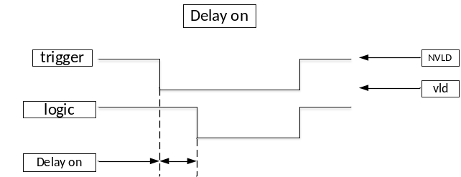
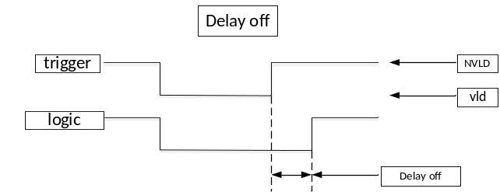
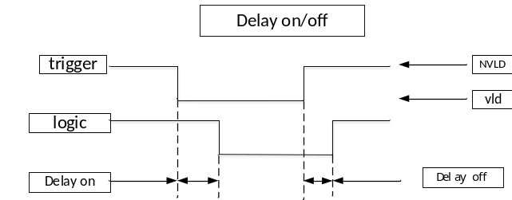
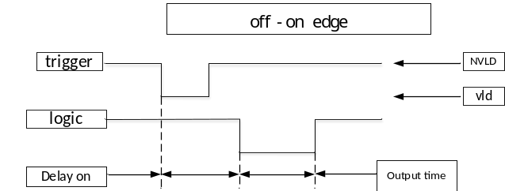
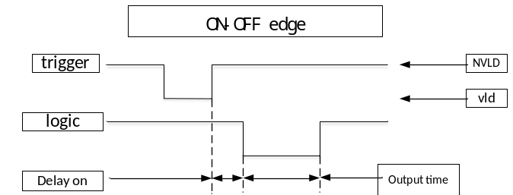
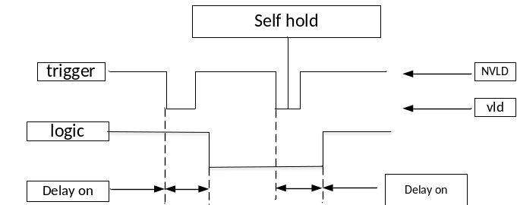
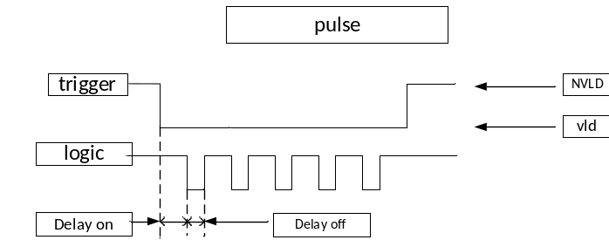
Example Illustration
Marking Function: After the bag clamp output signal becomes valid, delay for 1 second, then output OUT12 for 2 seconds to control the marking machine to print the code onto the bag after clamping is completed.
Settings as follows:
【Logic Type】: OFF-ON Edge Trigger
【Delay Activation Time】: 1s
【Output Valid Time】: 2s
【Trigger Type】: Signal Trigger
【Trigger Signal Setting】: Bag Clamp
【Logic Signal Output Port】: OUT12

Through the combination of different trigger signals, trigger conditions, and the coordination of 5 sets of logic programming signals, very flexible logic outputs can be achieved.
For example, to implement the following logic: Detect in real-time that the weight exceeds 1kg and output OUT10 for alarm indication. After the alarm becomes valid, delay for 2 seconds, then output OUT11 for 3 seconds to control the unloading mechanism to discharge the material.00
Settings as follows:
Logic Programming 1: Implement detection that weight exceeds 1kg and output OUT10.00
【Logic Type】: Delay ON
【Delay Activation Time】: 0s
【Trigger Type】: Condition Trigger
【Trigger Condition Setting】: > set value
【Set Value 1】: 100kg
【Logic Signal Output Port】: OUT10
Logic Programming 2: Implement a delay of 2 seconds after OUT10 becomes valid, then output OUT11 for 3 seconds.
【Logic Type】: OFF-ON Edge Trigger
[Delay On Time]: 2s
[Output Valid Time]: 3s
【Trigger Type】: Signal Trigger
[Trigger Signal Setting]: Logic Output 1
[Logic Signal Output Port]: OUT11

Analog
Analog output function requires optional analog output expansion.
Analog Interface:
U1+/ I1+: Positive terminal for voltage/current type analog output.
U1-/ I1-: Negative terminal for voltage/current type analog output.
For voltage type output, connect analog signal to U1+ and U1-.
For current type output, connect analog signal to I1+ and I1-.
Select output voltage/current type analog via DIP switch.

Output Settings
Set parameters related to analog output function.
Num | Parameter | Description | Initial
11.1 | Output Set
11.1.1 | Output Range | ①[0-5V]/②[0-10V]/③[4-20mA]/④[0-20mA]/⑤[0-24mA]/⑥[user set U]/⑦[User set I] | ①[0-5V]
11.1.2 | Output Meaning | ①Feeding: During feeding, corresponding analog values for Fast, medium, and Fine feeding can be output separately to control the feeding device.  For detailed functions, refer to section 3.4.4. | ①Feeding
11.1.3 | Output Max | When [11.1.1 Output Range] is set to ⑥[user set U]or⑦[User set I], use these two parameters to define the output voltage or current range. | 0
11.1.4 | Output Min |  | 0

Analog Calibration
Calibration operation for analog signals. Use the analog calibration function when there is a deviation between the analog output value and the actual value to calibrate the analog output.
Analog Calibration Method:
- Enter the 【11.2 Analog Calibration】 interface and set the DIP switch to the voltage analog output terminal.
- Enter the 【11.2.1 [0V]】 option interface. At this time, use a multimeter to measure the voltage output by the analog signal (normally around 0V), input the measured value into the interface, and press Confirm.
- Enter the 【11.2.2 [2.5V]】 option interface. At this time, use a multimeter to measure the voltage output by the analog signal (normally around 2.5V), input the measured value into the interface, and press Confirm.
- Enter the 【11.2.3 [5V]】 option interface. At this time, use a multimeter to measure the voltage output by the analog signal (normally around 5V), input the measured value into the interface, and press Confirm.
- Enter the 【11.2.4 [7.5V]】 option interface. At this time, use a multimeter to measure the voltage output by analog signal U1 (normally around 7.5V), input the measured value into the interface, and press Confirm.
- Enter the 【11.2.5 [10V]】 option interface. At this time, use a multimeter to measure the voltage output by the analog signal (normally around 10V), input the measured value into the interface, and press Confirm.
- After completing the above steps, the analog calibration operation is finished.
Note: When measuring output voltage, ensure the multimeter is set to DC voltage mode, connect the positive probe to the controller's analog terminal output port (pin 3 of the DB9 connector), and connect the negative probe to the controller's analog terminal output port (pin 8 of the DB9 connector).
Current calibration operation is similar to voltage calibration. For current calibration, set the toggle switch to the current analog output terminal, and select calibration parameters [11.2.6 [0mA]]-[11.2.10[24mA]].
Num | Parameter | Description | Initial
11.2 | Analog Calibration
11.2.1 | [0V] | 0.000~12.000V; Analog output 0V calibration point. | 0.000
11.2.2 | [2.5V] | 0.000~12.000V; Analog output 2.5V calibration point. | 2.500
11.2.3 | [5V] | 0.000~12.000V; Analog output 5V calibration point. | 5.000
11.2.4 | [7.5V] | 0.000~12.000V; Analog output 7.5V calibration point. | 7.500
11.2.5 | [10V] | 0.000~12.000V; Analog output 10V calibration point. | 10.000
11.2.6 | [0mA] | 0.000~26.000mA; analog output 0mA calibration point. | 0.000
11.2.7 | [4mA] | 0.000~26.000mA; analog output 4mA calibration point. | 4.000
11.2.8 | [12mA] | 0.000~26.000mA; analog output 12mA calibration point. | 12.000
11.2.9 | [20mA] | 0.000~26.000mA; analog output 20mA calibration point. | 20.000
11.2.10 | [24mA] | 0.000~26.000mA; analog output 24mA calibration point. | 24.000
Note: When resetting all parameters, the analog output settings and calibration data are not reset. Analog parameters need to be selected separately under 【9.1.11 Analog】 to perform the reset operation for analog parameters.

Process Description

Ton Bag Scale Packaging Process
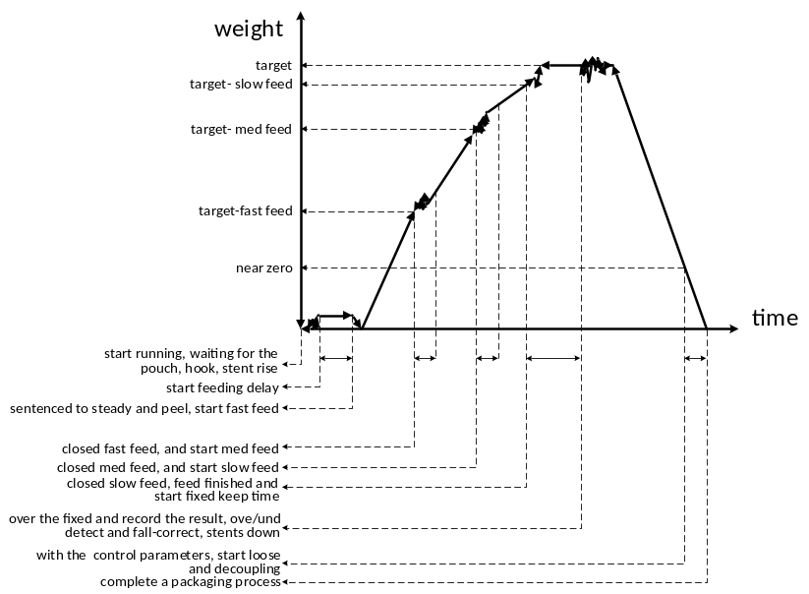
Now, the basic packaging process of the ton bag scale will be explained in combination with the above figure:
- Start operation.
- After waiting for bag clamping and hooking to complete, support rises^{①}.
- After the support rises, start the pre-feeding delay; after the delay ends, stabilize and tare (net weight packaging tares, gross weight packaging does not tare).
- After successful taring, open the Fast feed. When the weight value ≥ target value- Fast feed advance amount, close the Fast feed and enter medium feed.
- When the weight value ≥ target value- medium feed advance amount, close the medium feed and enter Fine feed.
- When the weight value ≥ target value -Fine feed drop amount, close the Fine feed, end feeding, and start the constant value hold time.
- If the flap bag function^{②} is enabled during feeding, then the flap bag action will be performed simultaneously during the above feeding process.
- After the constant value hold time ends, record the feeding weight, and based on control parameter settings, determine whether to perform over/under detection and drop correction^{③}.
- Support fall^{①}.
- Based on control parameter settings, perform bag loosening and unhooking.
- After the support descends, if the conveyor control function^{④} is enabled, output the conveyor signal to control the conveyor to transport the packaging bag away.
- Complete one packaging cycle and return to step 1 to start a new packaging cycle.
Remarks：
Bracket Lifting Control: For specific control parameter settings, refer to section 3.3.2.
Process when [3.2.1 Lift table Control Mode] is set to "Air":
Bracket rising process: When the digital output signal "Q13 Rise (air)" becomes active, the bracket begins to rise. After the set [3.2.2 Rise Time] elapses, it is considered that the bracket has completed rising.
Bracket descending process: When the digital output signal "Q13 Rise (air)" becomes inactive, the bracket begins to descend. After the set [3.2.3 fall Time] elapses, it is considered that the bracket has completed descending.
Process when [3.2.1 Lift table Control Mode] is set to "motor 2 Limit":
Bracket rising process: When the digital output signal "Q14 Rise (motor)" becomes active, the bracket begins to rise. When the digital input signal "I18 Rise limit" becomes active, the digital output signal "Q14 Rise (motor)" becomes inactive, and it is considered that the bracket has completed rising.
Bracket descending process: When the digital output signal "Q15 fall（motor）" becomes active, the bracket begins to descend. When the digital input signal "I19 fall limit" becomes active, the digital output signal "Q15 fall（motor）" becomes inactive, and it is considered that the bracket has completed descending.
Process when [3.2.1 Lift table Control Mode] is set to "Air 2 limit":
Support rising process: The discrete output signal "Q13 Rise (Air)" becomes active, and the support begins to rise. The process is considered complete when the discrete input signal "I18 Rise limit" becomes active.
Support lowering process: The discrete output signal "Q13 Rise (Air)" becomes inactive, and the support begins to lower. The process is considered complete when the discrete input signal "I19 fall Limit" becomes active.
Process when [3.2.1 Lift Support Control Mode] is set to "motor":
Support rising process: The discrete output signal "Q14 Rise (motor)" becomes active, and the support begins to rise. The process is considered complete after the set [3.2.2 Rise Time] has elapsed.
Support lowering process: The discrete output signal "Q15 Lower (motor)" becomes active, and the support begins to lower. The process is considered complete after the set [3.2.3 fall Time] has elapsed.

Flap bag Function: For detailed control parameter settings, refer to section 3.3.5.
Over/Under Detection and Drop Correction: For detailed control parameter settings, refer to section 3.3.6.
Conveyor Function: For detailed control parameter settings, refer to section3.3.7.

Stop, Pause, Slow Stop, and End
After the stop signal is input, the controller will immediately shut down output signals related to feeding and enter the stop state. Restarting will initiate the packaging process again.
After the pause signal is input, the controller will immediately shut down output signals related to feeding and enter the pause state. The user can choose to restart or enter the stop state. Restarting will resume the packaging process from the state before pause.
After the slow stop signal is input, the controller will stop after completing the current packaging cycle.
After the end signal is input, if the controller is in the process before fixed value, it will enter the fixed value process and stop after completing the current ton bag process; if it is in the fixed value or later process, it will stop after completing the current ton bag process.

Alarm information
When an alert occurs in the controller, an alert message will be displayed on the bottom line of the screen, as shown below:
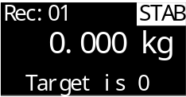
Presskey or input "I6 clear alert" to clear the alert.
For detailed explanations of specific alerts, refer to the following table:
Num | Content | Description
1 | Target is 0 | When starting, the parameter [4.2.1 Target value] is not set.
2 | OFL cannot start | Cannot start when weight overflow occurs
3 | Zeroing Out of Range | During zeroing operation, weight exceeds zeroing range, cannot zero.  Adjust parameter settings in 【2.1.2 Zeroing Range】.
4 | Zeroing Unstable | During zeroing operation, weight is unstable, cannot zero.  Investigate cause of weight fluctuation instability, such as mechanical vibration. Also adjust 【2.1.3 Stab. Range】 and 【2.1.4 Stab Time】to modify stability condition determination.
5 | Zeroing with OFL | Cannot zero when weight overflows.
6 | Zeroing Not Allowed During Operation | Zeroing not allowed during operation state.
7 | Feed Result Over/Under Deviation | Current feed result shows over/under deviation. View parameter settings for over/under deviation detection function for related parameters.
8 | Over/Under Deviation Pause | Feed result exceeds deviation and pauses feeding, awaiting handling.
9 | Batch Completed | 【7.1.1 Batch Settings】 configured, and set number of batches has been completed, alarm prompts.
10 | Stop Input Active | During startup, the 'I2 Stop' signal is detected as active, preventing startup and triggering an alarm.
11 | IO Test Cannot Start | Currently in IO test mode, startup is not possible.
12 | Support Lowering Timeout | The time for support lowering exceeded the duration set in [3.2.5 Lowering Timeout].
13 | Support Rising Timeout | The time for support rising exceeded the duration set in [3.2.4 Rising Timeout].
14 | Incomplete Hook Release Alarm | Refer to the parameter description in [3.7.7 Incomplete Hook Release Alarm] for details.

Common Troubleshooting
During controller operation, the bottom line of the display will show real-time prompts indicating the function and process currently being executed by the controller. These prompts help determine the current operational stage of the controller and assist in troubleshooting. For example, as shown in the image below, the controller is in the process of waiting for bag clamping:
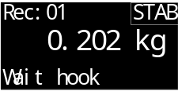
The table below lists some potential faults and troubleshooting methods that may be encountered during controller use:
Num | Content | Description
1 | ADOFL / -ADOFL | Sensor signal abnormal.  - Sensor wiring is incorrect or has poor contact. (Note the wiring methods for 4-wire and 6-wire systems)  - Sensor is damaged.  - Load on the sensor exceeds the range.
2 | OFL / -OFL | Weight overflow; OFL is displayed when the weight in the hopper exceeds the setting of [1.4 Maximum Range]. If OFL is displayed on an empty scale, check:  - Whether [1.4 Maximum Range] is set correctly.  - Calibration is abnormal; recalibrate.  - Whether the sensor is damaged.
3 | Unstable abnormal weight fluctuations in the device's stationary state. | - Whether the sensor wiring connection is correct and reliable, and whether the wiring is rusted or oxidized.  - Whether the weighing mechanism is affected by external forces or vibrations.  - Whether the sensor is damaged.  - Sensor or controller is interfered with by nearby electrical equipment, such as motors, frequency converters, etc.  - Whether [2.1.5 Filter Level] is set appropriately.
4 | Cannot start. | - Whether external start button and other input lines are properly connected to the controller (can be checked via digital input test).  - Whether the input port for the start signal is correctly defined as the start function.
5 | Inaccurate feeding result. | - Controller displays inaccurate result after feeding is completed:  - Adjust the recipe parameters for Fast, medium, and Fine feed advance settings. Ensure the Fine feed process has sufficient time to guarantee accuracy.  - Whether the feeding mechanism is functioning normally, such as whether the discharge port is clogged or whether material flow is smooth.  - Controller displays accurate result, but actual reweighing result is inaccurate.  - Calibration is needed if there is a deviation between displayed and actual weight.  - It is best to use weights or materials of the same weight as the target value for calibration, and ensure that the weighing platform is evenly loaded without partial loading during calibration.
6 | Inaccurate Accumulation | The controller records the cumulative value at the end of the constant value process, so check whether the setting in [3.6.1 Constant Value Hold] is sufficient. Ensure that by the end of the constant value hold time, the controller’s displayed weight has stabilized and is no longer fluctuating significantly, so that an accurate cumulative feeding result can be recorded.

